A Story to tell

Mummy, Mummy!” I shouted. I ran across the playground as fast as I could. I wanted to tell her my good news.

Mummy was standing at the school gate talking to Mrs Brown. I got to her out of breath and all hot and bothered.

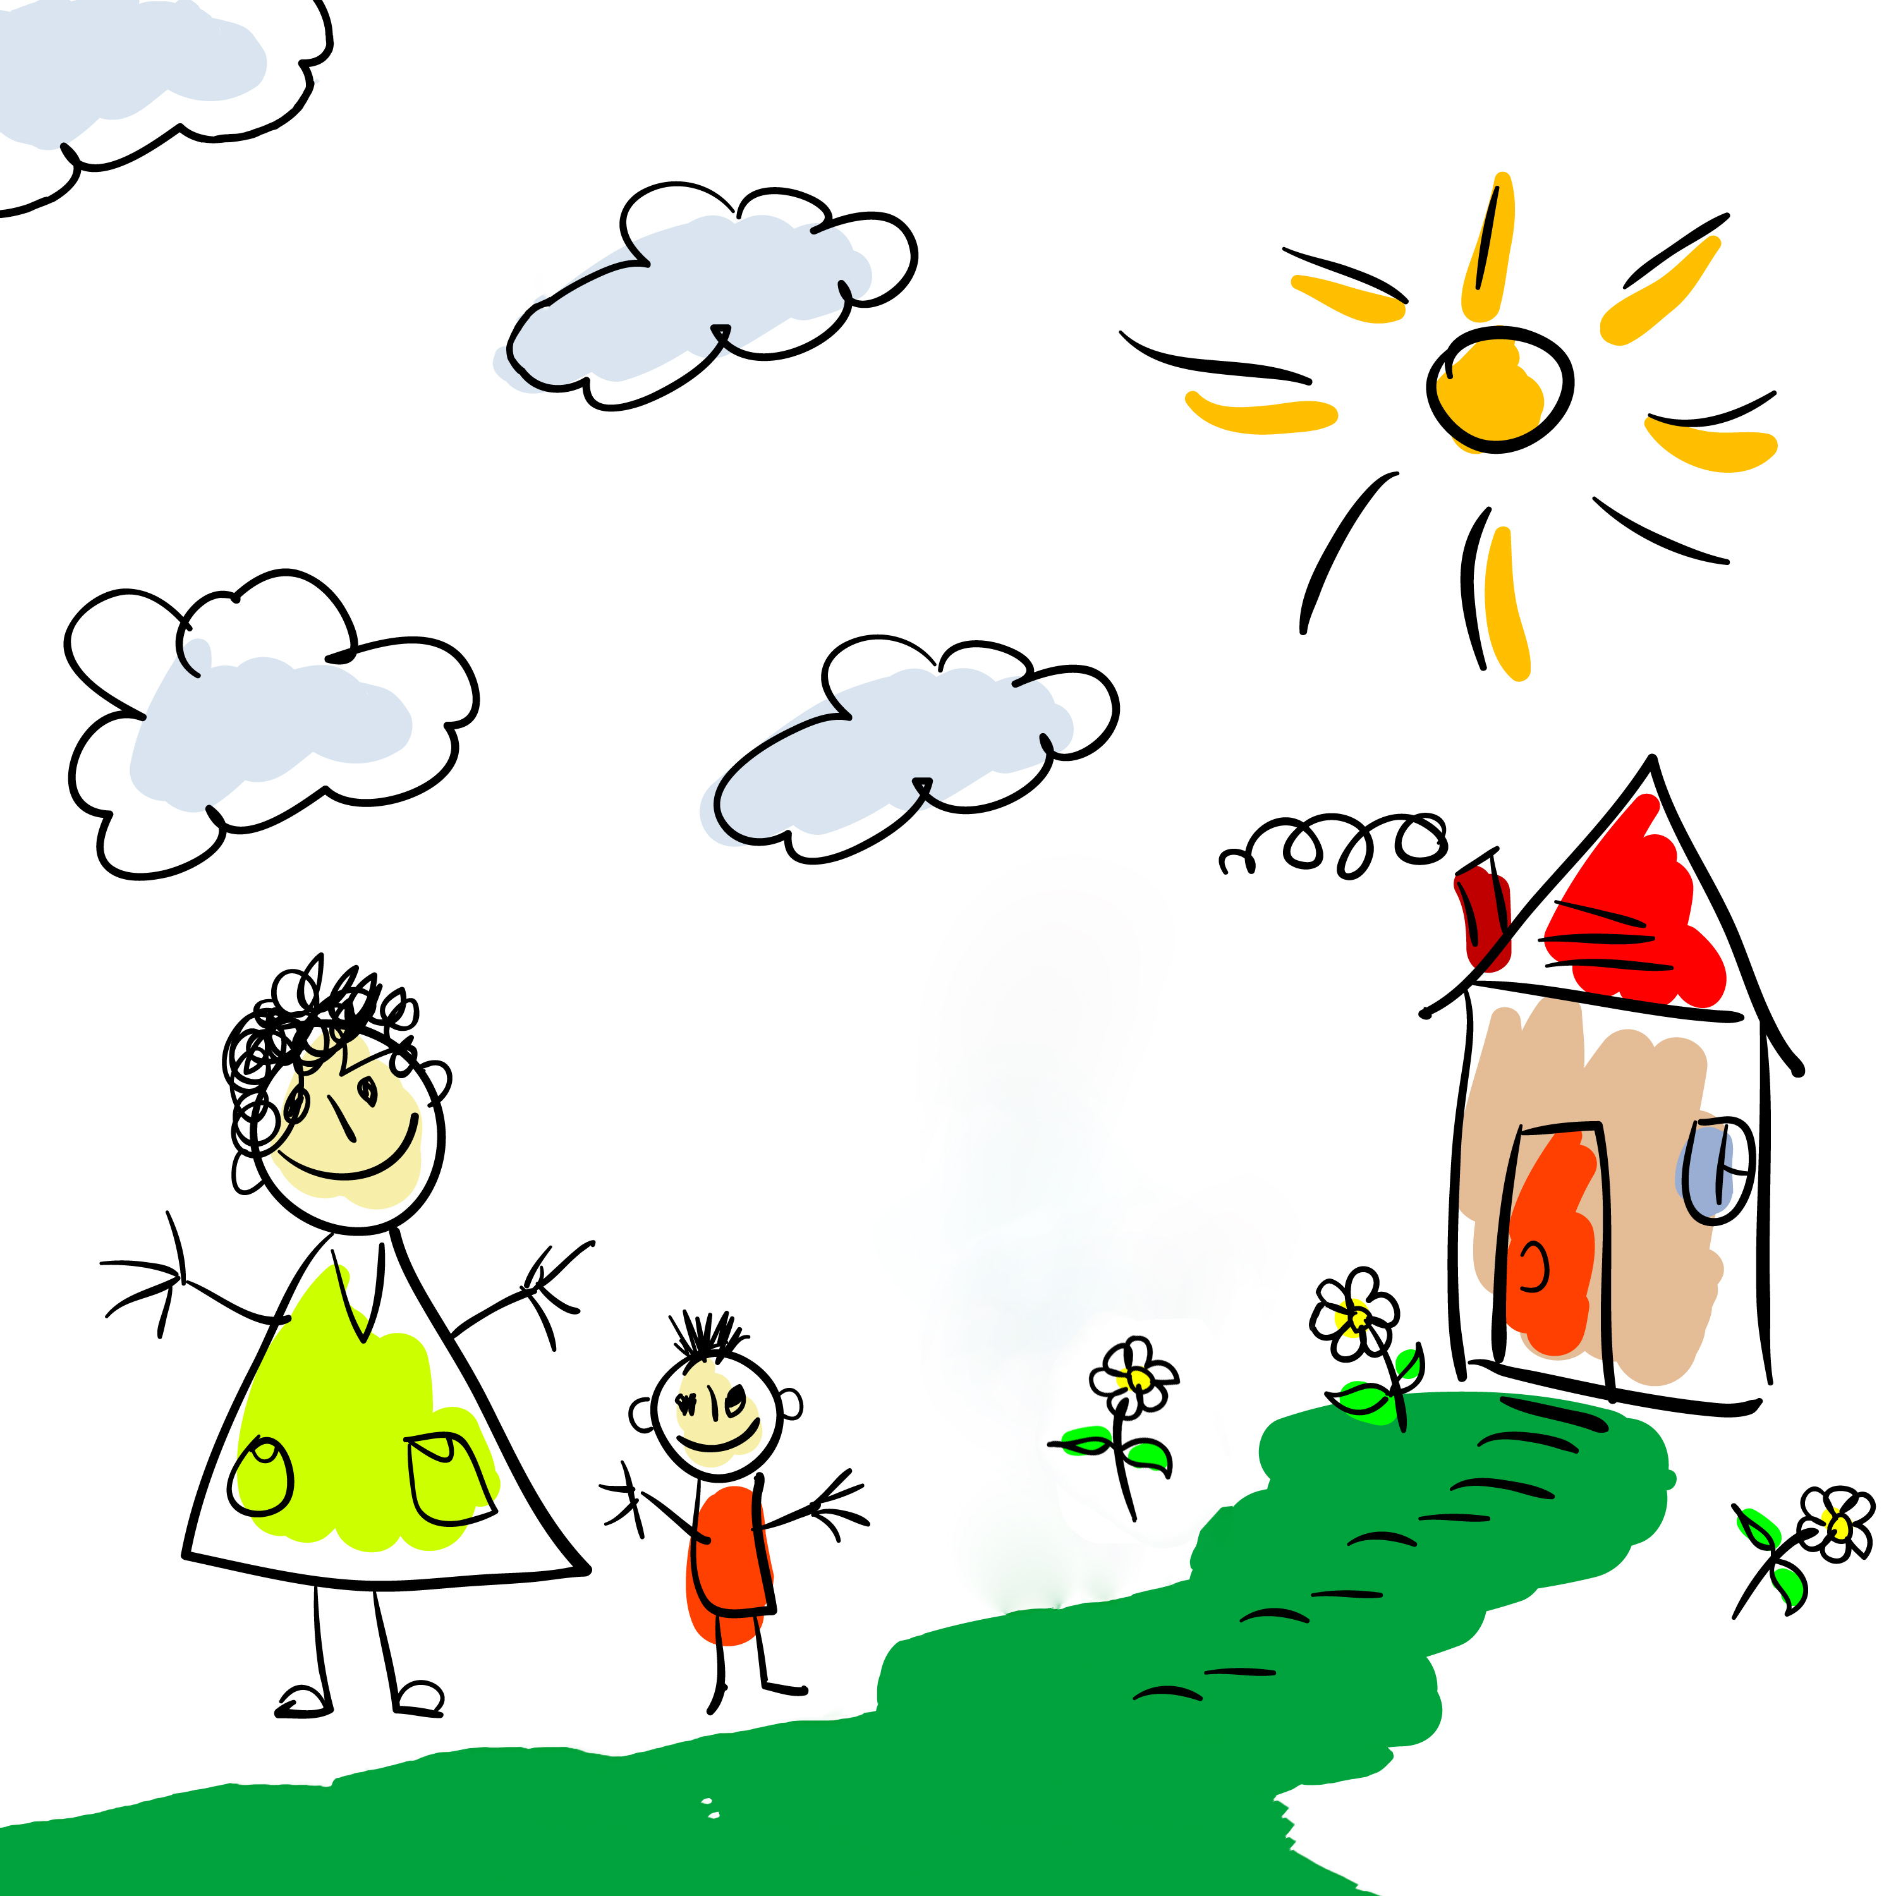

“Mummy, Mummy!” I said, excitedly. “I painted a lovely picture,” I told her. “It was you and me going shopping. Mrs White said she’ll put it on the wall for everyone to see!”

“That is good news,” said Mummy. “Well done, Darren.”

