Digital Homework for 2022-23

Flip and Reading Progress Homework Timetable for 2022-23

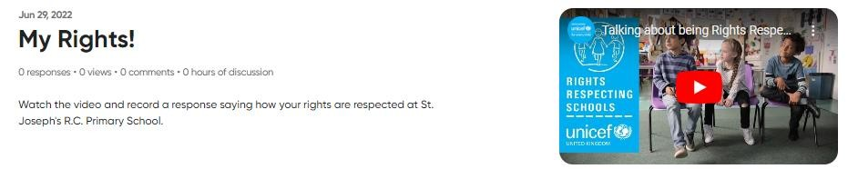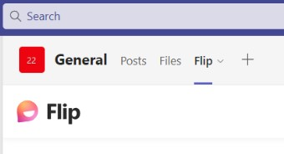Flip is a video discussion and video sharing app. Children are expected to record short video responses to a range of different topics throughout the year. All topics can be accessed by clicking the ‘Flip’ tab in Microsoft Teams.

Flip and Reading Progress homework activities must be completed by children in the following classes:

• St. Teilo 2
• St. Gwynno 3
• St. Tydfil 3
• St. Dwynwen 3

You need to record a  response on the following topics: | Where can you find it? | You need to record your response by:
My Rights! | Go to Hwb and select  ‘Office 365’. Click on  Microsoft Teams and  select ‘Flip’ in the tabs.  Choose the correct topic and record your response.  Remember to ‘Join with  Microsoft’. | Monday 24th October 2022
My Voice! |  | Monday 24th October 2022
Compassionate and Loving |  | Monday 24th October 2022
Four Purposes |  | Monday 12th December 2022
Faith-filled and Hopeful |  | Monday 12th December 2022
Eloquent and Truthful |  | Monday 13th February 2023
Learned and Wise |  | Monday 27th March 2023
Curious and Active |  | Monday 22nd May 2023
Intentional and Prophetic |  | Monday 17th July 2023
My Journey with micro:bit! |  | Monday 17th July 2023

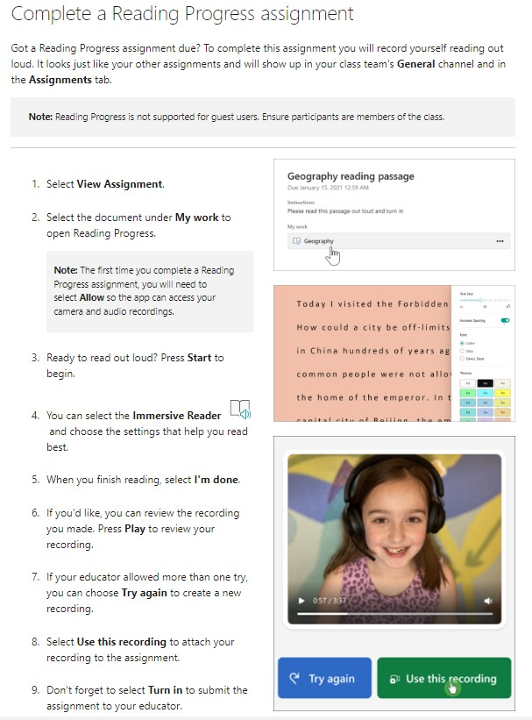Homework Timetable for 2022-23

Reading Progress is a free tool built into Microsoft Teams designed to support and track reading fluency. Students record their reading on camera and submit it to their teacher.

These Reading Progress activities need to be completed by: | Where can you find it? | Record a response on topic called:
Monday 24th October 2022 | Go to Hwb and select  ‘Office 365’. Click on  Microsoft Teams and  select ‘Assignments’ in  the tabs. | Reading Progress Homework 1
Monday 13th February 2023 |  | Reading Progress Homework 2
Monday 22nd May 2023 |  | Reading Progress Homework 3
If you require additional support to complete these activities, please visit the ‘Homework Support’ tab under the
‘PARENTS/RHIENI’ heading on the school website. Mr McHugh will also be holding a parental workshop this term.

