Helpwr Heddiw
Blwyddyn Pedwar
Mrs Houston

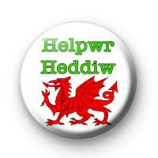
Cymraeg
Helpwr Heddiw Support
Welsh Language hints to help you express yourself in Welsh, to read in Welsh and to write in Welsh
Mae: There is a - there are no words for the word ‘a’ in Welsh
If you wish to add ‘ing’ to a verb in Welsh then you must place ‘yn before it e.g.
Cerdded: walk
Yn cerdded: walking
I you wish to demand something in Welsh you add ‘wch’ to the end of the word. E.g.
Rhedeg – run
Rhedwch – RUN!
In Welsh there are lots of ways to say the word the
‘r = the
Y = the
Yr = the
Mae’r = the
In Welsh we say ‘in’ as
Mewn – in a
Yn – in

Joining words in Welsh
A – and
Ac – and
Hefyd – also
Achos – because
Achos mae’n – because it is
Ond - but

Dw i’n – I am
Roedd hi’n - It was / She was
Roedd e’n – he was
Roedd i’n – I was
Mae hi’n – she is / it is
Mae e’n - he is
I don’t - dydw i ddim

dd in Welsh is pronounced as ‘th’.

Cymraeg
Helpwr Heddiw Support
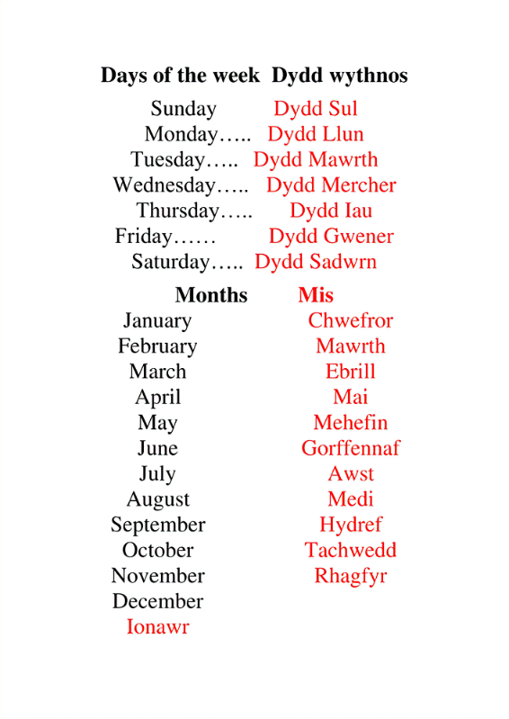

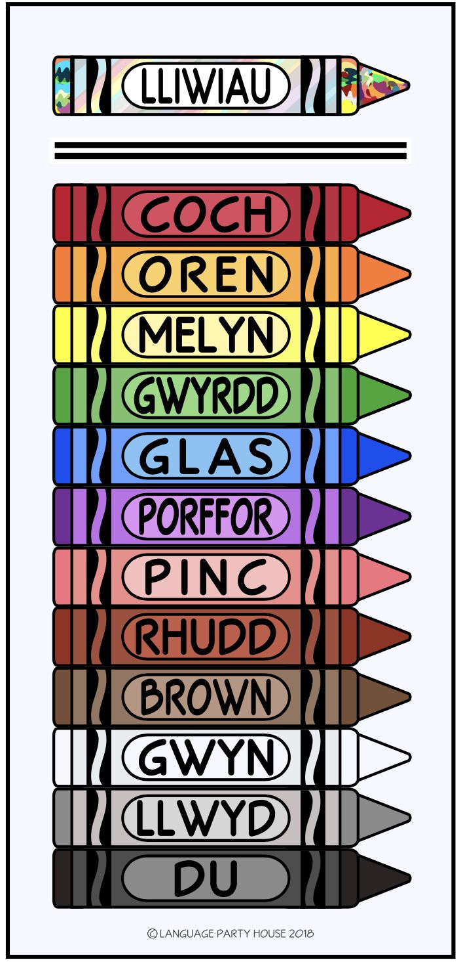
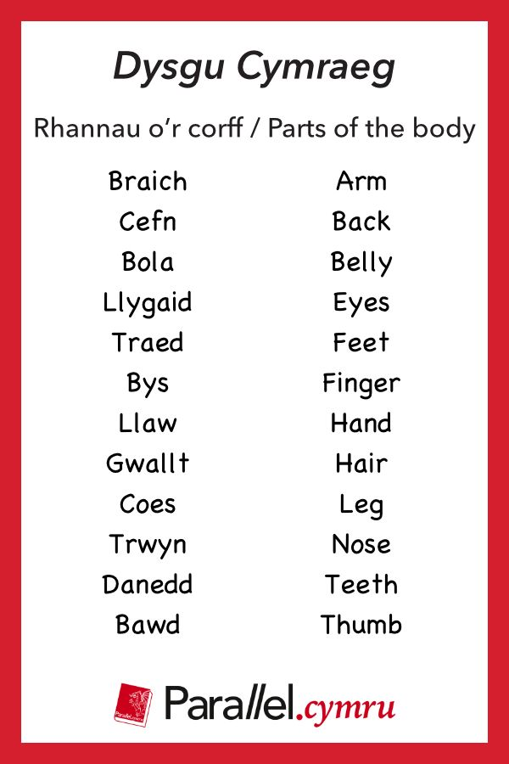
- Briachiau – arems
- Llygad – eyes
- Wyneb – face
- Boch – cheek
- Bociau – cheeks
- Coesau – legs
- Finger – bys
- Fingers - bysiau
- Hands – llaw
- Clustiau – ears
- Wyneb - face

Reasons for liking and disliking …… in Welsh
Remember you have to support your opinions and ideas in Welsh – try not to repeat yourself in a piece of writing or oracy work
- Mae hi’n gwych – it is great
- Mae hi’n diddorel – it is interesting
- Mae hi’n sbwriel – it is rubbish
- Mae hi’n bendigedig – it is fantastic
- Mae hi’n galed – it is hard
- Mae hin gyffous – it is exciting
- Mae hi’n ddoniol – it is funny
- Mae hi’n hwyl – it is fun
- Mae hi’n cwl – it is cool
- Mae hi’n ymlacio – it is relaxing
- Mae hi’n ych a fi – it is horrible
- Mae hi’n fiaidd – it is disgusting
- Mae hi’n flasus iawn – it is delicious
- Mae hi’n felys – it is sweet
- Mae hi’n hyfryd – it is lovely
- Mae hi’n difflas – it is boring
- Mae hi’n belerus – it is enjoyable
- Mae hi’n heriol – it is challenging
- Mae hi’n annodd – it is difficult
- Dydy hi ddim un annodd – it is not difficult
- Dydy hi ddim yn ddoniol – it is not funny
- Dydy hi ddim yn wych – it is not great
- Dydy hi ddim yn gyffrous – it is not exciting

Chwraeon / Sports
LO: To create a series of word webs so information can be used to support oracy, reading and writing.
Word Web two: Chwaraeon / Ymarfer Corff
LO: To be able to pronounce and spell vocabulary associated with Chwareon / Games.
Task: Create a word web of ‘chwaraeon vocabulary. You MUST ensure that you spell all words correctlt – do not be careless! Record Welsh vocabulary in red and Engish vocabulary in blue
Helpwr Heddiw Support
Sentence structures to use with the vocabulary for chwareon
Beth wyt ti eisiau gwneud?
What do you want to do?
Dw i eisiau . . . . . . .
I want to
Beth wyt ti ddim eisiau gwneud?
What don’t you want to do?

Dw i ddim eisiau . . . . .

Wyt ti eisiau . . . . . . .?
What do you want
Ydw, dw i eisiau . . . . . .
Yes I want
Nac ydw, dw i ddim eisiau . . .
No I do not want

Pwy sy eisiau . . . . . . . ?

gwneud gymnasteg
chwarae pêl droed
chwarae rygbi
reidio ceffyl

chwarae pêl rwyd
chwarae badminton
rhedeg

Chwaraeon | Sports
Aerobeg | aerobics
Bocsio | boxing
Cerdded | walking
Criced | cricket
Dawnsio | dancing
Dringo | climbing
Golff | golf
Gymnasteg | gymnastics
Hoci | hockey
Hwylio | sailing
Loncian | jogging
Marchogaeth | horse riding
Nofio | swimming
Pêl-droed | football
Pêl-fâs | baseball
Pêl-fasged | basket ball
Pêl-rwyd | netball
Rhedeg | running
Sboncen | squash
Seiclo | cycling
Tenis | tennis
Ymarfer corff | physical education

Helpwr Heddiw Support – sentence structures for chwaraeon
Dw in hoffi sport a sport achos mae’n reason a reason.
I like … and … because it is … and …
Dw i’n mwynhau sport a sport achos mae’n
I enjoy … and … because it is … and …
Dw i’n dwli sport a sport achos mae’n reason a reason.
I love … and … because it is … and …
Mae’n well da fi sport a sport achos mae’n reason a reason.
I prefer … and … because it is …. and …
Mae’n gas da fi … a …. achos mae’n reason a reason.
I hat … and … because it is … and …

Negative sentences to use about sport in Helpwr Heddiw
Dydw i ddim yn hoffi sport a sport achos mae’n reason a reason.
I don’t like sport and sport because it is REASON and Reason.
Dydw i ddim yn fwynhau sport a sport achos mae’n reason a reason.
I don’t enjoy sport and sport because it is REASON and Reason.
Dydw i ddim yn dwli sport a sport achos mae’n reason a reason.
I don’t love FOOD and Food because it is REASON and Reason.

Cymraeg
Helpwr Heddiw Support
School / Yr Ysgol
LO: To create a series of word webs so information can be used to support oracy, reading and writing.
Word Web Three: School - Ysgol
LO: To be able to pronounce and spell vocabulary associated with School /Ysgol
Task: Create a word web of ‘Yr Ysgol’ vocabulary. You MUST ensure that you spell all words correctly – do not be careless! Record Welsh vocabulary in red and English vocabulary in blue.
Helpwr Heddiw Support – sentence structures for school subjects
Pynciau Ysgol – School Subjects
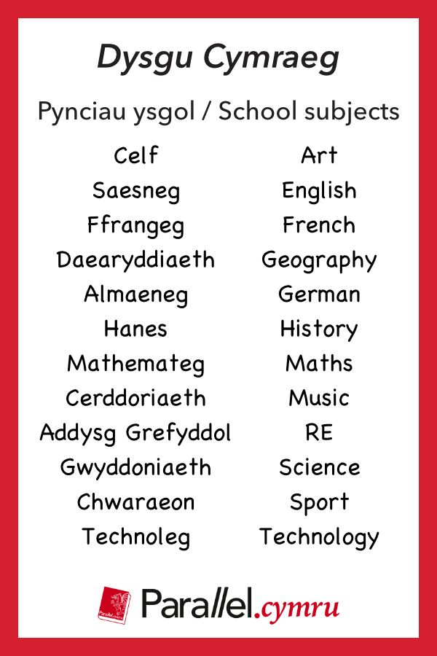

Dw i’n hoffi Subject a Subject achos mae’n reason a reason.
I like … and … because it is … and …
Dw i’n mwynhau subject a subject achos mae’n
I enjoy … and … because it is … and …
Dw i’n dwli subject a subject achos mae’n reason a reason.
I love … and … because it is … and …
Mae’n well da fi subject a subject a chos mae’n reason a reason.
I prefer … and … because it is …. and …
Mae’n gas da fi … a …. achos mae’n reason a reason.
I hat … and … because it is … and …
Negative sentences to use about subject in Helpwr heddiw
Dydw i ddim yn hoffi SUBJECT a SUBJECT achos mae’n reason a reason.
I don’t like SUBJECT and Subject because it is REASON and Reason.
Dydw i ddim yn fwynhau SUBJECT a SUBJECT achos mae’n reason a reason.
I don’t enjoy SUBJECT and Subject because it is REASON and Reason.
Dydw i ddim yn dwli SUBJECT a SUBJECT achos mae’n reason a reason.
I don’t love SUBJECT and Subject because it is REASON and Reason.
Cymraeg
Helpwr Heddiw Support
Dillad / Clothes
LO: To create a series of word webs so information can be used to support oracy, reading and writing.
Word Web Four: Clothes / Dillad
LO: To be able to pronounce and spell vocabulary associated with clothes / dillad
Task: Create a word web of ‘Dillad’ vocabulary. You MUST ensure that you spell all words correctly – do not be careless! Record Welsh vocabulary in red and English vocabulary in blue
Helpwr Heddiw Support – sentence structures for school subjects
Dillad
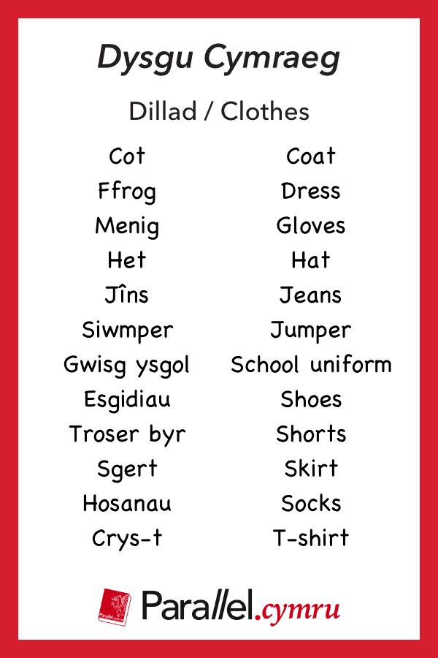
tie - Tei
School badge – bathodyn ysgol
Coat – cot
Jacket – siaced
Trowsu - trowser

Y Tywydd / The Weather
Questions and reponse in the present, past and future tense
Sut mae’r tywydd heddiw? – mae hi’n TYPE of Weather a Type of weather heddiw.
How’s the weather today? It is – type of weather / and type of weather heddiw.
Sut mae’r tywydd ddoe? How was the weather yesterday?
Roedd hi’n type of weather a type of weather ddoe.
It was type of weather and type of weather yesterday.
Sut fydd y tywydd yfory?
How is the weather tomorrow?
Bydd hi’n type of weather a type of weather yfory.
It will be type of weather and type of weather tomorrow.
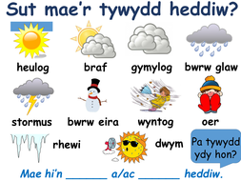

afal | apple
letys | lettuce
bara | bread
llefrith | milk
bisgedi | biscuits
llysiau | vegetables
brechdanau | sandwiches
menyn | butter
bwyd | subject
moron | carrots
bwyta | to eat
reis | rice
cawl | soup
pupur a halen | pepper & salt
caws | cheese
pwdin | dessert
cig | meat
pys | peas
cig moch / bacwn | bacon
sglodion | chips
cnau | nuts
siwgr | sugar
creision | crisps
creision ŷd | cereal
selsig | sausage
crempog | pancake
te | tea
cwrw | beer
ham | ham
cyw iâr | chicken
ffrwythau | fruit
uwd | porridge
pysgod | fish
ffa pob | baked beans
gwin gwyn | white wine
wyau | eggs
grawnfwyd | cereal
hufen iâ | ice cream
gwin coch | red wine

