How things Work

Electrical Circuits

LO – To be able to work with electrical circuits
AC1.1 Identify components in a simple circuit diagram
AC 1.2 State the purpose of the components in an electrical circuit

AC 3.1 Build simple working circuits from simple circuit diagrams

Instructions:

Make a prediction on whether the circuit will work

Build the circuit and check your prediction

Describe why the circuit worked or did not work to show your understanding of how components work. If possible, explain what could be changed for a circuit to work.

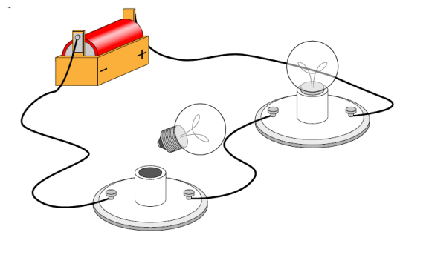  Will it work? YES NO  Did it work? YES NO  Explain why:  ______________________________________  ______________________________________  ______________________________________  ______________________________________ | 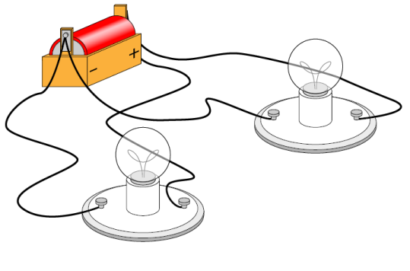  Will it work? YES NO  Did it work? YES NO  Explain why:  ______________________________________  ______________________________________  ______________________________________  ______________________________________
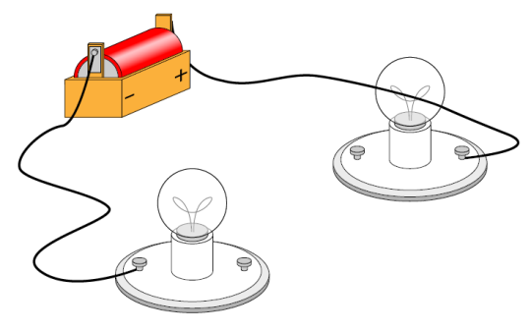  Will it work? YES NO  Did it work? YES NO  Explain why:  ______________________________________  ______________________________________  ______________________________________  ______________________________________ | Will it work? YES NO  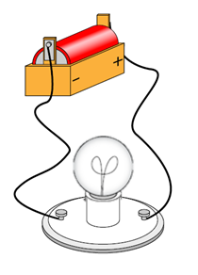  Did it work? YES NO  Explain why:  ______________________________________  ______________________________________  ______________________________________  ______________________________________
Will it work? YES NO  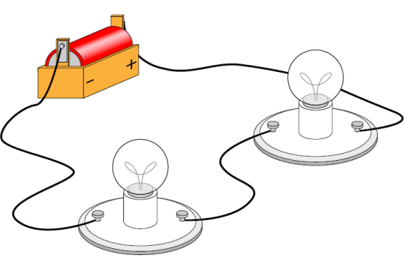  Did it work? YES NO  Explain why:  ______________________________________  ______________________________________  ______________________________________  ______________________________________ | Will it work? YES NO  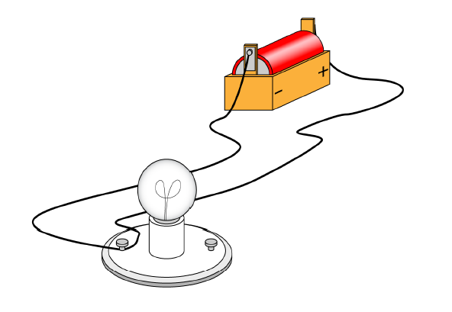  Did it work? YES NO  Explain why:  ______________________________________  ______________________________________  ______________________________________  ______________________________________

Conclusion:

Describe the purpose of the components in a circuit and how they need to be placed in order for a circuit to work properly:

____________________________________________________________________________

____________________________________________________________________________

____________________________________________________________________________

_____________________________________________________________________________

Green/Yellow/Red I/S/L

