How things work

Electrical circuits

LO – To be able to work with electrical circuits

Instructions:

Make a prediction on whether the circuit will work

Build the circuit and check your prediction

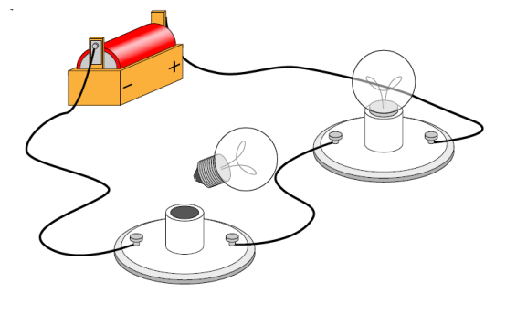  Will it work? YES NO  Did it work? YES NO | 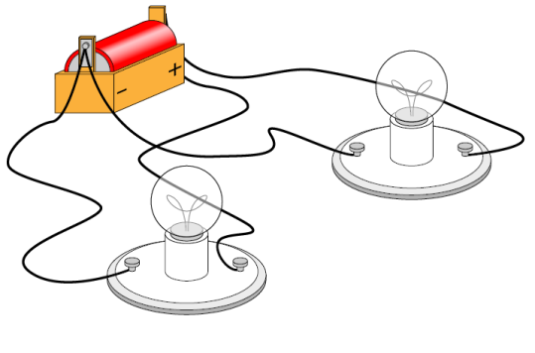  Will it work? YES NO  Did it work? YES NO
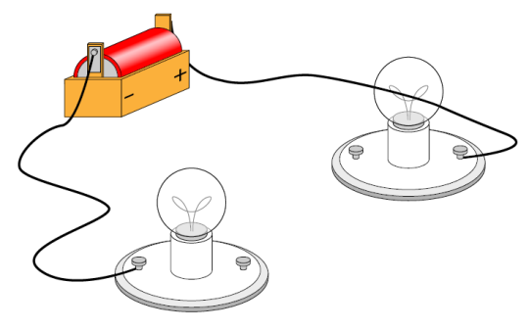  Will it work? YES NO  Did it work? YES NO | Will it work? YES NO  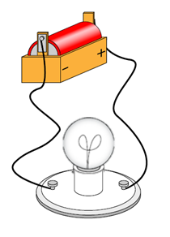  Did it work? YES NO
Will it work? YES NO  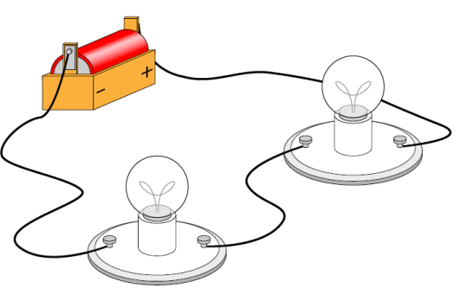  Did it work? YES NO | Will it work? YES NO  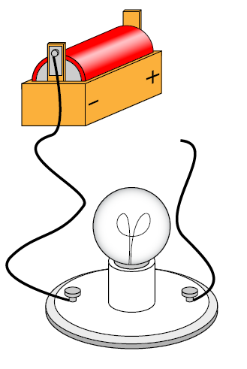  Did it work? YES NO
Will it work? YES NO  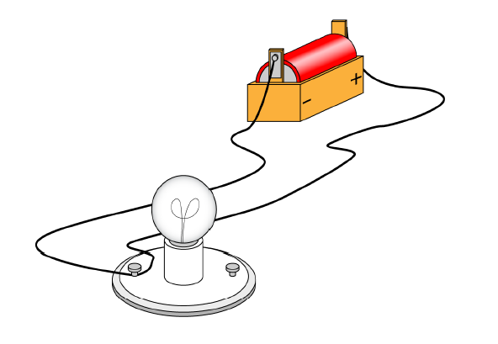  Did it work? YES NO | Will it work? YES NO  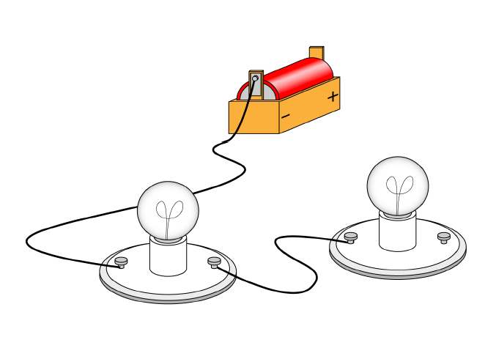  Did it work? YES NO

