Rights of the Child Project
Year Four – Mrs Houston
ACTIVITY 4: OBSTACLES TO GOOD HEALTH
ACTIVITY 5: Discrimination as a barrier to healthcare
OUTRIGHT: Speak out about children’s rights

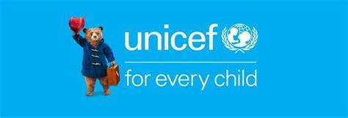

Activity Four and Five
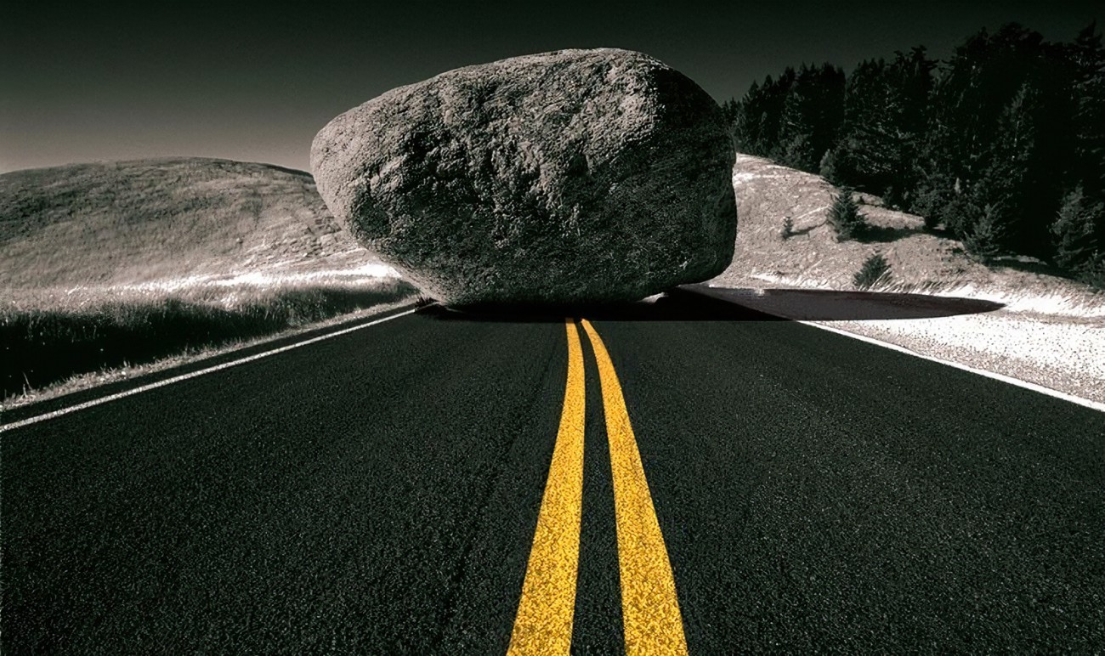

LO: Children explore and identify some of the obstacles that keep children from accessing their right to the best possible health and begin to consider how weak health systems put children’s rights at risk.
Teacher Introduction
In the last activity we learned that the health system in our community is created to look after us and get us the care we need. But what happens if this system –or parts of it– don’t work the way they’re supposed to, or if there are obstacles preventing children from accessing this care? In many places around the world, including in the UK, weak parts of health systems and other obstacles prevent children from having access to the care they need. This means that children’s right to the best possible health is at risk. In this activity we’ll explore why health systems sometimes don’t work the way they should, and how this puts children’s rights and futures at risk.

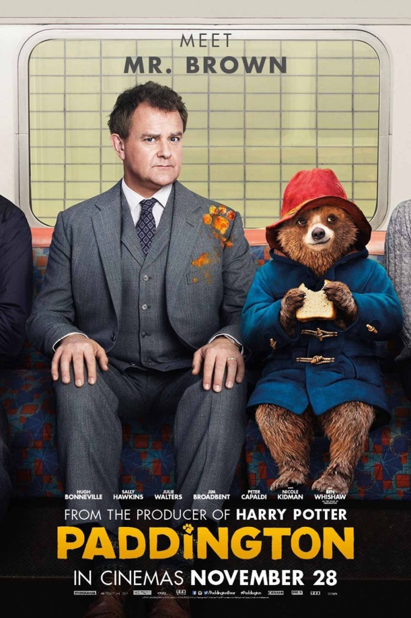

Watch Video: YouTube video – Mr. Brown’s Best Moments
Mr. Brown is a risk analyst. This means his job is to think about everything that might go wrong and why. When Paddington first met the Browns, Mr. Brown was terribly worried about all the risks that could come of keeping a bear in his house with his family.
- “What do you think were some of the risks (or potential for dangerous situations) that Mr. Brown worried about? What might have been the risks for Paddington if the Browns hadn’t given him a home?”
The risks Mr Brown may have felt were …..

Task One
Thinking Map – Obstacles experienced in the COVID Lockdown



Task One: To work collaboratively in your groups to share experiences about the Covid lockdown before the vaccine – what was the impact of not having access to medical care that could address the pandemic? Each group will feed back and a class mind map will be created based on your ideas and opinions. Use the final mind map to reflect on what life must be like for those children who do not have access to health care on a daily basis. (Class discussion)

Task Two: PART 1: BREATHING EXERCISE WARM-UP
1. Ask children if they know what an obstacle is. Explain that in today’s activities they’ll be discussing obstacles, or things that get in the way and stop us from getting where we need to go or doing what we need to do. Ask: “Can you think of a time when you’ve faced an obstacle?
What feelings have you had when you couldn’t do something that you needed to do?” Share that frustration, and sometimes even anger, can be a very normal feeling to have when we have to face an obstacle.
2. To be prepared to talk about obstacles, begin by doing a quick warm-up breathing exercise.
Breathing is an important way to help manage our mental health when we feel strong emotions like frustration and anger.
3. Introduce the group to a simple breathing exercise, like Take 5 Breathing or 4-7-8 Breathing.

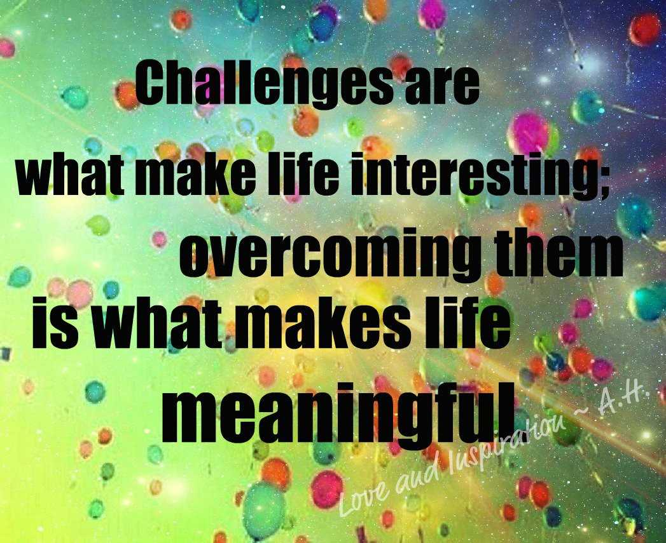
Task Three: Obstacles
Short Burst Writing Task
Genre: Reflective Writing
- Describe a time that you faced an obstacle in life that caused you to struggle.
- How did you feel? Explain why?
- What was the effect of this on your life?
- How did effect the people around you?
- Did you overcome the obstacle? Did you NOT overcome the obstacle? Describe how and why.
- Share your ideas with your group.

Rights of the Child
Do all children have access to healthcare? If not , why not?
Reading Comprehension Task

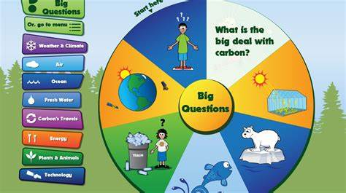
Environmental threats to children’s rights to health care

The lives of all children are threatened by greenhouse gases which cause climate change. Children’s lives today, and future existence, are at risk from rising sea levels, extreme weather events, water and food insecurity, heat stress and new infectious diseases These issues are already affecting hundreds of millions of children today.
Air pollution is responsible for an estimated 7 million deaths (2016). Air pollution is associated with poor childhood breathing health; it negatively effects the lungs and the brain and increases the risk of heart disease, obesity and type 2 diabetes
Climate-related health risks are made worse because 40% of the world’s children who live in poor living conditions such as poor housing, overcrowding, dangerous locations, unhealthy living conditions, poverty and poor access to basic services - these obstacles to health care can harm children’s health and well-being.
Questions:
List the effects of climate change on children’s health.
Climate change places children’s health at risk because:
a)
b)
c)
d)
How many deaths were caused in 2016 as a consequence of air pollution?
The number of child deaths as a consequence of air pollution in 2016 was …
What illnesses does air pollution cause in children?
The illnesses caused in children as a result of air pollution are …
What conditions effect children’s access to health and well – being?
The conditions that stop children’s acess to health and well being are:
a)
b)
c)
d)

The effect of advertisements on children’s health and well – being

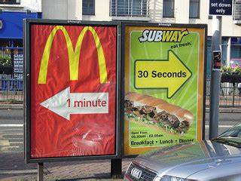
The huge rise in childhood obesity is one of the most serious public health challenges of the 21st century, with the number of children affected by obesity increasing more than ten times from 11 million in 1975 to 124 million in 2016.
Children are frequently shown harmful advertisements including fast food and sugar-sweetened drinks which contribute to obesity and diseases, as well as online gambling services, which can harm their relationships, school achievement, and mental health.
Evidence suggests that children in some countries see as many as 30 000 advertisements on television alone in a single year, many for harmful products.
Questions:
How has child obesity increased between 1975 and 2016?
Child hood obesity has …
Why are online and TV adevertidements often a danger to children’s health and well being?
TV and on line advertisements have a negative effect on children’s health and well - being because …
Evidence shows that children can see how many negative advertisements that effect their mental and physical well – being?
Evidence shows that some children see ….
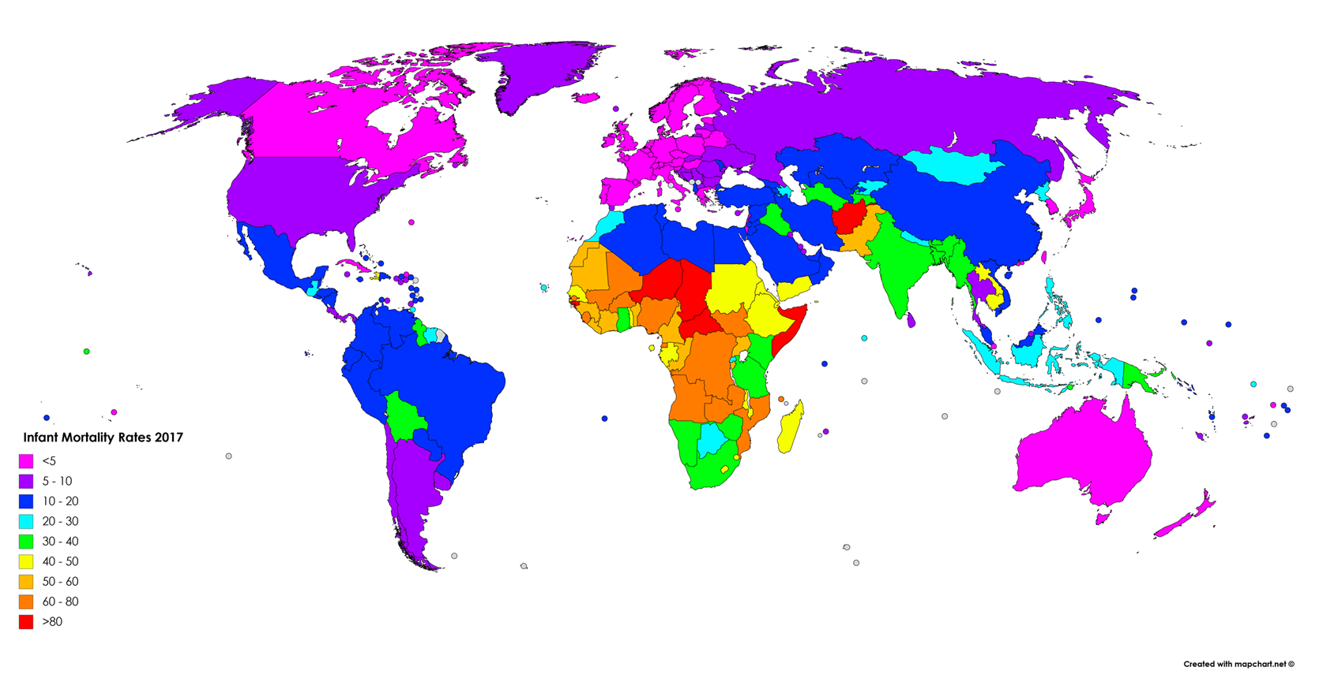

Use your map reaing skills to investigate where infant mortality rates suggests a lack of access to health care.

- Name two countries where infant mortality is 80%.
- Name two countries where infant mortality is between 60 and 80 %
- Name two countries where infant mortality is between 50 and 60%
- Name two countries where infant mortality is between 40 and 50%.
- Name two countries that infant mortality is between 30 and 40%.
- Name two countries where infant mortality is between 20 and 30%
- Name two countries where infant mortality is between 20 and 10%
- Name two countries where infant mortality is at 5 to 10%
- Name two countries where infant mortality is at 5%
- Which continent according to the map has the poorest healthcare for children?

Discrimination as a barrier to healthcare: Activity 5

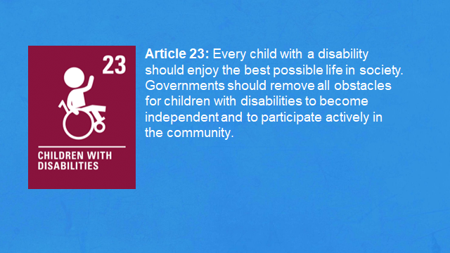
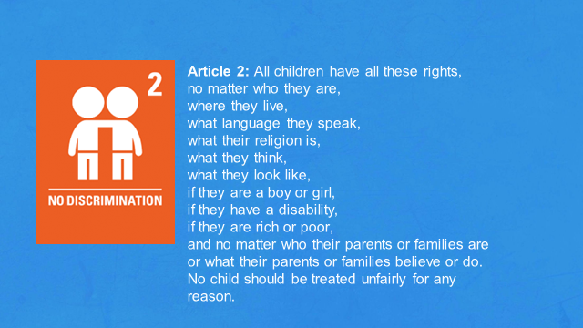
Watch PPT

How do you think health systems could change, or be stronger, to make sure everyone gets the care they need?

What does discrimination mean interms of health care and well – being for children?

Watch and Discuss PPT

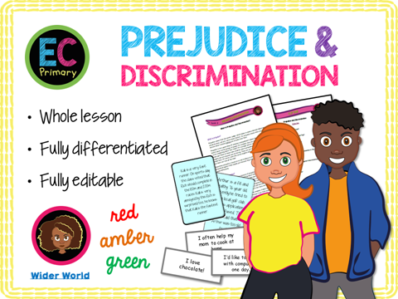

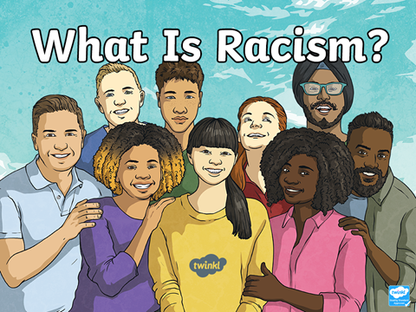

Rights of the child

Task = Research and make a poster to investigate why discrimination of children is wrong.

Comprehension Task

DISCRIMINATION AGAINST CHILDREN
Discrimination means the unjust treatment of different groups of people based on their race, age, or sex. In other words, treating people differently without any reasonable cause.
People should not be placed at a disadvantage simply because of their race, religion, disability, age or sex. Discrimination is simply wrong and against the law. Discrimination against children can be more severe because children have less power.
Children face discrimination because of their dependence on adults and adults’ reluctance to give them more decision-making power as they develop the ability to exercise it themselves. Children face discrimination on other grounds, such as their race, gender, immigration status, disabilities, or a combination of such things.
Article 2 of the CRC prohibits discrimination of any kind, including race, colour, sex, language, religion, political or another opinion, property or disability..”
A child should be child protected against all forms of discrimination.
Despite the existence of these laws designed to stop discrimination it is a massive problem today. For example, if children are called insulting names because of their colour or their age or because of some physical or mental disability, we all know that such behaviour is wrong. If we can learn to truly love others the way we love ourselves, discrimination will gradually disappear from the society. Discrimination feeds mistrust, resentment, violence, crime, and insecurity, and reduces productivity. It does not benefit society in any way.
Questions:
1)What is the meaning of the word ‘discrimination’?
The meaning of the word discrimination is …
2) List the reasons children can be discriminated against?
The reasons children are discriminated against are …
3) Who causes discrimination against children?
Children are discriminated by ,,,,
4) What article if the Convention for children’s rights says they should not be discriminated against>
The number of the article of the Children’s right s convention which states that children should not be discriminated against is Article ….
5) Why is discrimination against children a massive problem?
Discrimination against children is still a massive problem because …
6) is discrimination against children a positive thing.
Discrimination against children is a ...

