Topic Title: Plastic Fantastic – The impact of recycling
Authentic Context/Relevance: To know about the importance of recycling to protect our environment. |  |  |  |  |  |  |  |  |  | Visits/fieldwork/visitors: Visit to the National Museum for Wales – Recycling Workshops.
Pairs of Virtues: Compassionate and loving / faith – filled and hopeful
EAL:  Isabella; Rose; San; Bernice; Joen; Mahira; Arlo; Mahin; Makan; Sachin; Francisco; Stanley, Richa, Jonas |  | MAT  Patrick, Bernice, Phoebe, Charlie,Stanley, Sarah-Rose, |  |  | ALN  Leo  Vernon |  |  | eFSM  Makan; Cody - Capri, Bernice, Gracie |  |  | Aspire |  | CLA  Toby
Literacy Texts: Iron Man – Ted Hughes  What is recycling?  How to sort waste  What materials can we recycle  Why is cycling important?  Plastic in our oceans |  |  |  |  |  |  | Genre/s of writing to be developed:  Factual research writing – why is recycling important?  Letter Writing  Report Writing  Analytical Writing (Poetry)
Week  Date | Learning Objective |  |  | Differentiated Activities  (inc AfL; HoM) |  |  |  | Statement of What Matters |  |  |  | AOLE Skills  (Cross curricular) |  | Evaluation
Wk 1 4th September | LO: To apply my ability work collaboratively in learning books to debate why recycling is important. |  |  | PPT: what is recycling?  PPT: Why is recycling important?  PPT: What materials can were cycle?  Context: Plastic Fantastic – Why is recycling important?  Lesson 1  LO: To apply my ability work collaboratively in learning books to debate why recycling is important.  AoLE: Languages, Literacy and Communication  Success criteria:  I can work collaboratively with others. B / D / M  I can listen to the views of others. B/ D / M  I make sensible and valuable contributions to learning discussions. B / D / M  I can use a range of resources to locate information. B / D / M  LA: Four points  MA: Six points  UA: Exceed 10 points |  |  |  | 1. Learning about identity and culture through languages prepares us to be citizens of Wales and the world.  2. Learners who listen and read effectively are prepared to learn throughout their lives.  3. Learners who speak and write effectively are prepared to play a full part in life and work.  4. Literature fires imagination and inspires creativity. |  |  |  | AoLE: Languages, Literacy and Communication
Wk 2 11th September | LO: To apply my literacy skills to interrogate a non – fiction text about recycling  LO: To apply my previous learning to recycle materials according to their properties. |  |  | GGR: Why recycle? – differentiated three ways.  Context: Plastic Fantastic – Why is recycling important?  Lesson 2 – GGR  Success criteria:  I can read the text fluently. B / D / M  I can extract the appropriate information to extract information to answer questions. B/ D / M  PPT: How to sort materials accurately for recycling  Lesson 3 – Classification of materials according to their properties LO: To apply my ability to classify materials according to their properties.  AoLE: Science  Success criteria:  I am able to use my listening skills and previous learning to classify materials for recycling. B / D / M  Differentiation: Number of objects to be classified differed according to ability. |  |  |  | 1. Exploring the expressive arts is essential to developing artistic skills and knowledge and it enables learners to become curious and creative individuals.  2. Responding and reflecting, both as artist and audience, is a fundamental part of learning in the expressive arts.  3. Creating combines skills and knowledge, drawing on the senses, inspiration and imagination. |  |  |  | AoLE: Languages, Literacy and Communication  Science – classification of materials according to their properties
Wk 3 18th September | LO: To apply my literacy skills to define meanings of vocabulary associated with recycling.  LO: To apply my literacy skills and previous learning to classify information as true or false. |  |  | Context: Plastic Fantastic – Why is recycling important?  Lesson 4  Success criteria:  I can apply my previous learning to identify vocabulary associated with recycling. B / D / M  I can extract the appropriate information to extract information to answer questions. B/ D / M  Context: Plastic Fantastic – Why is recycling important?  Lesson 5 – True or fals classification of information - GGR  Success criteria:  I can apply my previous learning to identify vocabulary associated with recycling. B / D / M  I can extract the appropriate information to extract information to answer questions as being true or false. B/ D / M |  |  |  | 1. Exploring the expressive arts is essential to developing artistic skills and knowledge and it enables learners to become curious and creative individuals.  2. Responding and reflecting, both as artist and audience, is a fundamental part of learning in the expressive arts.  3. Creating combines skills and knowledge, drawing on the senses, inspiration and imagination. |  |  |  | AoLE: Languages, Literacy and Communication  AoLE: Languages, Literacy and Communicatiion
Wk 4 25th september | LO: To apply my literacy skills to interrogate a poem about recycling |  |  | Context: Plastic Fantastic – Why is recycling important?  Lesson 6– GGR – Analysing Poetry  Success criteria:  I can read the text fluently. B / D / M  I can extract the appropriate information to extract information to answer questions. B/ D / M  I can describe how a poem is organised. B/ D / M  Task: Read the following poem within your group. Discuss the questions so that you can feed your ideas back to the class. Write a short piece of writing about the poem using the questions below to help you. (See resources file) |  |  |  | 1. Exploring the expressive arts is essential to developing artistic skills and knowledge and it enables learners to become curious and creative individuals.  2. Responding and reflecting, both as artist and audience, is a fundamental part of learning in the expressive arts.  3. Creating combines skills and knowledge, drawing on the senses, inspiration and imagination. |  |  |  | AoLE: Languages, Literacy and Communication
Week 5 1st November | LO: To apply my learning on Venn diagrams to identify materials we can recycle at home / school or both.  LO: To apply my literacy skills to interrogate a non – fiction text about recycling.  LO: To apply my knowledge of keys and data handling to interrogate a graph showing data about Wales and how it recycles waste in comparison with the rest of the Uk. |  |  | Context: Plastic Fantastic – Why is recycling important?  Lesson 7– Venn diagrams  Success criteria:  I can apply my problem solving skills. B / D / M  I can apply my previous learning to sort materials. B/ D / M  Context: Plastic Fantastic – Why is recycling important?  Lesson 8 – GGR – Recycling Week  LO: To apply my literacy skills to interrogate a non – fiction text about recycling  Success criteria:  I can read the text fluently. B / D / M  I can extract the appropriate information to extract information to answer questions. B/ D / M  Context: Plastic fantastic.  Welsh Link  Lesson 10 – Exploring how the different countries of the United Kingdom recycle materials and to discover how Wales compares in comparison with these countries..  AoLE: Mathematics  Success criteria:  I am able to use a key to locate information. B / D / M  I am able to interrogate information to draw conclusions about data. B / D / M  I am able to make sensible estimates about data. B / D / M |  |  |  | 1. The number system is used to represent and compare relationships between numbers and quantities.  2. Algebra uses symbol systems to express the structures of relationships between numbers, quantities and relations.  3. Geometry focuses on relationships involving properties of shape, space and position, and measurement focuses on quantifying phenomena in the physical world.  4. Statistics represent data, probability models chance, and both support informed inferences and decisions . |  |  |  | AoLE: Mathematics  AoLE: Languages, Literacy and Communication  AoLE: Languages, Literacy and Communication  AoLE: Mathematics
Week 7 8th Nov | LO: To apply my knowledge of keys and data handling to interrogate a map showing data about Wales and how it recycles waste. To apply numeracy skills to compare rates of recycling in different areas of Wales  LO: To apply my knowledge of keys and data handling to interrogate a graph showing data about Wales and how it recycles waste.  LO: To apply my knowledge of keys and data handling to interrogate a graph showing data about Wales and how it recycles waste |  |  | Context: Plastic fantastic.  Welsh Link  Lesson 11 – Exploring how the different areas of the Wales recycle materials.  Success criteria:  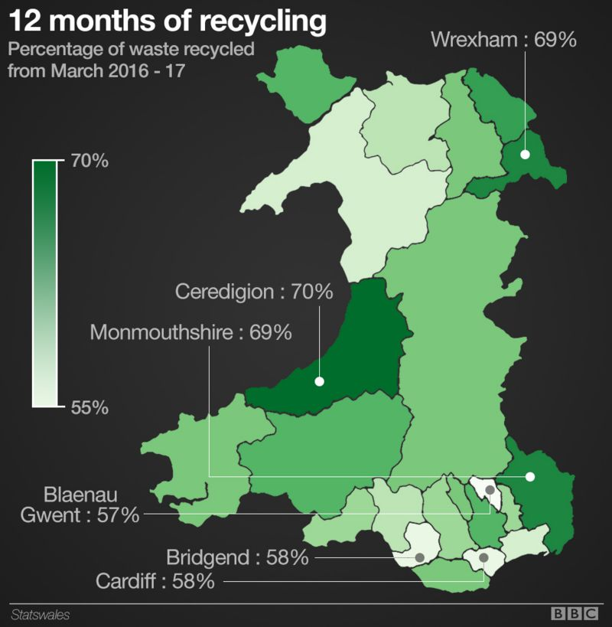  I am able to use a key to locate information. B / D / M  I am able to interrogate information to draw conclusions about data. B / D / M  I am able to make sensible estimates about data. B / D / M  Context: Plastic fantastic.  Lesson 12 – Exploring how the different counties of the world recycle plastic.  LO: To apply my knowledge of keys and data handling to interrogate a graph showing data about Wales and how it recycles waste.  Success criteria:  I am able to plot a graph. B / D / M  I ensure that each axis is labelled and divided up at equal intervals. B / D / M  I am able to interrogate information to draw conclusions about data. B / D / M  I am able to apply my numeracy skills to make calculations about data. B / D / M  I ensure my graph has a heading so that it makes sense. B / D / M  . |  |  |  | 1. Developing an enquiring mind enables learners to explore and investigate the world, past, present and future, for themselves.  2. Events and human experiences are complex, and are perceived, interpreted and represented in different ways.  3. Our natural world is diverse and dynamic, influenced by physical processes and human actions.  4. Human societies are complex and diverse, and shaped by human actions and beliefs.  5. Informed, self-aware citizens engage with the challenges and opportunities that face humanity, and are able to take considered, ethical and sustainable action.  1. The number system is used to represent and compare relationships between numbers and quantities.  2. Algebra uses symbol systems to express the structures of relationships between numbers, quantities and relations.  3. Geometry focuses on relationships involving properties of shape, space and position, and measurement focuses on quantifying phenomena in the physical world.  4. Statistics represent data, probability models chance, and both support informed inferences and decisions |  |  |  | AoLE: Mathematics and Humanities  AoLE: Mathematics and Humanities / Citizenship
 | LO: TO apply learning on recycling to write a letter about your concerns and what actions are being taken to address plastic pollution. |  |  | Letter Writing:  To write to the prime minister about plastics and recycling.  LO: TO apply learning on recycling to write a letter about your concerns and what actions are being taken to address plastic pollution.  Success criteria:  I can apply my learning in a present day context? B / D / M  I can apply my learning on how to write a formal letter to the Prime Minister. B / D / M  I can produce a fluent and joined script. I am beginning to paragraph my writing.  I can achieve an accurate level of spelling. B / D / M  My independent writing is grammatically correct. B / D / M |  |  |  | 1. Exploring the expressive arts is essential to developing artistic skills and knowledge and it enables learners to become curious and creative individuals.  2. Responding and reflecting, both as artist and audience, is a fundamental part of learning in the expressive arts.  3. Creating combines skills and knowledge, drawing on the senses, inspiration and imagination. |  |  |  | Citizenship  AoLE: Languages, Literacy and Communication
 | Report Writing  LO: use your learning and observation and learning skills to write about your visit to the National Museum of Wales to learn about recycling. |  |  | Report Writing  Success criteria:  Do I adopt an appropriate tone and structure in my writing. B / D / M  Do I sequence events accurately/ B / D / M  I can produce a fluent and joined script. I am beginning to paragraph my writing.  I can achieve an accurate level of spelling. B / D / M  My independent writing is grammatically correct. B / D / M |  |  |  | 1. Exploring the expressive arts is essential to developing artistic skills and knowledge and it enables learners to become curious and creative individuals.  2. Responding and reflecting, both as artist and audience, is a fundamental part of learning in the expressive arts.  3. Creating combines skills and knowledge, drawing on the senses, inspiration and imagination. |  |  |  | AoLE: Languages, Literacy and Communication
 |  |  |  | Make recycled paper  Kandinsky Art Project  Design and make a bird feeder out of recycled products (outdoor learning)  Iron Man portraits – colour, form, tone and line and mark. |  |  |  | 1. Exploring the expressive arts is essential to developing artistic skills and knowledge and it enables learners to become curious and creative individuals.  2. Responding and reflecting, both as artist and audience, is a fundamental part of learning in the expressive arts.  3. Creating combines skills and knowledge, drawing on the senses, inspiration and imagination |  |  |  | Expressive Arts
UNCRC |  |  | Diversity: Behaviours between countries and attitudes towards recycling of plastics |  |  | Careers and Work Related Experiences |  |  |  | Local, National and International Contexts  Recycling in wales  Recycling in Britain  Recycling of plastics in the world.
Eco: Achieved |  |  | Fairtrade: / NA
Numeracy Skills/Activities:

DCF Skills:
Literacy Skills to be developed: |  |  |  |  |  |  |  | Possible Texts
Websites

