GGR Lesson One Street Child
Extracting Information from the Text.
LO: To use skim and scan reading skills from the cover of a book to extract information.
Present the following information in a paragraph using this writing frame.
- Look at the cover of the book. What do you see? What do you think the child is doing on the main cover and how do you think he feels?
- Look at the background of the picture, describe what you can see.
- What is the title of the book you are going to read and who is the author?
- Who published the book and in what year?
- Who is the illustrator of the book?
- To whom is the book dedicated?

GGR – Street Child – Lesson 2- Read the introduction to the text
Read the prologue: ‘Tell me your story Jim.’
Answer a series of questions on the first chapter. (Extracting information, identifying empathy and interpreting meaning based on evidence, but not stated)
Look at the following extract. Use it to find the opposites to create a paragraph on what Jim’s life was like before meeting Mister:

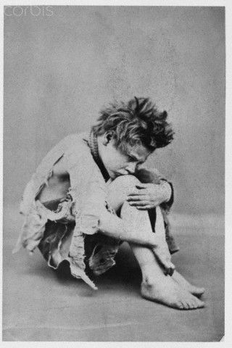
I can’t believe my luck, and that’s a fact. Here I am with food in my belly, and good hot food at that, and plenty more where that came from, he says. I’m wearing clothes that smell nice and that don’t have no holes in, neither. And I’m in this room where there’s a great big fire burning, and plenty more logs to put on it so it won’t die off. There’s me and him. The other boys are upstairs in their hammocks, all cosy in the big room we sleep in. And downstairs there’s me and him, special.
GGR – Street Child – Lesson 2- Chapter One
Read Chapter one
THE SHILLING PIE

LO: To be able to read the text with fluency and understanding. To extract information to draw conclusions about the character and circumstances of Jim’s life with his mother.

Answer the following questions about chapter one.

- Where was Jim going at the beginning of the chapter?
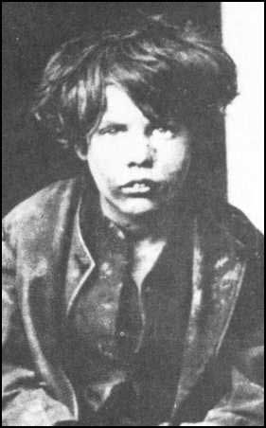
- Why do you think Mrs Hodder bit the coin that Jim gave her? How do you know she didn’t trust him?
- Jim’s sister makes him calm his excitement when returning to their shared room. Why? What does this suggest to you about Jim’s mother?
- What does the following quote suggest to you and the facts that Jim as a child does not yet understand? “I told you,” said Emily. “She don’t want food no more. That’s what she said.”

Autobiographical Text – Doctor Banardo
Summary Writing
LO: To read and draw conclusions from an autobiographical text
Questions
1. When was Thomas John Barnardo born?
4th July 1845
4th June 1866
4th January 1867
4th May 1870
2. Match the place to its relevance.(see resource)
3. List two things that ragged schools gave to needy boys.
4. Who took Dr Barnardo for a walk around the East End of London?
5. Find and copy a word or phrase from the ‘Stepney Causeway’ section which tells you that Dr Barnardo wanted to help all children.
6. Why do you think that Dr Barnardo trained the boys in carpentry, metalwork and shoe making?
7. Explain why lots of children didn’t make it to their fifth birthday.
Summary Writing: The Life of Doctor Banardo
LO: To apply previous learning on how to write a summary of a person’s life.
Resource: Read and discuss PPT on the experiences of Doctor Banardo before reading the text.
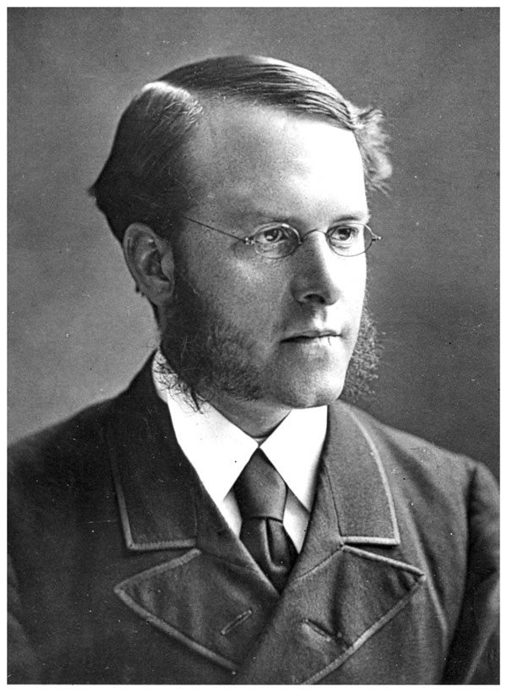

Comparative Writing
What rights do we as children enjoy that were not experienced by Victorian Street Children?
Resource: PPT Presentation

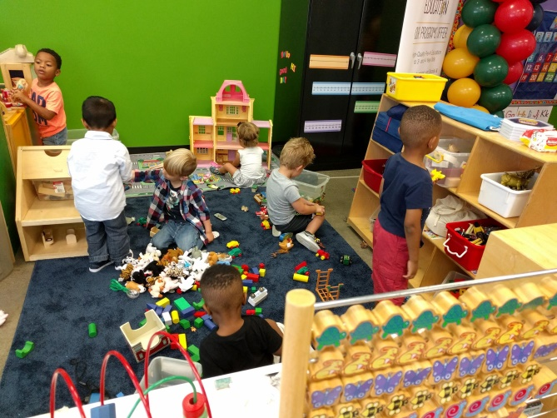
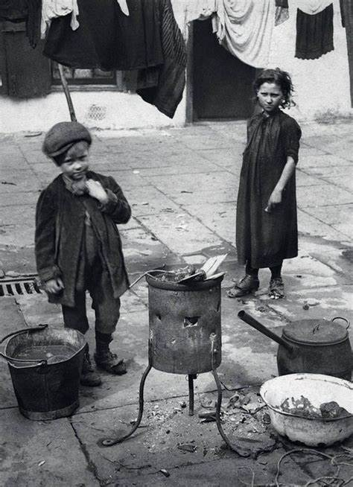
LO: To use a comparative style of writing.
Sentence starters to help you vary your sentence structures within your writing.
- The difference between …
- In comparison …
- Unlike …
- Our lives and the rights, that we enjoy, are dissimilar because …
- Our lives contrast because …
- The rights that we enjoy are poles apart because …
Remember to try and think and record why this makes our lives so different. This will result in a much more engaging piece of writing – try to avoid basic responses.

Task One – use the above pictures to make thinking maps of the rights which are not and enjoyed by Victorian children and ourselves.
Task Two: Use your thinking maps to create a comparative piece of writing.
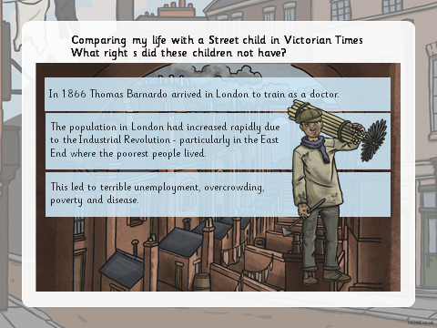
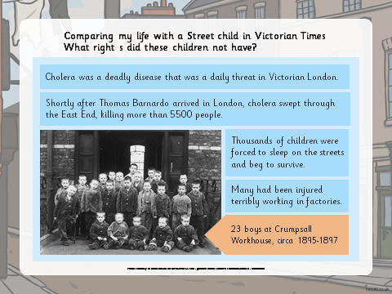

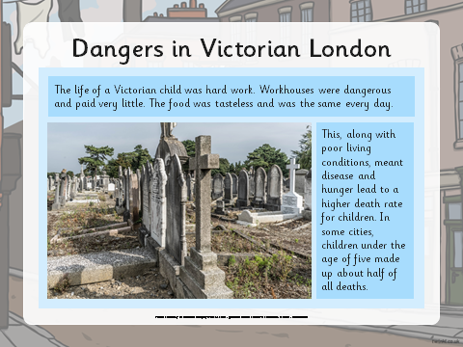

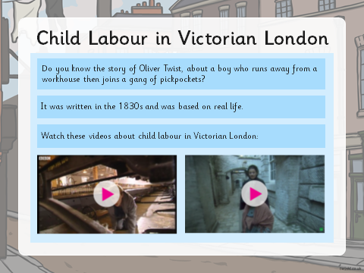

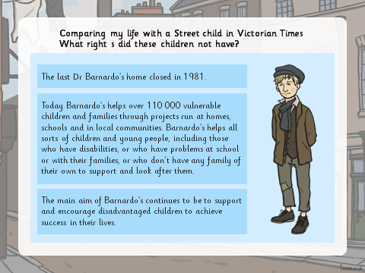

Chapter Two – Street Child - GGR
The Stick Man
Descriptive Writing / Opinion Writing
LO: To produce a piece of descriptive writing of the stick man incorporating your opinion of the character.
Task: Read Chapter two: Read out loud as individuals, groups and whole class. (teacher to model read initially.
Comprehension task:
- What woke Jim’s family?
- How do you know Emily is afraid of the Stick Man?
- What is the stick Man trying to say / imply when he describes Jim’s family as ‘lie – abeds’?
- The Stick Man asks is Jim’s mother dead? What does this tell you about the character?
- Why is describing Jim’s mother as a ‘grand lady’ a cruel thing to say?
- What does the following quote from the text tell us about the Stick Man? ‘Mingling the loose coins there like little bells, as if they made sweet music to his ears.’
- Why is the Stick Man so eager to evict Jim’s family from the room? What does this tell us about him?

