GGR: What is Modern day Child labour? 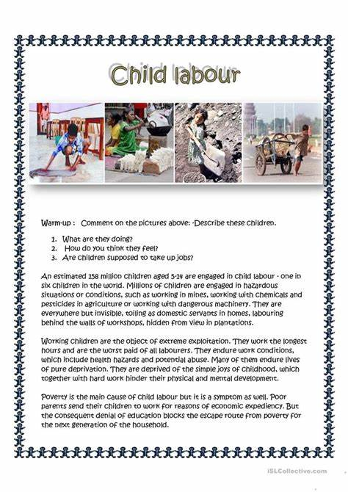

Cut out each of the pictures. In your learning groups discuss and then answer the following questions.
- What are each of these child workers doing?
- How do you think these children feel? Why?
- What, in your opinion, should these children be doing with their time? Why?
- Do you think it is right that children as young as four years of age are made to work? Why?
Use your dictionary skills to find definitions for the following words in this non – fiction text.
- Estimate:
- Hazard:
- Pesticides:
- Exploitation
- Abuse:
- Hinder:
- Expediency:
- Denial:
- Poverty:
Extract the correct information from the text to answer these questions in complete sentences.
- How many children are estimated to have to work in the world?
- List the different jobs child labourers are required to do.
- Write a detailed response about the consequence for children of being a child labourer.
- What is the main cause of child labour in the world?
- What is the main consequence of child labour and means that it is allowed to continue?

