Lesson Nine – Rights - living conditions past and present
The Victorian Workhouse
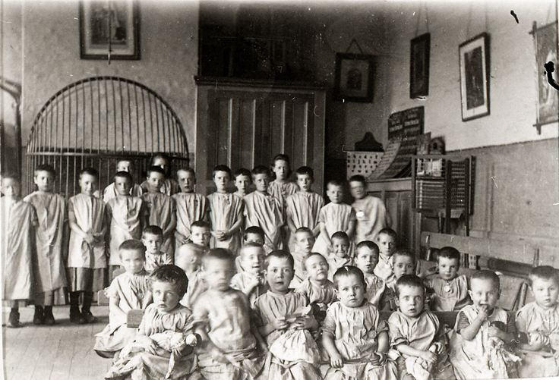
LO: To use my literacy skills to interrogate a non – fiction text on the rights of children in terms of shelter in the Victorian period and today.
Success criteria:
I can read the text fluently and with understanding. B / D / M
I can apply my skim and scan skills to locate relevant information B / D / M
I respond to the text in complete sentences demarcated with capital letters and full stops B / D / M
I can express my opinions about the text and support them by using evidence from the text. B/ D / M
I can sequence events. B / D / M
I can classify information. B / D / M

