Context for Learning Spring Term: Child of the 20s’
How have my rights evolved? Does every child have access to these rights?
Improving the rights of children in the Victorian Period
Lesson five : Have the rights of children in the 2000s always enjoyed rights?
Timeline
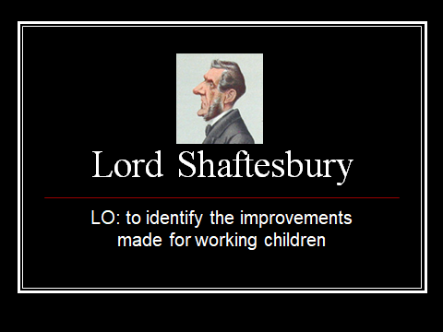
.LO: To apply my number sequencing skills to create a timeline of the work conducted by Lord Shaftesbury to improve the rights of children.
Success criteria:
I can read the text fluently and with understanding. B / D / M
I can use my measuring skills to construct a timeline B / D / M
Introduction: Watch a PPT on the work of Lord Shaftesbury in increasing the rights of children.
Task: To create a timeline of the actions taken to improve the rights of children in the Victorian era.

