Context for Learning Spring Term: Child of the 20s’
How have my rights evolved? Does every child have access to these rights?
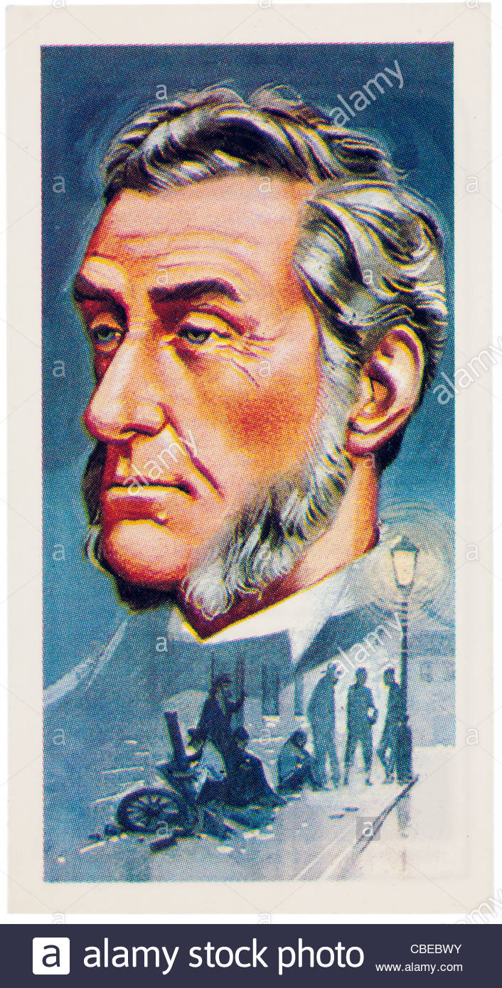
Lesson Four: Have the rights of children in the 2000s always enjoyed rights? Research the work of Lord Shaftesbury who was a pioneer in allowing us to enjoy the rights we have in 2000s’

The Rights Protector: Lord Shaftesbury – How did he help children working in Welsh mines?

LO: To apply my learning on the Rights of the child to produce a piece of research / explanation on how Lord Shaftesbury championed the rights of children in the Victorian period. Writing.
Success criteria:
I can make detailed observations. B / D / M
I can use thinking maps to record my ideas. B / D / M
I can use a range of resources to learn. B/ D / M
I can apply my literacy writing skills to produce an independent piece of comparative writing. B/ D / M

Introduction: Watch a PPT on the work of Lord Shaftesbury in increasing the rights of children.
Use your independent research skills to locate information on how Lord Shaftesbury helped improve the rights of children in Wales.

