Task OneTas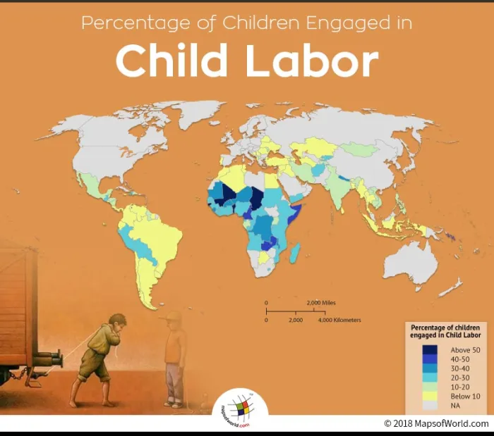
(Geography / Humanities / Maths across the curriculum.)
LO: To be able to draw conclusions about child labour using a key and data.
Use your atlas / map reading skills to identify those countries where child labour still exists today.
- How many countries can you name where the employment of children is over 50%?
- How many countries can you name where the employment of children is between 40 and 50%?
- How many countries can you name where the employment of children is between 30 and 40%?
- How many countries can you name where the employment of children is between 20 and 30%?
- How many countries can you name where the employment of children is between 10 and 20%?
- How many countries can you name where the employment of children is below 10%?
- Name three countries where child labour in the present day does not exist.
- In which continent of the worl is child labour the most prevelant.

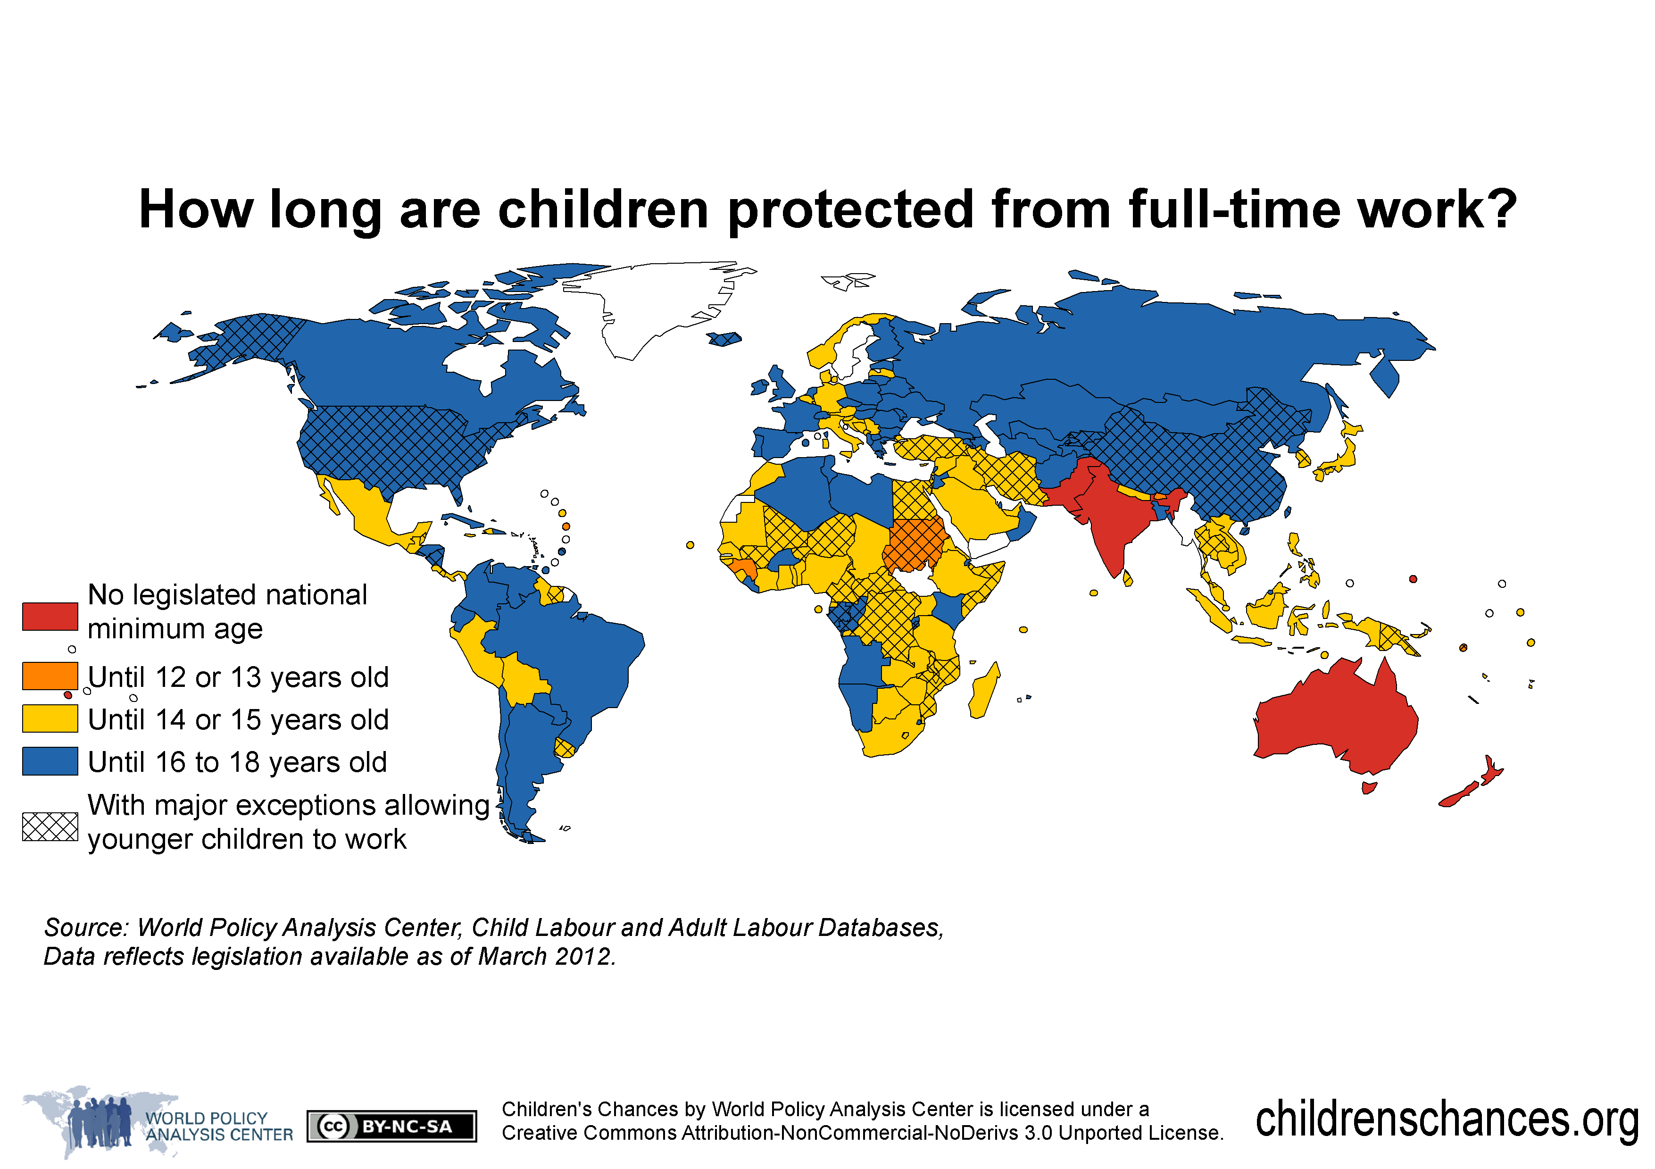

(Geography / Humanities / Maths across the curriculum.)
LO: To be able to draw conclusions about child labour using a key and data.
Drawing conclusins fro data in a map using a key.
Use your map reading skills to identify countries of the world.
- What is the dominant colur on the map? What does his tell you about the age children are allowed to work in these countries?
- In what countries are there no legal limits on the age in which a child can be made to work?
- Name the countries in which children are not allowed to be made to work until they are between 14 and 15.
- Name the countries where children are not permitted to work until they are sixteen.

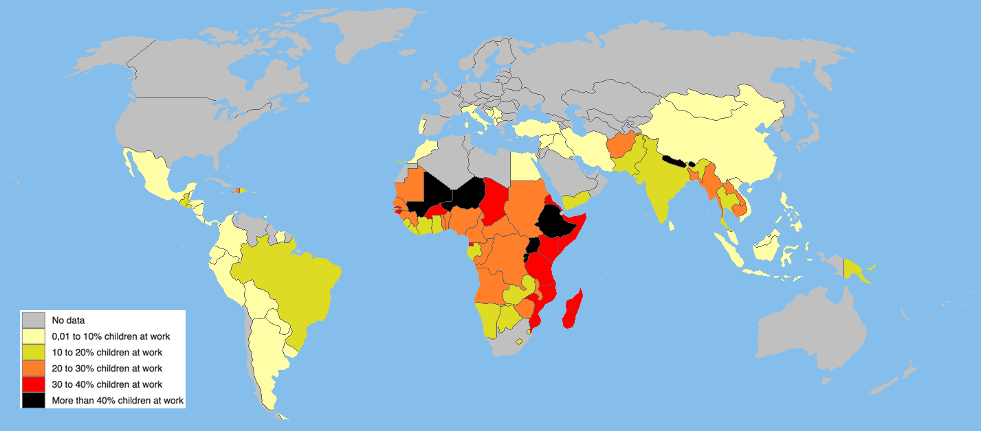
How many children are forced to work today?
(Geography / Humanities / Maths across the curriculum.)
LO: To be able to draw conclusions about child labour using a key and data.
- Name those countries that force 40% of children to work.
- Name those countries where between 30 and 40% of children are made to work.
- Name those countries where between 20 and 30% of children are made to work.
- Name those countries where between 10 and 20% of children are made to work.
- Name those countries where between o and 10% of children are made to work.
- In what countries is there no data? Why do you think this is the case
Drawing conclusions from a data in a graph about children under the age of 16 who are required to work in different countries of the world.
LO: To be able to draw conclusions about child labour using data. To be able to make sensible estimates from data.
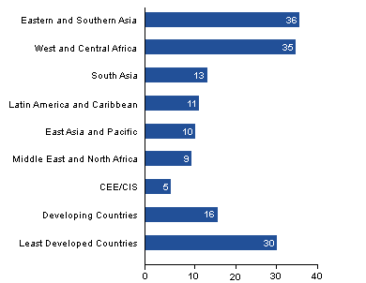

C
O
T
I
N
E
N
T

PERCENTAGE OF CHILDREN EMPOLYED UNDER THE AGE OF SIXTEEN IN % OF THE POPULATION

- In what continent are the most children who are required to work under the age of sixteen located?
- In which continent are the least amount of children required to work under the age of sixteen.
- RANGE: What is the difference between the highest and lowest continent for the percentage of children that are required to work?
- What is the mean of the data? Show your workings. (Remember a good mathematician includes the unit of measurement)
- What is the median of the data? Show your workings. (Remember a good mathematician includes the unit of measurement)
- Calculate the DIFFERENCE (-) of the children employed under the age of sixteen in the following continents. (Remember a good mathematician includes the unit of measurement)
- Eastern and southern Asia and Developing countries.
- Western and central Africa and East Asia and the Pacific
- Least developed countries and Latin America and Carribean.

In the world’s poorest countries, slightly more than 1 in 5 children are engaged in child labour
Children around the world are routinely engaged in paid and unpaid forms of work that are not harmful to them. However, they are classified as child labourers when they are either too young to work or are involved in hazardous activities that may compromise their physical, mental, social or educational development. In the least developed countries, slightly more than one in four children (ages 5 to 17) are engaged in labour that is considered detrimental to their health and development.
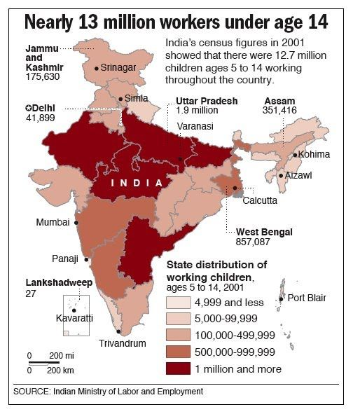
LO: To use data, data handling skills and keys to draw conclusions about child labour in India. To apply rounding skills. Many children in Saint Joseph’s School originate from India. Look at a map and data from India to use keys and data to learn about child labour in India.
Rounding and reading data.:
- What is the child labour figure in Dehli: Round the figure to the nearest tens of thousands.
- What is the child labour figure in Utar Pradesh: Round the figure to the nearest million.
- What is the child labour figure in Dehli: Round the figure to the nearest hundreds of thousand?
- What is the child labour figure in West bengal: Round the figure to the nearest hundreds of thousands.
- Look at a map of India: Name those area of India where child labour exceed more than a million children.
- Look at a map of India: Name those area of India where child labour exceed between qoo,000 and 499, 999 thousand children.

