(Geography / Humanities / Maths across the curriculum.)
LO: To be able to draw conclusions about child labour using a key and data.
Use your atlas / map reading skills to identify those countries where child labour still exists today.
- How many countries can you name where the employment of children is over 50%?
- How many countries can you name where the employment of children is between 40 and 50%?
- How many countries can you name where the employment of children is between 30 and 40%?
- How many countries can you name where the employment of children is between 20 and 30%?
- How many countries can you name where the employment of children is between 10 and 20%?
- How many countries can you name where the employment of children is below 10%?
- Name three countries where child labour in the present day does not exist.
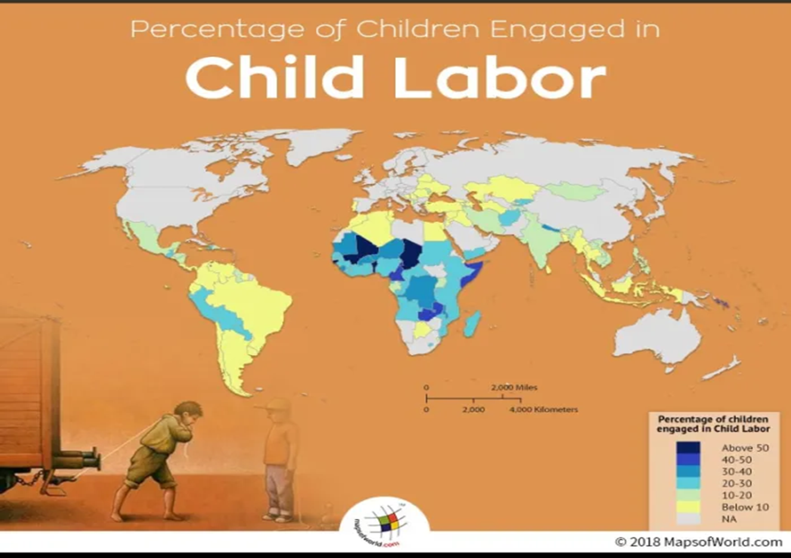
- In which continent of the worl is child labour the most prevelant.

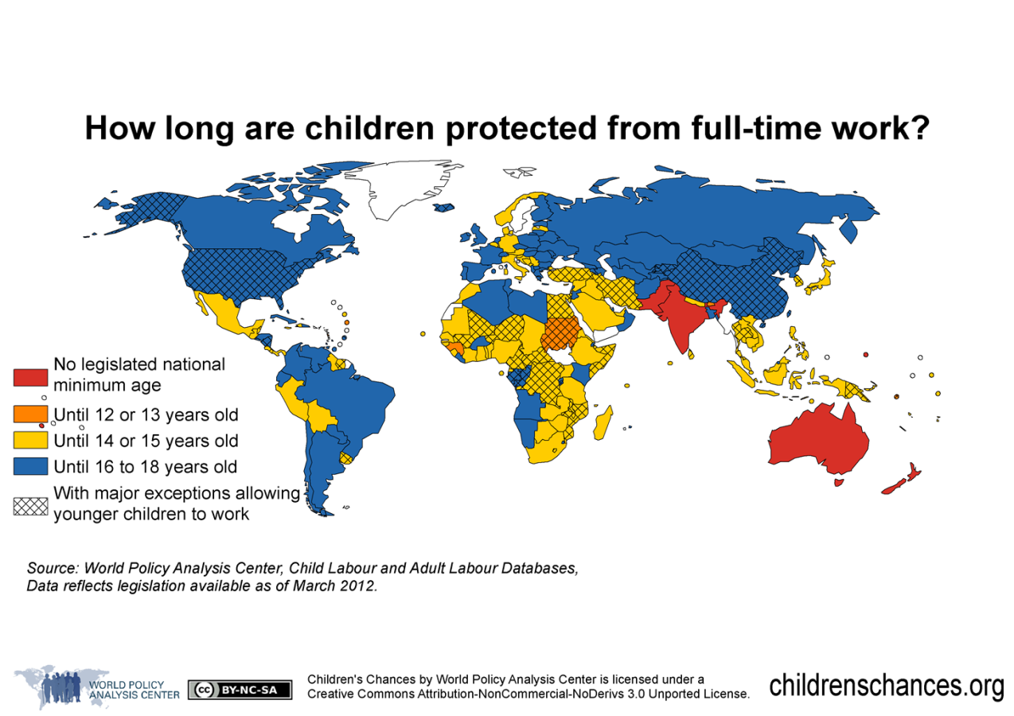

(Geography / Humanities / Maths across the curriculum.)
LO: To be able to draw conclusions about child labour using a key and data.
Drawing conclusins fro data in a map using a key.
Use your map reading skills to identify countries of the world.
- What is the dominant colur on the map? What does his tell you about the age children are allowed to work in these countries?
- In what countries are there no legal limits on the age in which a child can be made to work?
- Name the countries in which children are not allowed to be made to work until they are between 14 and 15.
- Name the countries where children are not permitted to work until they are sixteen.

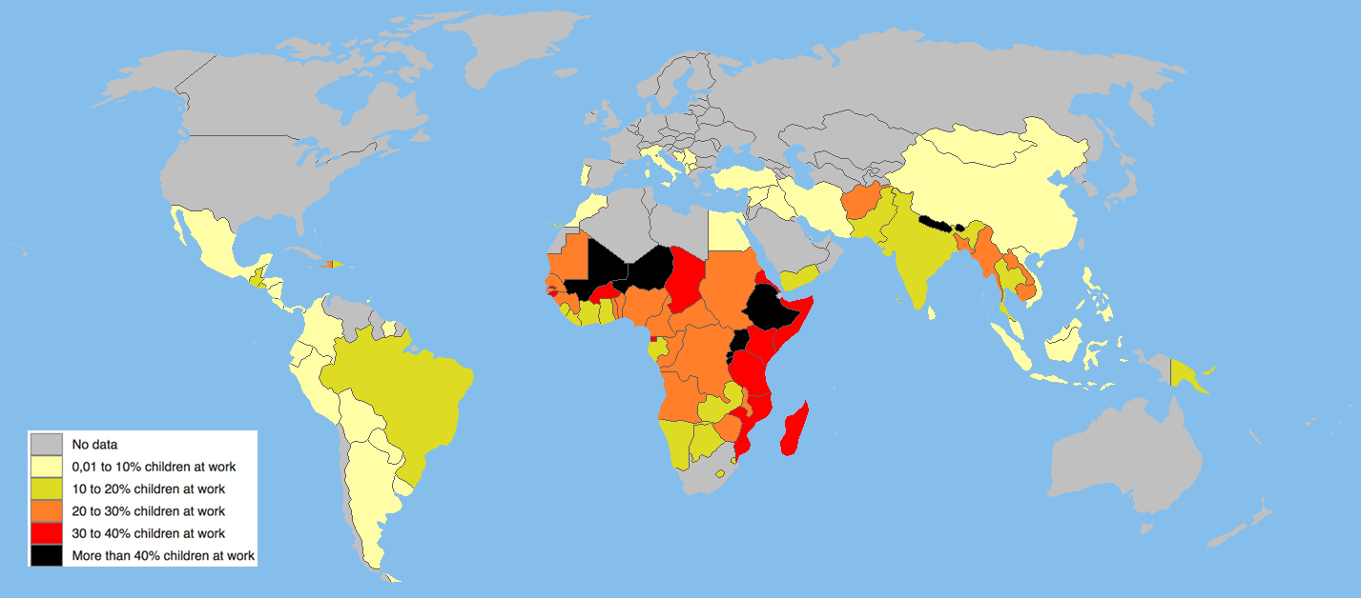
How many children are forced to work today?
(Geography / Humanities / Maths across the curriculum.)
LO: To be able to draw conclusions about child labour using a key and data.
- Name those countries that force 40% of children to work.
- Name those countries where between 30 and 40% of children are made to work.
- Name those countries where between 20 and 30% of children are made to work.
- Name those countries where between 10 and 20% of children are made to work.
- Name those countries where between o and 10% of children are made to work.
- In what countries is there no data? Why do you think this is the case

PERCENTAGE OF CHILDREN EMPOLYED UNDER THE AGE OF SIXTEEN IN % OF THE POPULATION
PERCENTAGE OF CHILDREN EMPOLYED UNDER THE AGE OF SIXTEEN IN % OF THE POPULATION
Drawing conclusions from a data in a graph about children under the age of 16 who are required to work in different countries of the world. To plot data in a graph form.
LO: To be able to draw conclusions about child labour using data. To be able to make sensible estimates from data.
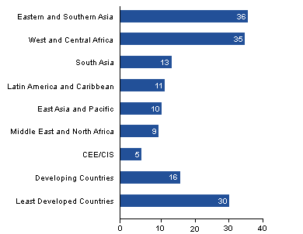
C
O
T
I
N
E
N
T
PERCENTAGE OF CHILDREN EMPOLYED UNDER THE AGE OF SIXTEEN IN % OF THE POPULATION
- In what continent are the most children who are required to work under the age of sixteen located?
- In which continent are the least amount of children required to work under the age of sixteen.
- RANGE: What is the difference between the highest and lowest continent for the percentage of children that are required to work?
- What is the mean of the data? Show your workings. (Remember a good mathematician includes the unit of measurement)
- What is the median of the data? Show your workings. (Remember a good mathematician includes the unit of measurement)
- Calculate the DIFFERENCE (-) of the children employed under the age of sixteen in the following continents. (Remember a good mathematician includes the unit of measurement)
- Eastern and southern Asia and Developing countries.
- Western and central Africa and East Asia and the Pacific
- Least developed countries and Latin America and Caribean.

In the world’s poorest countries, slightly more than 1 in 5 children are engaged in child labour
Children around the world are routinely engaged in paid and unpaid forms of work that are not harmful to them. However, they are classified as child labourers when they are either too young to work or are involved in hazardous activities that may compromise their physical, mental, social or educational development. In the least developed countries, slightly more than one in four children (ages 5 to 17) are engaged in labour that is considered detrimental to their health and development.
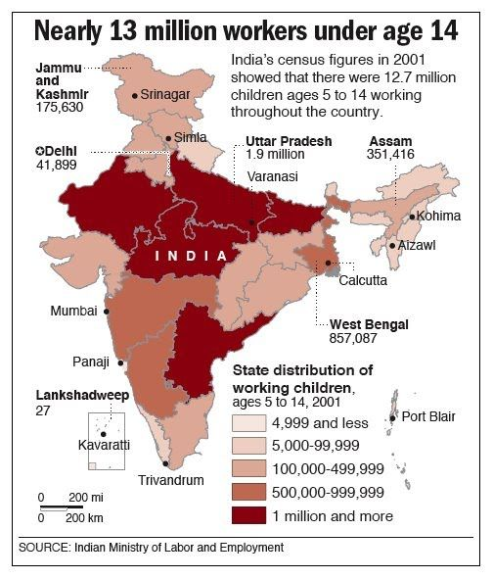
LO: To use data, data handling skills and keys to draw conclusions about child labour in India. To apply rounding skills. Many children in Saint Joseph’s School originate from India. Look at a map and data from India to use keys and data to learn about child labour in India.
Rounding and reading data.:
- What is the child labour figure in Dehli: Round the figure to the nearest tens of thousands.
- What is the child labour figure in Utar Pradesh: Round the figure to the nearest million.
- What is the child labour figure in Dehli: Round the figure to the nearest hundreds of thousand?
- What is the child labour figure in West bengal: Round the figure to the nearest hundreds of thousands.
- Look at a map of India: Name those area of India where child labour exceed more than a million children.
- Look at a map of India: Name those area of India where child labour exceed between 100,000 and 499, 999 thousand children.

Child Labour Jobs for Children in India
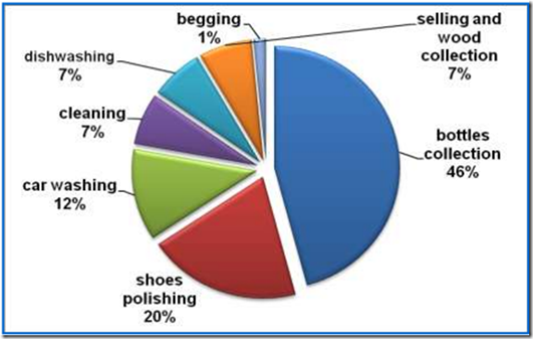

LO: To apply data handling skills to investigate child labour in India. To plot data from a pie chart into a bar chart. To begin to learn how to calculate, the mean, median and mode with teacher support.
- These are the most common types of child labour in India. They are all challenging. Which of these jobs would you least like to do? Explain why.
- How do you think these children feel about th types of occupations that they are made to do? What do you think these child labourers would like be doing? Explain why?
- In what occupation are most children employed in?
- What is the living that least child labourers in India are engaged in?
- What is the difference in the number of children engaged in selling wood and bottle collection?
- Calculate the mean of the data.
- Calculate the mode of the data.
- Calculate the median of the data.
- Pesent the data in the pie chart in a bar graph form.

Make a timeline of reforms to the practice of child labour in the Victorian period.
LO: To apply place value and measure skills to create a timeline of child labour reforms in the victorian period.
1781 James Watt’s rotary steam engine invented, this could be used to lower miners down a shaft or to pump water out of a mine.
1794 James Buddle’s exhaust pump was invented. This could draw stale air out of a mine.
1815 Sir Humphrey Davy invented the miners’ safety lamp.
1833 Factory Act, this banned children from working in textile factories under the age of nine. From nine to thirteen they were limited to nine hours a day and 48 hours a week.
1836 Registration of Births, Deaths and Marriages, this enabled factory inspectors to check the ages of children working in factories (only applicable in England and Wales).
1842 Publication of the ‘First Report of the Children’s Employment Commissioners: Mines and Collieries’, which had been prepared by Lord Ashley (later Lord Shaftesbury).
1842 Mines Act, this banned the employment underground of boys under the age of ten and all women and girls. No one under the age of fifteen was to be in charge of machinery.
1844 Factory Act, this classed women as young persons under the age of eighteen and limited the hours of both groups to twelve on weekdays and nine on Saturdays.
1847 The Ten Hour Act, this cut the hours of women and the under-eighteens to ten a day and 58 a week.
1850 The Ten Hour Act, this set the working day for all workers at ten and a half hours. 1867 Factory Act, the legislation was extended to all workshops with more than 50 workers.

