Topic Title: Child of the 2000s’: How have my rights evolved from the past to the present day?
Authentic Context/Relevance: Children must know that they have rights. They should know that their rights come with responsibility. To know not all children are protected by rights. To know about societies from the past and famous figures were instrumental in making the rights they enjoy now possible. |  |  |  |  |  |  |  |  | Visits/fieldwork/visitors: Big Pit  Visit from Doctor Banardo Charity shop.
Pairs of Virtues: Eloquent and Truthful / Learned and Wise
EAL:  Isabella; Rose; San; Bernice; Joen; Mahira; Arlo; Mahin; Makan; Sachin; Francisco; Stanley, Richa, Jonas |  | MAT  Patrick, Bernice, Phoebe, Charlie, Stanley, Sarah-Rose, |  |  | ALN  Leo  Vernon |  |  | eFSM  Makan; Cody - Capri, Bernice, Gracie |  |  | Aspire |  | CLA  Toby
Literacy Texts:  Street Child – true story / narrative  Life in the workhouse – non fiction  Rights of the Child – non fiction  Doctor Banardo - Biographical  Lord Shafesbury – biographical  Victorian Britain to place learning in context – non – fiction – historical  Child Labour in the modern day. |  |  |  |  |  |  | Genre/s of writing to be developed:  Reflective writing based on learning  Comparative Writing  Note taking / recording learning – mind maps  Explanation writing  Biographical Writing  Research Writing  Summary Writing
Week  Date | Learning Objective |  |  | Differentiated Activities  (inc AfL; HoM) |  |  |  | Statement of what matters |  |  |  | AOLE Skills  (Cross curricular) |  | Evaluation
Wk. 1 4th September | Lesson One: What are rights, needs and wants?  LO: To work collaboratively to determine from a series of cards what a want, a need or a right is.  Lesson One: What are rights, needs and wants?  LO: To work collaboratively to determine from a series of cards what a want, a need or a right is.  Lesson Two : To apply my collaborative learning skills to classify rights.  LO: To work collaboratively to determine whether rights are a basic need, those who protect us from harm or to express themselves |  |  | Does every child have access to these rights?  Success criteria:  I can work well with others. B / D / M  I listen to the opinions of others. B / D / M  I actively participate in collaborative learning tasks. B/ D / M  I can argue my point, but be respectful of the ideas and opinions of others. B/ D / M  Introduction: Watch PPT to introduce the Rights of the Child.  Task - RIGHTS, WANTS OR NEEDS?  In table groups, students sort a set of 20 cards into the  following categories:  MOST IMPORTANT  IMPORTANT  LEAST IMPORTANT  Group decides which the 6 most important cards are.  Groups share their list of most important cards with the class.  The class discusses:  Reflective Writing  • Was it difficult to select some items over others?  • How did you decide which items were most important?  • What is the difference between “wants” and “needs”?  • Do all children have these rights met?  • What other rights do you think children should have?  • What can be done to ensure children everywhere have all their rights met?  Differentiation  LA: To be able to identify eight basic needs of humans.  Context for Learning Spring Term: Child of the 20s’  How have my rights evolved? Does every child have access to these rights?  Lesson Two : to apply my collaborative learning skills to classify rights.  LO: To work collaboratively to determine whether rights are a basic need, those who protect us from harm or to express themselves  Success criteria:  I can work well with others. B / D / M  I listen to the opinions of others. B / D / M  I actively participate in collaborative learning tasks. B/ D / M  I can argue my point, but be respectful of the ideas and opinions of others. B/ D / M  I can provide sensible reasons for classifying rights  Introduction: Watch PPT to introduce the Rights of the Child. |  |  |  | The learners’ journey through this Area will encourage enquiry and discovery, as they are challenged to be curious and to question, to think critically and to reflect upon evidence. Enquiry is more than an academic exercise; it enables reflection, which can help learners understand the human condition. This, in turn, can add meaning to learners’ own lives and contribute to their sense of place and worldview. Experiences in this Area can encourage a critical understanding of how societies are and have been organised, structured and led, in the learners’ own locality and in Wales, as well as in the wider world. Societies are characterised by a range of cultural, linguistic, economic, legal and political norms and values. Language can also help learners to develop the skills to become unbiased and critically-aware interpreters of what they hear, read and see in order to interact as capable, informed citizens of Wales and the world. The learning and experience supports them to develop an awareness of how they use a range of languages to express themselves for different purposes and audiences.  Computational processes have changed the way we live, work, study and interact with each other and our environment. They provide the foundation for all software and hardware systems, but learners should also be aware of the limitations of what computers can achieve. Enabling learners to recognise when and where to seek help and support; to develop awareness of mental health issues and are able to advocate on behalf of others. |  |  |  | Communication and  Literacy  citizenship  Health and well – being.  Communication and  Literacy  citizenship  Health and well – being.
Wk. 2 11th September | Lesson Three: Do all children in the present day enjoy the same rights?  LO: To apply my learning on the Rights of the child to produce a piece of comparative writing. |  |  | Context for Learning Spring Term: Child of the 20s’  How have my rights evolved? Does every child have access to these rights?  Success criteria:  I can make detailed observations. B / D / M  I can use thinking maps to record my ideas. B / D / M  I can draw comparisons between different pieces of evidence. B/ D / M  I can apply my literacy writing skills to produce an independent piece of comparative writing. B/ D / M  Task: to compare a series of pictures of children living today and determine what rights they do or do not have.  Differentiation: The number of examples to be less for lower ability children. TA and teacher group support to be provided. |  |  |  | The learners’ journey through this Area will encourage enquiry and discovery, as they are challenged to be curious and to question, to think critically and to reflect upon evidence. Enquiry is more than an academic exercise; it enables reflection, which can help learners understand the human condition. This, in turn, can add meaning to learners’ own lives and contribute to their sense of place and worldview. Experiences in this Area can encourage a critical understanding of how societies are and have been organised, structured and led, in the learners’ own locality and in Wales, as well as in the wider world. Societies are characterised by a range of cultural, linguistic, economic, legal and political norms and values. Language can also help learners to develop the skills to become unbiased and critically-aware interpreters of what they hear, read and see in order to interact as capable, informed citizens of Wales and the world. The learning and experience supports them to develop an awareness of how they use a range of languages to express themselves for different purposes and audiences.  Computational processes have changed the way we live, work, study and interact with each other and our environment. They provide the foundation for all software and hardware systems, but learners should also be aware of the limitations of what computers can achieve. Enabling learners to recognise when and where to seek help and support; to develop awareness of mental health issues and are able to advocate on behalf of others. |  |  |  | Communication and  Literacy  citizenship  Health and well – being
Wk. 3 September 11th | LO: To apply my learning on the Rights of the child to produce a piece of observational writing.  LO: To apply my learning on the Rights of the child to produce a piece of observational writing. |  |  | Context for Learning Spring Term: Child of the 20s’  How have my rights evolved? Does every child have access to these rights?  Lesson Three: Have the rights of children in the 2000s always enjoyed rights?  Welsh Link  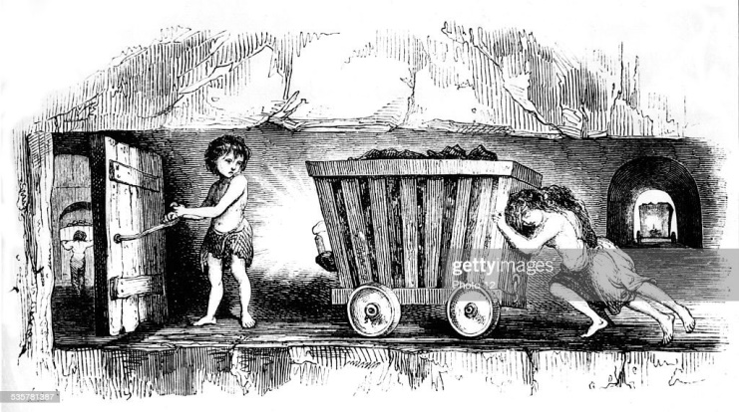  .  Success criteria:  I can make detailed observations. B / D / M  I can use thinking maps to record my ideas. B / D / M  I can draw comparisons between different pieces of evidence. B/ D / M  I can apply my literacy writing skills to produce an independent piece of comparative writing. B/ D / M  Have the rights of children in the 2000s always enjoyed rights?  Introduction: Watch a BBC Bitesize video on children working in the mines  - Discuss what you found interesting.  - Make a mind map of your learning.  - Write an account of life in Welsh mines for children.  Extension / Differentiation: To compare their lives of children in the mines with your own life today. |  |  |  | The learners’ journey through this Area will encourage enquiry and discovery, as they are challenged to be curious and to question, to think critically and to reflect upon evidence. Enquiry is more than an academic exercise; it enables reflection, which can help learners understand the human condition. This, in turn, can add meaning to learners’ own lives and contribute to their sense of place and worldview. Experiences in this Area can encourage a critical understanding of how societies are and have been organised, structured and led, in the learners’ own locality and in Wales, as well as in the wider world. Societies are characterised by a range of cultural, linguistic, economic, legal and political norms and values. Language can also help learners to develop the skills to become unbiased and critically-aware interpreters of what they hear, read and see in order to interact as capable, informed citizens of Wales and the world. The learning and experience supports them to develop an awareness of how they use a range of languages to express themselves for different purposes and audiences.  Computational processes have changed the way we live, work, study and interact with each other and our environment. They provide the foundation for all software and hardware systems, but learners should also be aware of the limitations of what computers can achieve. Enabling learners to recognise when and where to seek help and support; to develop awareness of mental health issues and are able to advocate on behalf of others. |  |  |  | Communication and  Literacy  Citizenship  Health and well – being  Humanities  Communication and  Literacy  Citizenship  Health and well – being  Humanities  Communication and  Literacy  Citizenship  Health and well – being  Humanities
Wk. 4 18th September | LO: To apply my learning on the Rights of the child to produce a piece of research / explanation on how Lord Shaftesbury championed the rights of children in the Victorian period.. |  |  | Context for Learning Spring Term: Child of the 20s’  How have my rights evolved? Does every child have access to these rights?  Lesson Four: Have the rights of children in the 2000s always enjoyed rights? Research the work of Lord Shaftesbury who was a pioneer in allowing us to enjoy the rights we have in 2000s’  The Rights Protector: Lord Shaftesbury – How did he help children working in Welsh mines?  Success criteria:  I can make detailed observations. B / D / M  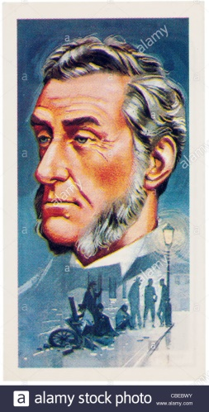  I can use thinking maps to record my ideas. B / D / M  I can use a range of resources to learn. B/ D / M  I can apply my literacy writing skills to produce an independent piece of comparative writing. B/ D / M  Introduction: Watch a PPT on the work of Lord Shaftesbury in increasing the rights of children.  Use your independent research skills to locate information on how Lord Shaftesbury helped improve the rights of children in Wales.  Differentiation: The number of points recorded to be differentiated. Expectation of the detail of response required between ability groups to be shared. |  |  |  | The learners’ journey through this Area will encourage enquiry and discovery, as they are challenged to be curious and to question, to think critically and to reflect upon evidence. Enquiry is more than an academic exercise; it enables reflection, which can help learners understand the human condition. This, in turn, can add meaning to learners’ own lives and contribute to their sense of place and worldview. Experiences in this Area can encourage a critical understanding of how societies are and have been organised, structured and led, in the learners’ own locality and in Wales, as well as in the wider world. Societies are characterised by a range of cultural, linguistic, economic, legal and political norms and values. Language can also help learners to develop the skills to become unbiased and critically-aware interpreters of what they hear, read and see in order to interact as capable, informed citizens of Wales and the world. The learning and experience supports them to develop an awareness of how they use a range of languages to express themselves for different purposes and audiences.  Enabling learners to recognise when and where to seek help and support; to develop awareness of mental health issues and are able to advocate on behalf of others. |  |  |  | Communication and  Literacy  Citizenship  Health and well – being  Humanities
Week 5 25th September | LO: To apply my number sequencing skills to create a timeline of the work conducted by Lord Shaftesbury to improve the rights of children. |  |  | Context for Learning Spring Term: Child of the 2000s’  Improving the rights of children in the Victorian Period  Timeline  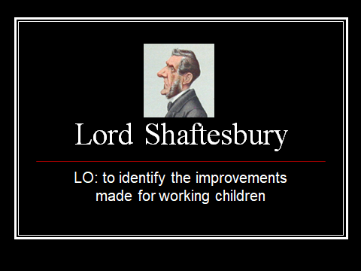.  Success criteria:  I can read the text fluently and with understanding. B / D / M  I can use my measuring skills to construct a timeline B / D / M  Introduction: Watch a PPT on the work of Lord Shaftesbury in increasing the rights of children.  Task: To create a timeline of the actions taken to improve the rights of children in the Victorian era.  Differentiation: The number of sequential dates to be determined by ability. MA To attempt to measure timeline with support. |  |  |  | The learners’ journey through this Area will encourage enquiry and discovery, as they are challenged to be curious and to question, to think critically and to reflect upon evidence. Enquiry is more than an academic exercise; it enables reflection, which can help learners understand the human condition. This, in turn, can add meaning to learners’ own lives and contribute to their sense of place and worldview. Experiences in this Area can encourage a critical understanding of how societies are and have been organised, structured and led, in the learners’ own locality and in Wales, as well as in the wider world. Societies are characterised by a range of cultural, linguistic, economic, legal and political norms and values. Language can also help learners to develop the skills to become unbiased and critically-aware interpreters of what they hear, read and see in order to interact as capable, informed citizens of Wales and the world. The learning and experience supports them to develop an awareness of how they use a range of languages to express themselves for different purposes and audiences.  Enabling learners to recognise when and where to seek help and support; to develop awareness of mental health issues and are able to advocate on behalf of others. |  |  |  | Communication and  Literacy  Citizenship  Health and well – being  Humanities  Mathematics
Week 6 1st October | LO: To apply my IT research skills to create a biographical piece of writing.  LO: To apply my IT research skills to create a biographical piece of writing. |  |  | Improving the rights of children in the Victorian Period  How did Doctor Banardo contribute to the rights we enjoy today  Link to Class reader: Street child  Biographical Writing. - Doctor Banardo  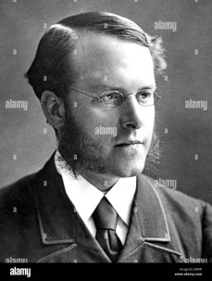  Success criteria:  I can read the text fluently and with understanding. B / D / M  I can use a range of resources to locate a range of information about Doctor Banardo B / D / M  I respond to my reading in my own words – I do not copy B / D / M  I present my final biography neatly, use appropriate spelling and begin to use paragraphs’ / D / M  Introduction: Watch a PPT on the work of Doctor Banardo in increasing the rights of children. |  |  |  | The learners’ journey through this Area will encourage enquiry and discovery, as they are challenged to be curious and to question, to think critically and to reflect upon evidence. Enquiry is more than an academic exercise; it enables reflection, which can help learners understand the human condition. This, in turn, can add meaning to learners’ own lives and contribute to their sense of place and worldview. Experiences in this Area can encourage a critical understanding of how societies are and have been organised, structured and led, in the learners’ own locality and in Wales, as well as in the wider world. Societies are characterised by a range of cultural, linguistic, economic, legal and political norms and values. Language can also help learners to develop the skills to become unbiased and critically-aware interpreters of what they hear, read and see in order to interact as capable, informed citizens of Wales and the world.  Computational processes have changed the way we live, work, study and interact with each other and our environment. They provide the foundation for all software and hardware systems, but learners should also be aware of the limitations of what computers can achieve. |  |  |  | Information Technology  Literacy and Communication  Humanities
Week 6 1st October | LO: To use my literacy skills to interrogate a non – fiction text on the life and work of Doctor Banardo. |  |  | GGR: The Life of Doctor Banardo  Summary writing  Differentiation: Text differentiated three ways.  Improving the rights of children in the Victorian Period  LO: To use my literacy skills to interrogate a non – fiction text on the life and work of Doctor Banardo.  Success criteria:  I can read the text fluently and with understanding. B / D / M  I can apply my skim and scan skills to locate relevant information B / D / M  I respond to the text in complete sentences demarcated with capital letters and full stops B / D / M  I can express my opinions about the text and support them by using evidence from the text. B/ D / M  I can sequence events. B / D / M  I can match words to the correct definition. B / D / M |  |  |  |  |  |  |  | Communication and  Literacy  Citizenship  Health and well – being  Humanities
Wk. 7 9th October | Biographical Writing -Doctor Banardo  LO: To apply my IT research skills to create a biographical piece of writing presented in a Sway or PPT format. |  |  | How did Doctor Banardo contribute to the rights we enjoy today?  Link to Class reader: Street Child  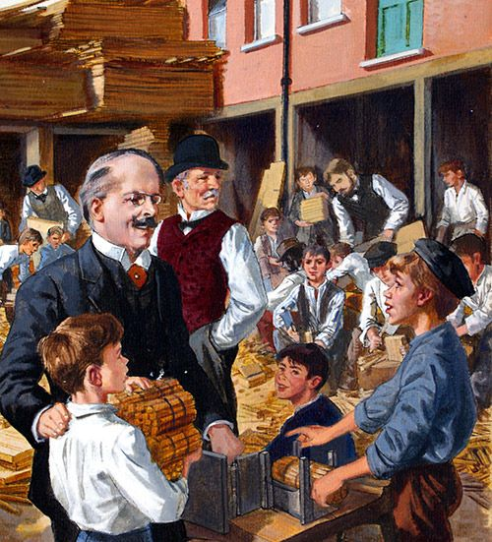  Success criteria:  I can use my biographical writing to create a PPT on the life and work of Doctor Banardo. B / D / M  I can use a range of IT skills to create a PPT. B / D / M  Facts are brief and written using my own words. B / D / M  I use a consitent background, font and style to present each slide so that the PPT is carefully organised. B / D / M  I am able to speak in front of an audience to share my learning. B / D / M  I can use a range of resources to locate a range of information about Doctor Banardo B / D / M  I respond to my reading in my own words – I do not copy B / D / M  I present my final biography neatly, use appropriate spelling and begin to use paragraphs’ / D / M  Introduction: Watch a PPT on the work of Doctor Banardo in increasing the rights of children. Watch BBC video clip - Bite size. |  |  |  | The learners’ journey through this Area will encourage enquiry and discovery, as they are challenged to be curious and to question, to think critically and to reflect upon evidence. Enquiry is more than an academic exercise; it enables reflection, which can help learners understand the human condition. This, in turn, can add meaning to learners’ own lives and contribute to their sense of place and worldview. Experiences in this Area can encourage a critical understanding of how societies are and have been organised, structured and led, in the learners’ own locality and in Wales, as well as in the wider world. Societies are characterised by a range of cultural, linguistic, economic, legal and political norms and values. Language can also help learners to develop the skills to become unbiased and critically-aware interpreters of what they hear, read and see in order to interact as capable, informed citizens of Wales and the world. The learning and experience supports them to develop an awareness of how they use a range of languages to express themselves for different purposes and audiences.  Enabling learners to recognise when and where to seek help and support; to develop awareness of mental health issues and are able to advocate on behalf of others. |  |  |  | Literacy and Communication  Humanities
Week 7 9th October | LO: To use my literacy skills to interrogate a non – fiction text on the rights of children in terms of shelter in the Victorian period and today |  |  | Rights - living conditions past and present  The Victorian Workhouse – comparative Writing  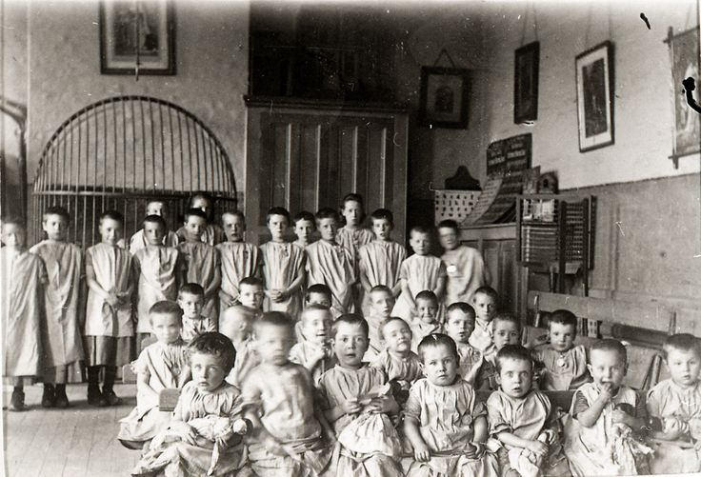  Success criteria:  I can read the text fluently and with understanding. B / D / M  I can apply my skim and scan skills to locate relevant information B / D / M  I respond to the text in complete sentences demarcated with capital letters and full stops B / D / M  I can express my opinions about the text and support them by using evidence from the text. B/ D / M  I can sequence events. B / D / M  I can classify information. B / D / M |  |  |  | The learners’ journey through this Area will encourage enquiry and discovery, as they are challenged to be curious and to question, to think critically and to reflect upon evidence. Enquiry is more than an academic exercise; it enables reflection, which can help learners understand the human condition. This, in turn, can add meaning to learners’ own lives and contribute to their sense of place and worldview. Experiences in this Area can encourage a critical understanding of how societies are and have been organised, structured and led, in the learners’ own locality and in Wales, as well as in the wider world. Societies are characterised by a range of cultural, linguistic, economic, legal and political norms and values. Language can also help learners to develop the skills to become unbiased and critically-aware interpreters of what they hear, read and see in order to interact as capable, informed citizens of Wales and the world. The learning and experience supports them to develop an awareness of how they use a range of languages to express themselves for different purposes and audiences. |  |  |  | Humanities  Literacy and Communication
 | Expressive Arts  LO: To apply, line and mark, shape tone and form to create a landscape of Big Pit  To apply measure and cutting skills for making a mine lantern.  Toapply composition, performance and evaluation skills |  |  | Art: creating a landscape of Big Pit.  DT. Making a miners lantern  Music: To compose, perform and evaluate children working in Big Pit during the Victorian period. |  |  |  | Expressive Arts:  Exploring this Area, both through their own creative work and other people’s, engages learners with genres, techniques, tools, materials and practices and enables them to become curious and creative individuals. Adopting the skills and critical vocabulary encountered in this Area can equip learners to consider creative work in a range of media, forms, genres and styles. During the creative process learners communicate through a variety of art forms or disciplines. Communication includes performing, presenting, sharing, exhibiting and producing with consideration of the audience. |  |  |  | Expressive Arts  Design technology
 | Humanities and Mathematics  LO: To be able to draw conclusions about child labour using a key and data. |  |  | (Geography / Humanities / Maths across the curriculum.)  LO: To be able to draw conclusions about child labour using a key and data.  Use your atlas / map reading skills to identify those countries where child labour still exists today. |  |  |  | Humanities: The learners’ journey through this Area will encourage enquiry and discovery, as they are challenged to be curious and to question, to think critically and to reflect upon evidence. Such thinking can help learners to understand human experiences and the natural world better. This Area will encourage learners to understand the interconnected nature of economic, environmental and social sustainability; justice and authority; and the need to live in and contribute to a fair and inclusive society that confronts and addresses racism. |  |  |  | Maths across the curriculum  Humanities - Geography
 | (Geography / Humanities / Maths across the curriculum.)  LO: To be able to draw conclusions about child labour using a key and data. |  |  | How long are children protected fom full time work in different countries around the world?  Drawing conclusins fro data in a map using a key.  Use your map reading skills to identify countries of the world. |  |  |  | Humanities: The learners’ journey through this Area will encourage enquiry and discovery, as they are challenged to be curious and to question, to think critically and to reflect upon evidence. Such thinking can help learners to understand human experiences and the natural world better. This Area will encourage learners to understand the interconnected nature of economic, environmental and social sustainability; justice and authority; and the need to live in and contribute to a fair and inclusive society that confronts and addresses racism. |  |  |  | Maths across the curriculum  Humanities - Geography
 | LO: To be able to draw conclusions about child labour using a key and data. |  |  | How many children are forced to work today?  (Geography / Humanities / Maths across the curriculum.) |  |  |  | Humanities: The learners’ journey through this Area will encourage enquiry and discovery, as they are challenged to be curious and to question, to think critically and to reflect upon evidence. Such thinking can help learners to understand human experiences and the natural world better. This Area will encourage learners to understand the interconnected nature of economic, environmental and social sustainability; justice and authority; and the need to live in and contribute to a fair and inclusive society that confronts and addresses racism. |  |  |  | Maths across the curriculum  Humanities - Geography
 | LO: To be able to draw conclusions about child labour using data. To be able to make sensible estimates from data. |  |  | PERCENTAGE OF CHILDREN EMPOLYED UNDER THE AGE OF SIXTEEN IN % OF THE POPULATION  Drawing conclusions from a data in a graph about children under the age of 16 who are required to work in different countries of the world. To plot data in a graph form. |  |  |  | Humanities: The learners’ journey through this Area will encourage enquiry and discovery, as they are challenged to be curious and to question, to think critically and to reflect upon evidence. Such thinking can help learners to understand human experiences and the natural world better. This Area will encourage learners to understand the interconnected nature of economic, environmental and social sustainability; justice and authority; and the need to live in and contribute to a fair and inclusive society that confronts and addresses racism. |  |  |  | Maths across the curriculum  Humanities - Geography
 | LO: To use data, data handling skills and keys to draw conclusions about child labour in India. To apply rounding skills. Many children in Saint Joseph’s School originate from India. Look at a map and data from India to use keys and data to learn about child labour in India.  LO: To apply data handling skills to investigate child labour in India. To plot data from a pie chart into a bar chart. To begin to learn how to calculate, the mean, median and mode with teacher support. |  |  | In the world’s poorest countries, slightly more than 1 in 5 children are engaged in child labour  Children around the world are routinely engaged in paid and unpaid forms of work that are not harmful to them. However, they are classified as child labourers when they are either too young to work or are involved in hazardous activities that may compromise their physical, mental, social or educational development. In the least developed countries, slightly more than one in four children (ages 5 to 17) are engaged in labour that is considered detrimental to their health and development.  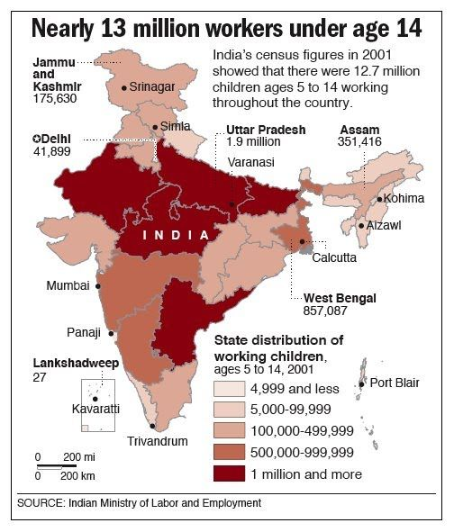  How are child labourers in India employed  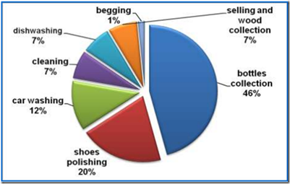 |  |  |  | Humanities: The learners’ journey through this Area will encourage enquiry and discovery, as they are challenged to be curious and to question, to think critically and to reflect upon evidence. Such thinking can help learners to understand human experiences and the natural world better. This Area will encourage learners to understand the interconnected nature of economic, environmental and social sustainability; justice and authority; and the need to live in and contribute to a fair and inclusive society that confronts and addresses racism.  Humanities: The learners’ journey through this Area will encourage enquiry and discovery, as they are challenged to be curious and to question, to think critically and to reflect upon evidence. Such thinking can help learners to understand human experiences and the natural world better. This Area will encourage learners to understand the interconnected nature of economic, environmental and social sustainability; justice and authority; and the need to live in and contribute to a fair and inclusive society that confronts and addresses racism. |  |  |  | Maths across the curriculum  Humanities – Geography  Maths across the curriculum  Humanities – Geography
UNCRC: Whole topic centred on the Rights of the Child in a present day and historical context. |  |  | Diversity: Not all children have access to the rights investigated in the context for learning project. |  |  | Careers and Work Related Experiences – Mining – Charity work |  |  |  | Local, National and International Contexts – The significance of the rights of the child intoday’s society. To appreciate that not all children have acces to these rights in the world.
 |  |  |  |  |  |  |  |  |  | Mo
Eco: N / A |  |  | Fairtrade: N / A
Numeracy Skills/Activities: N / A – previous topic dominated by mathematic based learning activities.

DCF Skills: understand that copying the work of others and presenting it as their own is called 'plagiarism', e.g. begin to consider consequences of plagiarism. find relevant information using different keywords and search techniques
select an appropriate website from search results and begin to consider if the content is reliable. Modify and present a range of text, image, sound, animation and video for selected purposes. Give an opinion about their own and others' work and suggest improvements independently and collaboratively,
Literacy Skills to be developed:  • explain information and ideas using supportive resources  • explain information and ideas, exploring and using ways to be convincing,  • express issues and ideas clearly, using specialist vocabulary and examples  • speak clearly, using formal language, varying expression, tone and volume, to keep listeners interested |  |  |  |  |  |  |  | Possible Texts:  Street Child – true story / narrative  Life in the workhouse – non fiction  Rights of the Child – non fiction  Doctor Banardo - Biographical  Lord Shafesbury – biographical  Victorian Britain to place learning in context – non – fiction - historical
Websites – recorded in resources section of the context planning for the project.

Dr Barnardo Presentation (teacher made) - Twinkl
https://www.twinkl.co.uk/resource/t2-h-5140-new-dr-barnardo-pr…

PPT - Dr Barnardo PowerPoint Presentation, free …

https://www.slideserve.com/neona/the-victorians
8 Top Doctor Banardo Ppt Teaching Resources

https://www.twinkl.co.uk/search?q=doctor+banardo+ppt

Dr Barnardo - Primary Resources
https://www.primaryresources.co.uk/history/powerpoint/… · PPT file · Web view
Rights of children - SlideShare

https://www.slideshare.net/bhavnoorsingh/rights-of-children
Convention on the Rights of the Child PPT - Primary …

https://www.twinkl.co.uk/resource/amp/cfe2-p-014-un-charter-rights-of..UN Convention on the Rights of the Child - UNICEF UK

https://www.unicef.org.uk/what-we-do/un-convention-child-rights

Lord Shaftesbury Information PowerPoint (teacher made)

https://www.twinkl.co.uk/resource/cfe2-h-205-lord-shaftesbury...

PPT - Lord Shaftesbury PowerPoint Presentation, free …

https://www.slideserve.com/ince/lord-shaftesbury

Workhouse PowerPoint (PPT) Presentations, Workhouse …
https://www.slideserve.com/search/workhouse-ppt-presentation

