Helpwr Heddiw Guide
Expectations In Progress Steps One to Three
Ms. Beynon, Mr Cobb, Mrs Zabeneh and Mrs Houston
AoLE Leader: Mrs Houston
Pwy wyt ti?  Who are you | Dawn ydw i. (All classes)
Beth ydy dy enw di?  What is your name | Dawn ydw i. (All classes)
Sut wyt ti’n teimlo?  How are you feeling?  Sut wyt ti?  How are you?  (Progression Step One to know 3 responses, Progression Step Two know 7 responses and Progression Step Three to know all.) | Dwi’n hapus, drist, sal, ddiflas, fendigedig, dda iawn, grac, ar ben y byd, wedi blino.  I am happy, sad, ill, miserable, fantastic angery good, on top of the world, tired  (Progression Step One to know 3 responses, Progression Step Two know 7 responses and Progression Step Three to know all.)
Beth sy’n bod gyda ti?  What’s the matter with you?  Wyneb – face  Tafod – tongue  Ysgwydd - shoulder  Gwallt – hair  Trwyn – nose  LLygaid – eye  Llygad - eyes  Clust – ear  Clustiau – ears  Cefn – back  Dant – tooth  Danedd – teeth | Dim byd – nothing.  Mae pen tost gyda fi – I have a bad head.  Mae clust tost gyda fi – I have a bad ear.  Mae coes tost gyda fi – I have a bad leg.  Mae dant tost gyda fi – I have a bad tooth  Mae braich tost gyda fi – I have a bad arm.  Mae bawd tost gyda fi – I have a bad thumb.  (Progression Step One to know 3 responses, Progression Step Two know 7 responses and Progression Step Three to know all.)
Progression step 2 and 3 only.  Beth sy’n bod ar Sam?  Beth sy’n bod ar Laura? | Progression step 2 and 3 only.  Mae bola tost gyda fe. He has a bad stomach  Mae braich tost gyda Sam. Sam has a bad arm  Mae pen tost gyda hi. She has a bad head  Mae pen dost gyda Laura. Laura has a bad head
All classes  Sawl PENCIL / bysedd etc sy yma?  How many pencil / fingers etc. are here? | All classes  Do NOT allow children to learn numbers by rote without knowing their meaning – yes they should be able to count, but also to be presented with a number and be able to say it in isolation. E.g. Beth 47 mewn Cymraeg. Pedwar deg saith.  Year 1– to 10  Year 2 – to 20  Year 3 and 4 to 50  Year 5 and 6 to 100
Greetings - All Classes | Greetings – All Classes
All classes: Incidental Welsh  Siwmae  Bore da  Nos da  Prynhawn da  Hwyl fawr  Noswaith dda – Progression step 3 only  Welai ti yfory Progression step 3 only | All classes: Incidental Welsh  Hello  Good morning  Good night  Goof afternoon  Bye  Good evening  See you tomorrow.
Colours All classes | Lliwiau – All classes
Pa liw ydy hwn? | Which colour is this?
Coch | red
Glas | blue
Melyn | yellow
Gwyrdd | green
Pinc | pink
Brown | brown
Du | black
Porffor | purple
Arian | silver
Aur | gold
Llwyd | grey
Oren | orange
Siapiau – All Classes  Pa saip ydy hwn? | Shapes – All classes  Which shape is this?
Sgwâr Sgwar ydy hwn. |   Square – It is a square
Cylch -Cylch ydy hwn | Circle - It is a circle
Triongl Triongl ydy hwn | Triangle – It is a triangle
Petryal - Petryal ydy hwn |   Rectangle – It is a rectangle
Dillad - All classes | Clothing – All classes
Beth wyt ti’n gwisgo?  Dwi’n gwisgo …, …., …., … a … | What are you wearing?  I am wearing a …, …., …., … and …
Het | hat
Menig | gloves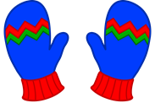
Scarff | scarf
Siaced | jacket
Siwmper | Jumper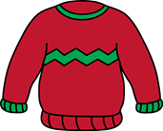
Trowsus | Trousers
Jins | Jeans 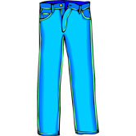
Sgert | Skirt
Sannau | Socks
Esgidiau | Shoes 
‘T’ Shirt | Crys ‘t’
Shirt | Crys
Boots | 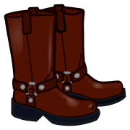Boots
Ffrog | Dress
Joggers | Tracwisg
Extend ‘dillad’ to include colours | Extend ‘dillad’ to include colours
Cot – cot coch, melyn, du, gwyn etc. | Coat - red, yellow, black, white coat
Siaced - siaced coch, melyn, du, gwyn etc | Jacket – red, yellow, black, white jacket
Ffrog – frog coch, melyn, du, gwyn etc | Dress - red, yellow, black, white dress
Teits - teits coch, melyn, du, gwyn etc | Tights - red, yellow, black, white tights
Add colours to ‘dillad’ consolidate mental recall of colours in a different scenario. | Add colours to ‘dillad’ consolidate mental recall of colours in a different scenario.
Beth wyt ti’n gwisgo? Progression Step 2 / 3 | Dw’n gwisgo siwmpwr llwyd, trowsus llwyd, crys t melyn, sannau llwyd a esgidiau du. I am wearing a grey jumper, grey trousers, a yellow t shirt, grey socks and black shoes.
Extension questions on Dillad.Progression Step 3  Wyt ti’n gwisgo siaced? Are you wearing a jacket?  Beth mae Sam yn gwisgo? What is Sam wearing  Pa liw ydy siwmper Sam? Which colour is Sam’s jumper? | Progression step 3  Ydw, Dwi’n gwisgo siaced.Yes I am wearing a jacket.  Nag ydw dydw i ddim yn gwisgo siaced. No I am not wearing a jacket.  Mae Sam yn gwisgo …, …, …, a …  Sam is wearing …  Mae siwmper sam ydy glas.  Sam’s jumper is blue
Bwyd – All classes | Food – All classes
Beth wyt ti’n hoffi bwyta? | What do you like eating?
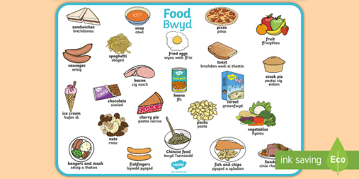
Bara  Brechdanau  Tesien  Cawl  Cig  Coffi  Te  Dwr  Creison  Crempog  Tost  Llaeth  Ffa pob  Losin  Mefus  Wy  Sglodion,  Cyw iar  Llysiau.  Sudd oren  Huffen ia  Taten bob  tatws  grefi  Wyt ti’n hoffi llysiau?  Ydw Dwi’n hoffi llysiau.  Nag ydw, dyw I ddim yn hoffi llysiau. | Bread  Sandwiches  Cake  Soup  Meat  Coffee  Tea  Water  Crisps  Pancake  Toast  Milk  Baked beans  Sweets  Strawberries  Egg  Chips  Chicken  Vegetables  Orange juice  Ice cream  Baked potato  Potatoes  Gravy  Do you like vegetables?  Yes I like vegetables.  No I don’t like vegetables.
Progress Step 3 Pam / Why  Wyt ti’n hoffi caws? Pam?  Ydw, Dwi’n hoffi caws achos mae’n flasus.  Nag ydw dydw i ddim yn hoffi caws achos mae’ ofnadwy.  Use a variety of foods –flashcards in teacher resources. | Progress step 3 Pam / Why  Do you like cheese?  Yes I like cheese because it is tasty.  No I do not like cheese because it is horrible.  Use a variety of foods –flashcards in teacher resources.
Reason to like and dislike food – Progression step 3  It is lovely.  It is nice  It is delicious  It is tasty  It is fantastic  It is sweet  It is sour  It is too hot  It is awful  It is unpleasant  It is wonderful | Reason to like and dislike food - Progression step 3  Mae'n hyfryd.  Mae'n braf  Mae'n flasus  Mae'n flasus  Mae’n ffantastig  Mae'n felys  Mae'n sur  Mae'n rhy boeth  Mae'n ofnadwy  Mae'n annymunol  Mae'n fendigedig
Beth wyt ti’n eisiau? What do you want? All classes | Beth wyt ti’n eisiau? What do you want?  All Classes
Beth wyt ti’n eisiau?  What do you want? | Dw i eisiau myn I nofio – I want to go and swim.  Dw i eisiau mynd allan I chware pel – droed – I want to fo outside to play football.  Dw i eisiau diod. I want a drink  Dw i eisiau ty bach os gwelwch yn dda. I want the toilet please  Dw i eisiau cinio os gwelwch yn dda. I want dinner please.  Dw i eisiau brechdanau os gwelwch yn dda. I want sandwiches please.
ALL CLASSES: Sut mae’r tywydd heddiw? Present tense  How is the weather today? (All Progression steps – year one can give a on word response.)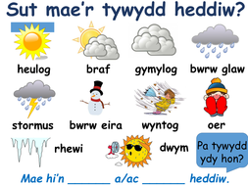 | ALL CLASSES: Sut mae’r tywydd heddiw? Present tense  Mae hi’n bwrw glaw – It is raining.  Mae hi’n gymylog – it is cloudy.  Mae hi’n niwlog – it is misty  Mae hi’n braf – it is fine  Mae hi’n boeth – it is hot  Mae hi’n oer – it is cold  Mae hi’n wyntog – it is windy  Mae hi’n ddiflas – it is miserable  Mae hi’n rhewi – it is freezing
Progression Step 2 and 3:  Sut oedd y tywydd ddoe? Past tense  (How was the weather yesterday? Progression step 2 and 3 – year 3 to year 6)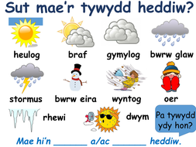 | Progression Step 2 and 3:  Roedd hi’n bwrw glaw – It was raining.  Roedd hi’n gymylog – it was cloudy.  Roedd hi’n niwlog – it was misty  Roedd hi’n braf – it was fine  Roedd hi’n boeth – it was hot  Roedd hi’n oer – it was cold  Roedd hi’n wyntog – it was windy  Roedd hi’n ddiflas – it is miserable  Roedd hi’n rhewi – it is freezing
Progression Step 3:  Sut fydd y tywydd yfory?  How is the weather tomorrow? (progression step 3 – year 4 to 6) | Progression Step 3:  Bydd hi’n bwrw glaw – It will be raining.  Bydd hi’n gymylog – it will be cloudy.  Bydd hi’n niwlog – it was misty  Bydd hi’n braf – it will be fine  Bydd hi’n boeth – it will be hot  Bydd hi’n oer – it will be cold  Bydd hi’n wyntog – it will be windy  Bydd hi’n ddiflas – it will be miserable  Bydd hi’n rhewi – it will be freezing
Extension questions on Y Tywydd Progression Step 3 only  Ydy hi’n boeth?  Is it hot? | Extension questions on Y Tywydd Progression Step 3 only  Ydy, mae hi’n boeth. Yes it it is hot.  Nag ydy, Mae hi’n bwrw glaw. No it is raining.
Personal Information | Personal Information
Ble rwyt ti’n byw? | Where do you live?
Yr 1 Yng Nghaerdydd  Yr 2 Dwi’n byw yng Nghaerdydd gyda fy nheulu  Yr 3 Dwi’n byw yng Nghaerdydd gyda fy mam, fy nhad, un chwaer ag un brawd.  Yr 4: Dwi’n byw Yng Nhgaerdydd gyda fy mam o’r enw Jean, Fy nhad o’r enw John a dwy chwaer o’r enw Poppy a Erin.  Yr 5 and 6: Dwi’n byw yng Nghaerdydd gyda fy mam o’r enw Sharon, fy nhad o’r enw William, dwy chwaer o’r enw Jessica a Hannah a un brawd o enw Mark. Hefyd Dwi’n byw gyda fy nghath o’r enw Indie, un ci o’r enw Ben a dau bysodyn aur o’r enw Frankie a George.  Gyda fy mrodyr – with my brothers  Gyda fy chwiorydd – with my sisters  Extended Writing:  Dwi’n byw yn Mynydd Bychan yng Nhgaerdydd. Dwi’n byw yn (type of home) fflat, ty ar whan, ty semi, ty teras, byngalo. Mae number ystafell wely yn fy nhy. (Bedrooms) (un ddwy, tair, pedair, pum) Mae number stafell molchi yn fy nhy. (un ddwy, tair, pedair, pum) Mae number doiled yn fy nhy (un ddwy, tair, pedair, pum) Mae … lolfa yn fy nhy (un ddwy, tair, pedair, pum) Dwi’n byw gyda fy mum o’r enw NAME a fy nhad o’r enw NAME , number chwaer o’r enw Name a Number brawd o’r enw NAME Hefyd Dwi’n byw gyda fy animal or enw NAME a number type of animal … or’ enw NAME. | Yr 1 In Cardiff  Yr 2 I live in Cardiff with my family  Yr 3 I live in Cardiff with my mum, dad, a sister and a brother.  Yr 4 I live in Cardiff with my mum called Jean, my dad called John and two sisters called Poppy and Erin.  Yr 5 and 6 I live in Cardiff with my mum called Sharon, my dad called William, two sisters called Jessica and Hannah, and one brother called Mark. Also I live with my cat called Indie, a cat called ben and two gold fish called  Frankie and George.
Progression Step 3.Ble mae Sam yn byw?  Where does Sam live? | Progression Step 3.Mae sam yn byw mewn bungalow / ty teras, tŷ ar wahân (detached) lled - tŷ ar wahân (semi – detached.)  Sam lives in a bungalow.
Pets and Family | Anifeiliaid anwes a theulu
Annifeiliad Anwes | Pets  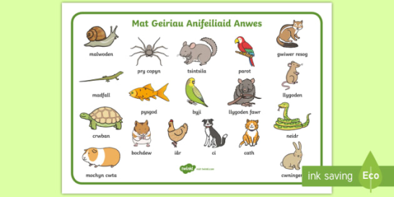
Oes?  Do you have?  (Remember if there is oes in the question there must be oes in the answer.) Highlighted blue is how Progression 3 can extend their answer to the question. Progression 2 only need a basic response of oes or nac oes)  Oes ci gyda ti?  Do you have a dog?  Oes chwaer gyda ti?  Do you have a sister?  Oes brawd gyda ti?  Do you have a brother?  Oes cath gyda ti?  Do you have a cat?  Oes bochdew gyda ti?  Do you have a hamster?  Oes cwiningen gyda ti?  Do you have a rabbit?  Oes crwbwn gyda ti?  Do you have a tortoise? | Oes?  (Remember if there is oes in the question there must be oes in the answer.) Highlighted blue is how Progression 3 can extend their answer to the question. Progression 2 only need a basic response of oes or nac oes)  Oes mae ci gyda fi – yes I have a dog  Nac oes does dim ci gyda fi ond mae cath gyda fi o’r enw Tiger. – I don’t have a dog but I have a cat called Tiger.  Oes mae chwaer gyda fi o enw Lorna.  Yes I have a sister called Lorna  Nag oes does dim chwaer gyda fi, ond mae un brawd gyda fi o’r enw Jack.  No I don’t have a sister, but I have a brother called William.  Oes mae brawd gyda fi o’r enw William. Yes I have a brother called William  Nag oes does dim brawd gyda fi ond my chwaer gyda fi o’r enw Menna.  No I do not have a brother but I have a sister called Menna.  Oes mae cath gyda fi o’r enw Charlie.  Yes I have a cat called Charlie.  Nag oes does dim cath gyda fi, ond mae ci gyda fi o’r enw Cici gyda fi o’r enw Indie.  No I don’t have a cat but I have a dog call Indie.No I don’t have a cat but I have a dog called Indie ed Indie.
Oes ci gyda Sam? | Oes mae ci gyda Ben.  Oes, mae ci gyda Sam. Yes Sam has a dog  Nag does dim ci gyda Sam. No Sam does not have a dog.
All Classes: Faint ydy dy oed di?  How old are you? | All Classes: Dwi’n ddeg oed. Dwi’n un ar ddeg oed.  I am ten years old. / I am eleven years old.
Pryd mae dy penblwydd di?  When is your birthday? | Mae fy mhenblwydd ym Mis Mai  My birthday is in May
  Ionawr | January
  Chwefror | February
  Mawrth | March
  Ebrill | April
  Mai | May
  Mehefin | June
  Gorffennaf | July
  Awst | August
  Medi | September
  Hydref | October
  Tachwedd | November
  Rhagfyr | December
Progression Step2 and 3 Faint ydy oed Sam? | Progression Step2 and 3 Mae Sam yn ddeg oed. Sam is ten years old.
Yr Ysgol – Year 4 – 6 Progression Step 3 | Yr Ysgol – Year 4 – 6 Progression Step 3
Pynciau'r Ysgol  Saesneg  Mathemateg  Cerddoriaeth  Daearyddiaeth  Hanes  Gwyddoniaeth  Addysg Grefyddol  Crefydd  Technoleg Gwybodaeth  Celf  Ynarfer Corff  Technoleg Dylunio  Cymraeg  Gemau | The School Subjects  English  Mathematics  Music  Geography  History  Science  Religous Education  Religion  Information Technology  Art  Physical Education  Design Technology  Welsh  Games
Dwi’n mynd i Ysgol Gynradd Joseff Sant yng Nghaerdydd ag dwi ym mlwyddyn chwech. | I go to Saint Joseph's Primary School in Cardiff and I am in year six.
Byddaf i yn mynd i Ysgol Uwchradd Corpws Christi ym Mis Medi 2023. | I will be going to Corpus Christi High School in September 2023
Enw fy athrawes ydy Mrs Houston .Mae fy athrawes yn fyr ac yn dennau ac mae hi’n mwynhau dysgu Cymraeg, Mathemateg ac Addysg Grefyddol. Dwi’n credu bod Mrs Houston yn …. a …. | . My teacher is called Mrs Houston. My teacher is short and thin and loves teaching Welsh mathematics and Religious Education. I think Mrs Houston is and …..
Yn Ysgol Gynradd Joseff Sant dwi’n gwisgo …  Dwi’n gwisgo, trowsus llwyd, siwmpwr llwyd, crys ‘T’ melyn, sannau / teits du / llwyd a sgert lleyd / a ffrog llwyd yn Ysgol Joseff Sant.  Mae’n well da fi gwisgo ….. ar y penwythnos achos mae’n … ag yn … | In Saint Joseph’s Primary School I wear ……..  I prefer to wear ……. On the weekend because it is
Dwi’n mwynhau dysgu … a …. achos mae’n …. a …..., ond mae’n gas da fi …. a… achos mae’n … a … Mae’n well da fi …. a … achos mae’n | I enjoy learning … and …. because it is … but I hate …. and … because it is … a …. I prefer …. and … because it is … and …
Progress step 3 expressing opinions on a variety of topics using positive and negative responses. | Progress step 3 expressing opinions on a variety of topics using positive and negative responses.
Dwi’n hoffi … a … achos mae’n … a …  Dwi’n mwynhau … a … achos mae’n … a …  Mae’n well da fi … a … achos mae’n … a …  Ond mae’s gas da fi … a … achos mae’n … a … | I like … and … because it is … and …  I enjoy … and … because it is …  I prefer … and … because it is … and …  But I hate … and … because it is … and …
Reasons not to like something. Teachers can add to these reasons as they deem appropriate. | achos mae’n annodd – because it is difficult  achos mae’n galed – because it is hard  achos mae’n sbwriel - because it is rubbish  achos mae’n ddim yn ddiddorol – because it is not interesting  achos mae’n ddim yn bleseru – because it is not enjoyable  achos mae’n ddiflas – because it is boring  achos mae’n ych a fi – because it is horrible achos mae’n ffiaidd – because it is disgusting.
Reasons to like something. Teachers can add to these reasons as they deem appropriate. | achos mae’n hyfryd – because it is lovely.  achos mae’n bedigedig – because it is fantastic  achos mae’n da iawn – because it is very good  achos mae’n diddorol – because it is interesting.  achos mae’n flasus – because it is delicious  achos mae’n gyffrous – because it is exciting
Bwyd | 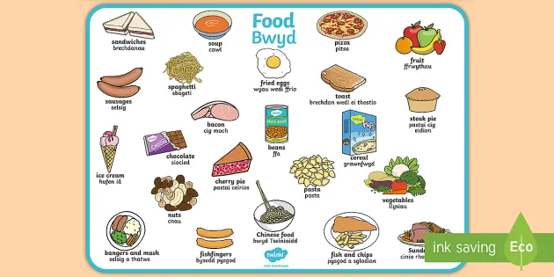
Hobbies / Hamdden | 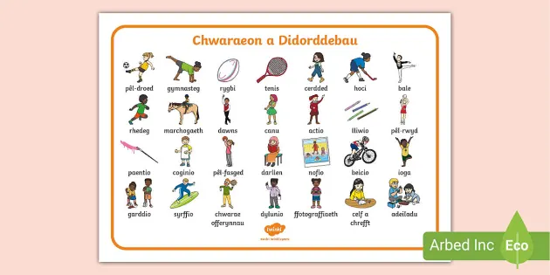
Beth wyt ti’n hoffi wneud?  What do you like doing? | Dwi’n hoffi merlota a chwarae pel droed.  Dwi ddim yn hoffi dawnsio achos mae’n rhy anodd.
Beth wyt ti’n mwynhau?  What do you enjoy? | Dwi’n mwynhau darllen achos mae’n ddiddorol ond dwi ddim yn hoffi nofio achos mae’ n ddiflas.  I like reading because it is interesting, but I don’t like swimming because it is boring.
Wyt ti’n hoffi / mwynhau mynd i’r sinema? Pam?  Do you like / enjoy going to the cinema? Why? | Dwi'n hoffi mynd i'r sinema achos mae’n ddifyr ac yn hwyl. Dwi’n mwynhau mynd gyda fy ffrindiau ar Dydd Sadwrn.  I like going to the cinema because it id entertaining and fun. I enjoy going with my friends on a Saturday.
Ydy Sam yn hoffi chwarae rygbi? Tenis, pel – droed, hoci, sboncen, golf, pel – fasged, pel, rwyd  Does Sam like playing ruby? | Ydw, mae Sam yn hoffi chwarae rugby achos mae’n hwyl ag yn gyffros. Tenis,pel – droed, squash, golf, basket - ball, net ball.  Yes, Sam likes playing rugby because it is fun and exciting.  Nag ydw dyd Sam ddim yn hoffi chware rugby achos mae’n sbwriel a ddiflas.  No Sam does not like playing rugby because it is rubbish and boring.
Wyt ti’n gallu canu?  Can you sing?  Wyt ti’n gallu reidio beic?  Can you ride a bike?  Wyt ti’n gallu reidio nofio?  Can you swim? | Ydw, Dwi’n gallu canu. Yes I can sing.  Nag ydw, dydw i ddim un gallu reidio beic.  No I cannot sing.  Ydw, Dwi’n gallu reidio beic. Yes I can ride a beic.  Nag ydy, dydw i ddim yn gallu reidio beic.  No I cannot ride a bike.  Ydw, Dwi’n gallu nofio. Yes I can swim.  Nag ydy, dydw i ddim un gallu nofio.  No I cannot swim.
Ydy Sam yn gallu nofio? reidio beic, canu,nofio etc  Can sam swim? | Ydw, mae Sam un gallu nofio.  Yes Sam can swim.  Nag ydy, dydy Sam ddim yn gallu nofio.  No sam cannot swim.
Beth wyt ti eisiau wneud?  What do you want to do? | Dwi’n eisiau i chwarae pel droed / rugbi, pel – rwyd / golf / pel – fasged achos mae’n fendigedig a gret.  I want to play football, rugby, netball, basket- ball because it is fantastic and great.
Wyt ti eisiau chwarae rygbi?  Do you want to play rugby? | Ydw, dwi eisiau chwarae rygbi achos mae’n rhagorol.  Yes I want to play rugby because it is outstanding.  Nag ydw, dydw i ddim yn eisiau chware rugi achos mae’n anodd.  No I don’t want to play rugby because if is difficult.
Beth ydy dy hoff raglen deledu? | What's your favourite TV programme?  Fy hoff raglen deledu ydy …. achos mae’n ddoniol, diddoreb, gret, da iawn, bendigedig.  My favourite TV programme is … because it is funny, interesting, great, very food, fantastic.
Pryd wyt ti’n chwarae rygbi?  When are you playing rygby?  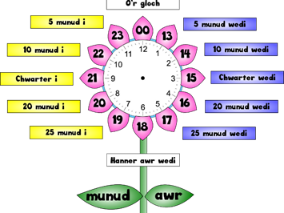 | 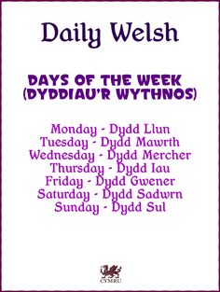  Dw i 'n chwarae rygbi ar ... Dydd Sadwrn am ddeg o gloch  I am laying rugby on Saturday at 10.00 o’ clock.
Beth wyt ti wedi bod yn wneud?
Beth welaist ti ar y teledu?  What did you see on the television? | Welais i …  I saw …
Beth wyt ti’n feddwl o One Direction?
Ble est ti dydd Sadwrn? | Es i i’r sinema gyda fy ffrindiau i gwylio ffilm newydd.  I went to the cinema with my friends to see a new film.
Ble est ti ar wyliau?  Where did you go on holiday? | Es i Sbaen gyda fy nheulu ym Mis Awst. Roedd hi’n boeth, braf ag yn heulog.  I went to Spain with my family in August. It was, hot, fine and sunny.
Sut est ti? How did you go?  I went on a boat it was fun.  I went on an aeroplane it was exciting.  I went in a car it was a long journey.  I went in a caravan it was brilliant.  I went on a train it was very comfortable. | Es i mewn cwch roedd hi’n hwyl.  Es i mewn awyren roedd hi’n gyffrous.  Es i mewn car roedd hi'n daith hir.  Es i mewn carafán roedd hi’n wych.  Es i ar drên roedd hi’n gyfforddus iawn.
Gyda phwy est ti?  With who did you go? | ES i gyda fy nheulu.  I went with my family.
Pryd wyt ti’n chwarae rygbi?
Pryd mae Sam yn nofio?
Beth hoffet ti wneud?

