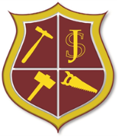
Saint David’s Day 2023.
Dydd Gwyl Dewi Sant 2023
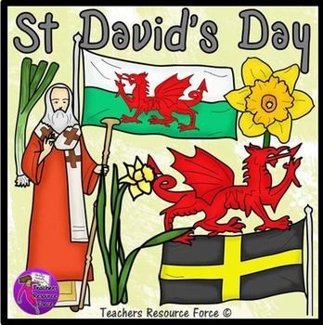

Dear Parent (s’) / Guardian (s’),
Saint David’s Day is an annual celebration that staff and children look forward to alike and is a fundamental part of our identity as a ‘Cymraeg Campus’ school where the integration of the Welsh Language is a daily feature of our school environment. We are eager that all children are represented in the Saint David’s Day competitions and performances in the forthcoming eisteddfod.
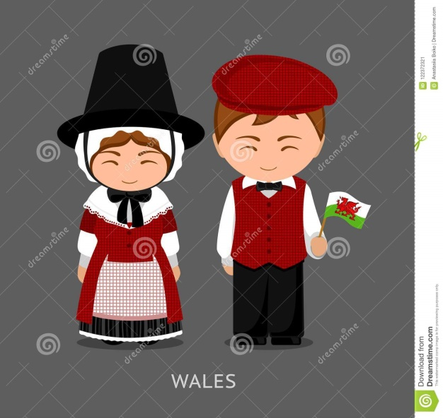
Our day of celebration will commence with a Saint David’s Day Mass led by Dosbarth Gwynno, ensued by the eisteddfod and then the crowning of the Year Six Bard in the Bardic Ceremony. All children will perform songs and recite a Welsh poem as part of their class’s contribution to the eisteddfod. With additional recitations and choral speaking.
Children are asked to come to school in Welsh traditional costume, rugby shirts etc.

There will be a series of internal and external competitions so that all children’s work is represented and valued. In order to give families plenty of notice, the following external competitions are being afforded and children can enter all or as many of the competitions as they so wish. We very much hope as many children as possible participate in these competitions. We ask that all competition entries are labelled with the child’s name and class so the awarding of winners is easier. There will be winners awarded at both Foundation Phase and KS2.
External Competitions
Cystadlu Un Competition One:
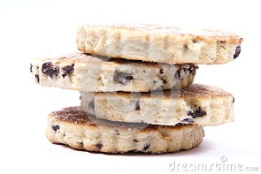
Cooking competition (All classes)- The children are asked to cook a Welsh traditional dish. This is to be judged by Mrs Tuff, but I feel sure all staff will be there to help them in the decision making process! Please ensure that the container in which the cooked item is delivered in is clearly marked with your child’s name and their class so that they can be returned to you on the afternoon of the eisteddfod. A certificate will be awarded for first, second and third at both Foundation Phase and Key Stage Two.
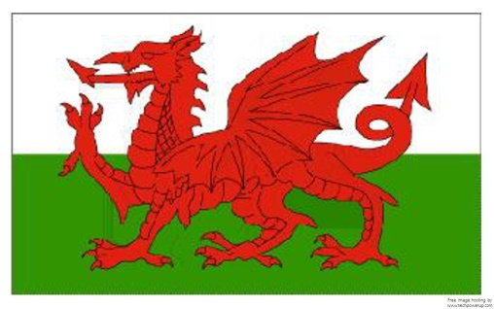
Cystadlu Dau / Competition Two: All Classes

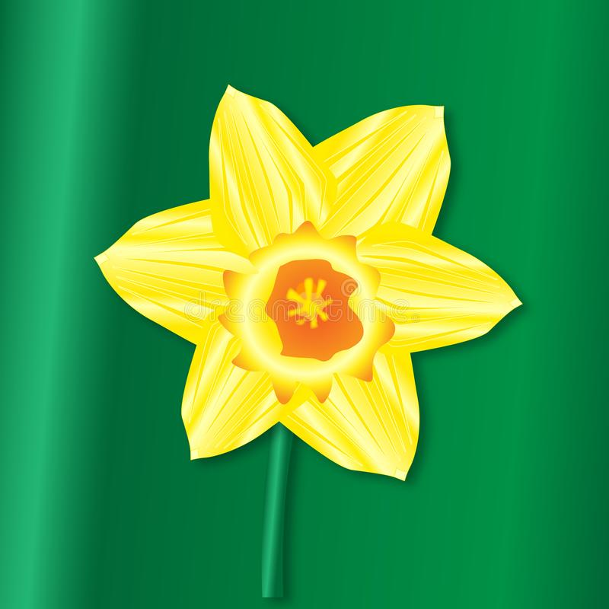
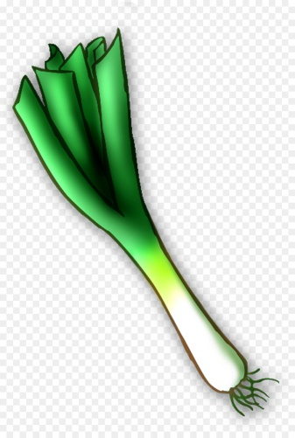
To design a new flag for Wales. To be judged and prizes to be awarded by Mr McHugh. (All classes) Three children from Progress Step 1, 2 and 3 A certificate will be awarded for first, second and third at both Foundation Phase and Key Stage Two.
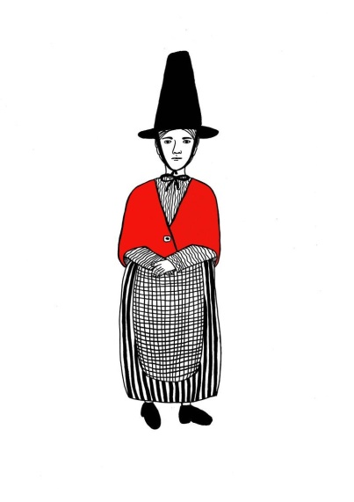

Cystadlu Tri / Competition Three: (All classes)
To make a 3D model of a leek, daffodil or a picture of Welsh traditional dress. A certificate will be awarded for first, second and third. To be judged and presented by Mrs Houston.
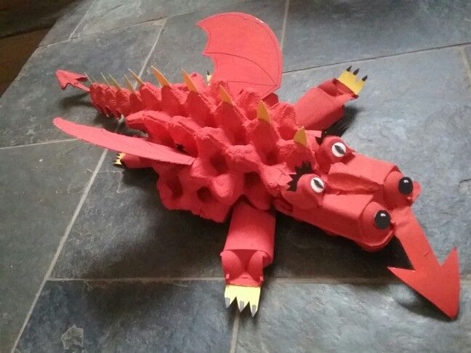
Cystadlu Pedwar / Competition Four: (All classes)
Model Making of Welsh dragons. To be judged and prizes to be awarded by Mrs Zabeneh for each class. A certificate will be awarded for first, second and third at Foundation Phase and Key Stage Two.

Cystadlu Pump / Competition Five:
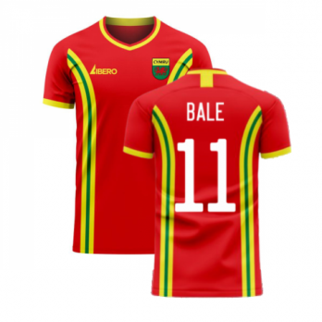
To design a new rugby kit for the Welsh Rugby Team / Football Team. (All classes) To be judged and prizes to be awarded by Mr Cobb. A certificate will be awarded four first, second and third. A certificate will be awarded for first, second and third at both Foundation Phase and Key Stage Two.
Cofiwn gynnes iawn,
Mrs Riorden (Headteacher)

