Why must God come first in our lives?

Gather

Opening Hymn: Freely, freely
God Forgave My Sin In Jesus’ Name
I’ve Been Born Again In Jesus’ Name
And In Jesus’ Name I Come To You
To Share His Love As He Told Me To
He Said: ‘Freely, Freely, You Have Received
Freely, Freely Give
Go In My Name, And Because You Believe
Others Will Know That I Live.’
All Power Is Given In Jesus’ Name
In Earth And Heaven In Jesus’ Name
And In Jesus’ Name I Come To You
To Share His Power As He Told Me To
He Said: ‘Freely, Freely, You Have Received
Freely, Freely Give
Go In My Name, And Because You Believe
Others Will Know That I Live.’

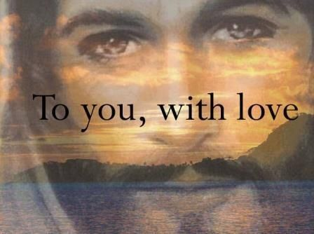
Gather

Welcome: Today we hear about a dishonest manager and about how we cannot love God and money equally. God must come first in our lives.

Opening prayer:
All: Yn enw’r Tad a Mab a Ysbryd Glan. Amen

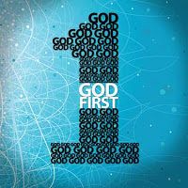
Generous God, in you we have all we need. Help us to put you first in all that we do and to trust that you will care for us always. Amen.
Yn enw’r Tad a Mab a Ysbryd Glan. Amen.

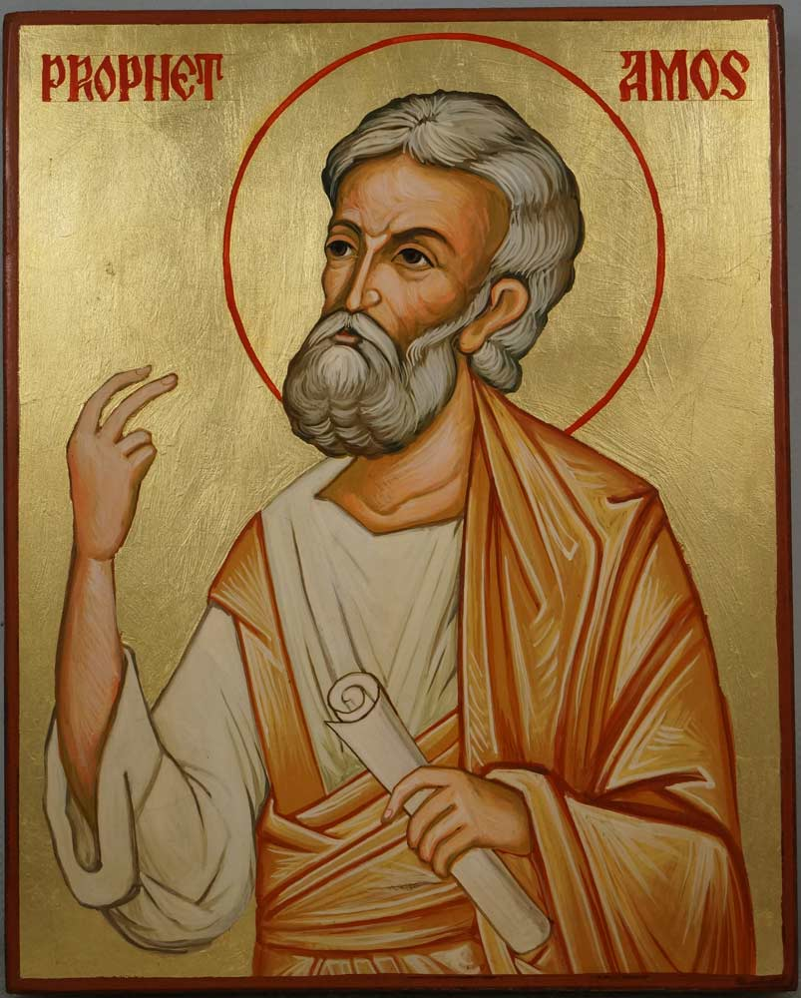
The Word of God

Phoebe: A reading from the book of Amos
Hear this, you who trample the needy and do away with the poor of the land, saying, “When will the New Moon be over that we may sell grain, and the Sabbath be ended that we may market wheat?”— skimping on the measure, boosting the price and cheating with dishonest scales, buying the poor with silver and the needy for a pair of sandals, selling even the sweepings with the wheat. The Lord has sworn by himself, the Pride of Jacob: “I will never forget anything they have done.
PAUSE
The word of the Lord
All: Thanks be to God

The Word of God
The Responsorial Psalm

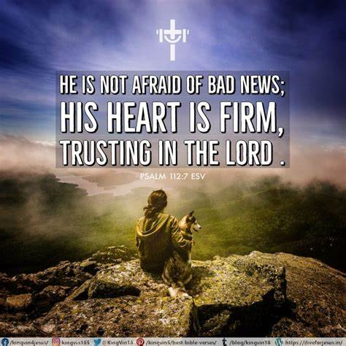
Psalm 112
Charlie: The response is: Praise the Lord / Canmol yr Arglwydd
Blessed are those who fear the Lord,
who find great delight in his commands.
Response: Praise the Lord / Canmol yr Arglwydd

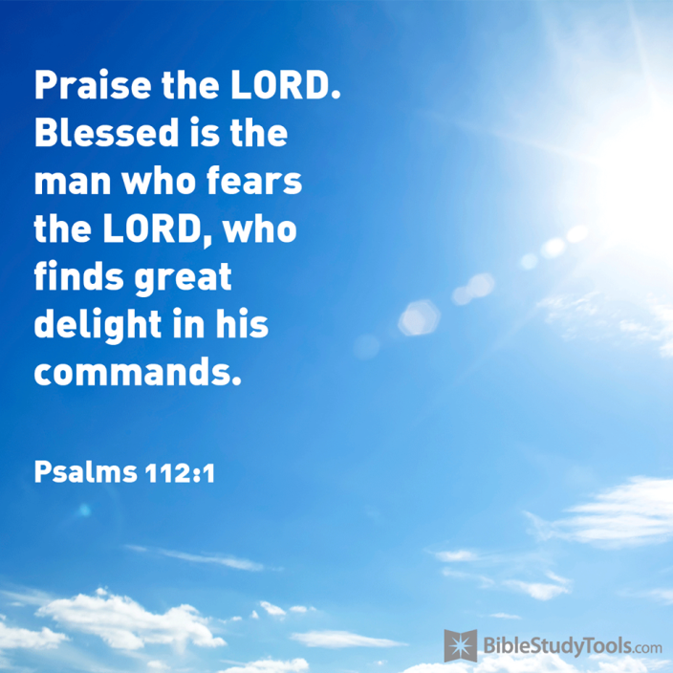
Bella: Blessed are those who fear the Lord,
² Their children will be mighty in the land;
the generation of the upright will be blessed.
Response: Praise the Lord / Canmol yr Arglwydd
Patrick: Wealth and riches are in their houses,
and their righteousness endures forever.
Response: Praise the Lord / Canmol yr Arglwydd
Stanley: Even in darkness light dawns for the upright,
for those who are gracious and compassionate and righteous.
Response: Praise the Lord / Canmol yr Arglwydd
T. Good will come to those who are generous and lend freely,
who conduct their affairs with justice.
Response: Praise the Lord / Canmol yr Arglwydd

Bernice: Surely the righteous will never be shaken;
they will be remembered forever.
Response: Praise the Lord / Canmol yr Arglwydd

The Word of God
Gospel Acclamation: Sung
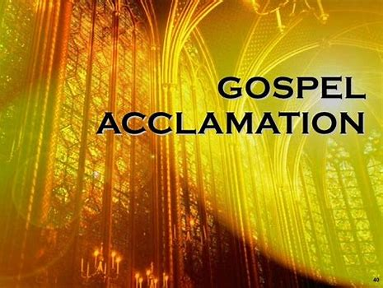

The Lord be with you
All: and with your Spirit
A reading from the Holy Gospel of Luke
All: Glory to you o Lord. (Cross forehead, mouth and heart)

Gospel: Luke 16:1-13

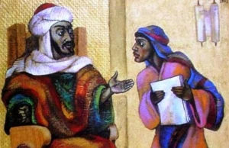

Jesus said to his disciples, “There was once a rich man who had a servant who managed his property. The rich man was told that the manager was wasting his master's money, so he called him in and said, ‘What is this I hear about you? Hand in a complete account of your handling of my property, because you cannot be my manager any longer.’ The servant said to himself, ‘My master is going to dismiss me from my job. What shall I do? I am not strong enough to dig ditches, and I am ashamed to beg. Now I know what I will do! Then when my job is gone, I shall have friends who will welcome me in their homes.’
So he called in all the people who were in debt to his master. He asked the first one, ‘How much do you owe my master?’ ‘100 barrels of olive oil,’ he answered. ‘Here is your account,’ the manager told him; ‘sit down and write fifty.’ Then he asked another one, ‘And you—how much do you owe?’ ‘A thousand sacks of wheat,’ he answered. ‘Here is your account,’ the manager told him; ‘write 800.’ As a result the master of this dishonest manager praised him for doing such a shrewd thing; because the people of this world are much more shrewd in handling their affairs than the people who belong to the light.”
And Jesus went on to say, “And so I tell you: make friends for yourselves with worldly wealth, so that when it gives out, you will be welcomed in the eternal home. Whoever is faithful in small matters will be faithful in large ones; whoever is dishonest in small matters will be dishonest in large ones. If, then, you have not been faithful in handling worldly wealth, how can you be trusted with true wealth? And if you have not been faithful with what belongs to someone else, who will give you what belongs to you?
“No servant can be the slave of two masters; such a servant will hate one and love the other or will be loyal to one and despise the other. You cannot serve both God and money.”
Pause
The Gospel of the Lord
All: Praise to you Lord Jesus Christ.
Response to the Word of God

In today’s Gospel, Jesus says that if we can't be trusted in small things we won't be trusted with bigger things. Jesus says we can’t serve both God and money in our lives. God must come first. Then other people. Then money and the things we own last. He also says that we should be generous with the money that we do have and use it to look after others. In this way, we will be welcomed into heaven by God.
Response to the Word of God
Bidding Prayers

How will you make sure that you put God and other people before your possessions in the coming week? What will you do to show that you serve God in your life?
Jesus asked us to put God first so in God's name we pray together...

Bella: We pray for world leaders: that they may care for their people and for what is right more than for money and power. May they rule wisely and justly. Lord, in your mercy response…
All: Clywed ein gweddi / hear our prayer

Charlie: We pray for our brothers and sisters in every country: that we may share what we have with one another, so that all people may have enough to live well. Lord in your mercy... All: Clywed ein gweddi / hear our prayer

Stanley: We pray for our parish, family and friends: that we may share what we have fairly and always remember what is truly important. Lord in your mercy...
All: Clywed ein gweddi / hear our prayer

Go Forth
Closing prayer

God of plenty, we thank you for all that you have given us. Help us to remember what is really important in our lives and to be generous in all that we do. Amen.

Let us conclude our assembly with the words God our father gave us.
Yn enw’r tad, a Mhab a Ysbryd Glan. Amen
All: Our Father ….
Yn enw’r tad, a Mhab a Ysbryd Glan. Amen

Opening Hymn: Freely, freely
God Forgave My Sin In Jesus’ Name
I’ve Been Born Again In Jesus’ Name
And In Jesus’ Name I Come To You
To Share His Love As He Told Me To
He Said: ‘Freely, Freely, You Have Received
Freely, Freely Give
Go In My Name, And Because You Believe
Others Will Know That I Live.’
All Power Is Given In Jesus’ Name
In Earth And Heaven In Jesus’ Name
And In Jesus’ Name I Come To You
To Share His Power As He Told Me To
He Said: ‘Freely, Freely, You Have Received
Freely, Freely Give
Go In My Name, And Because You Believe
Others Will Know That I Live.’

