Class Assemblies Wednesday 2.50pm  School Mass/Reconciliation – 2pm – School Hall  Class Masses/Prayer Service Thursday 2.30pm;  Mass in Church 9.15am |  |  | Mass in Church  Friday
Class | Assembly  Wednesday | Masses/Liturgies  Thursday
Welcome Mass - Whole School – Mrs Tuff
Thursday 25th September 2025
St Dwynwen | Wednesday 8th October | Class Mass – 20th Nov | Friday 12th Sept
St Tydfil | Wednesday 17th September | Class Mass – 27th Nov | Friday 5th Dec
St Cadoc | Wednesday 14TH November | Class Mass - 9th Oct | Friday 21st Nov
St Gwynno | Wednesday 12th November | Class Mass – 18th Sept | Friday 3rd Oct
St Teilo | Wednesday 24th September | Liturgy – 13th Nov | Friday 28th Nov
St Illtyd | Wednesday 1st October | Liturgy – 16th Oct
Mini Vinnies | Friday Oct 10th | HARVEST FESTIVAL
 |  | Friday 12th December Advent Penitential Service
 | Year 6 | Thursday 18th December – Whole School Christmas Mass 2pm – Year 6 to lead
SPRING TERM
 | Holy week assemblies - wk beg: 23/3/25 | Tuesday 6th January – Feast of the Epiphany – Mass in Church?? Years 3-6
St Dwynwen | Easter Sunday - The Resurrection | 15th January – Class Mass | 30th January
St Tydfil | Good Friday | 22nd January – Class Mass | 6th February
St Cadoc | Stations of the Cross | 29th January – Class Mass | 13th February
St Gwynno | Gethsemane – Jesus' arrest | 5th February – Class Mass | 16th January
St Teilo | The Last Supper | 12th February - Liturgy | 23rd January
St Illtyd | Turning of the tables – Jesus in the Temple | 19th February – Liturgy (St Illtyd and St David)
St David | Palm Sunday | 19th February – Liturgy (St Illtyd and St David)
 | Whole School Mass for the Feast of St Joseph – 19th March 2pm – St Cadoc to lead
 |  | Lenten Penitential Service – 12th March 2pm
SUMMER TERM
St Dwynwen | Leavers’ Assembly - TBC | Leavers Mass – 16th July 2pm | 17th April
St Tydfil | Wednesday 22nd April | Thursday 30th April | 12th June
St Cadoc | Wednesday 29th April | Thursday 11th June | 19th June
St Gwynno | Wednesday 10th June | Thursday 23rd April | 8th May
St Teilo | Wednesday 17th June | Thursday 7th May - Liturgy | 26th June
St Illtyd | Wednesday 20th May | Thursday 25th June - Liturgy
St David | Tuesday 7th July | Thursday 18th June - Liturgy
 | Feast of the Ascension – 14th May 2pm– Whole School Mass led by St Tydfil
 | May Procession – Wk beginning: 18th May 2026 (day to be confirmed by Fr.)

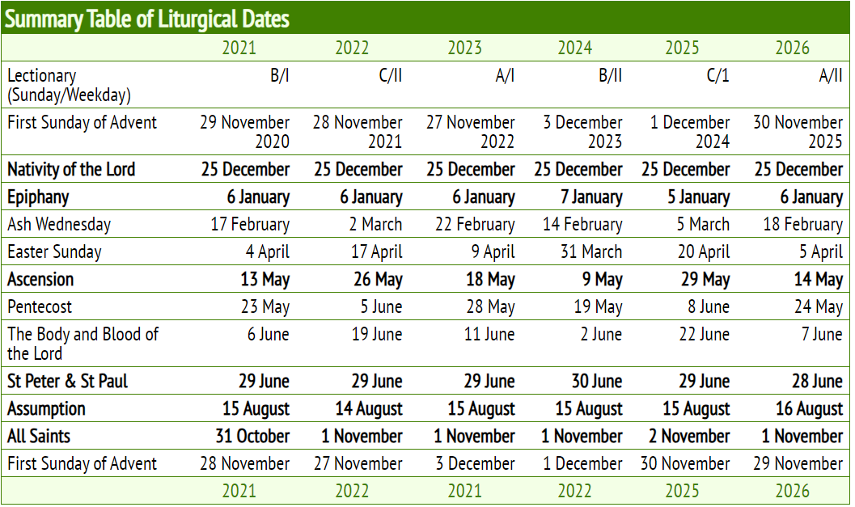
Holy Days of Obligation

