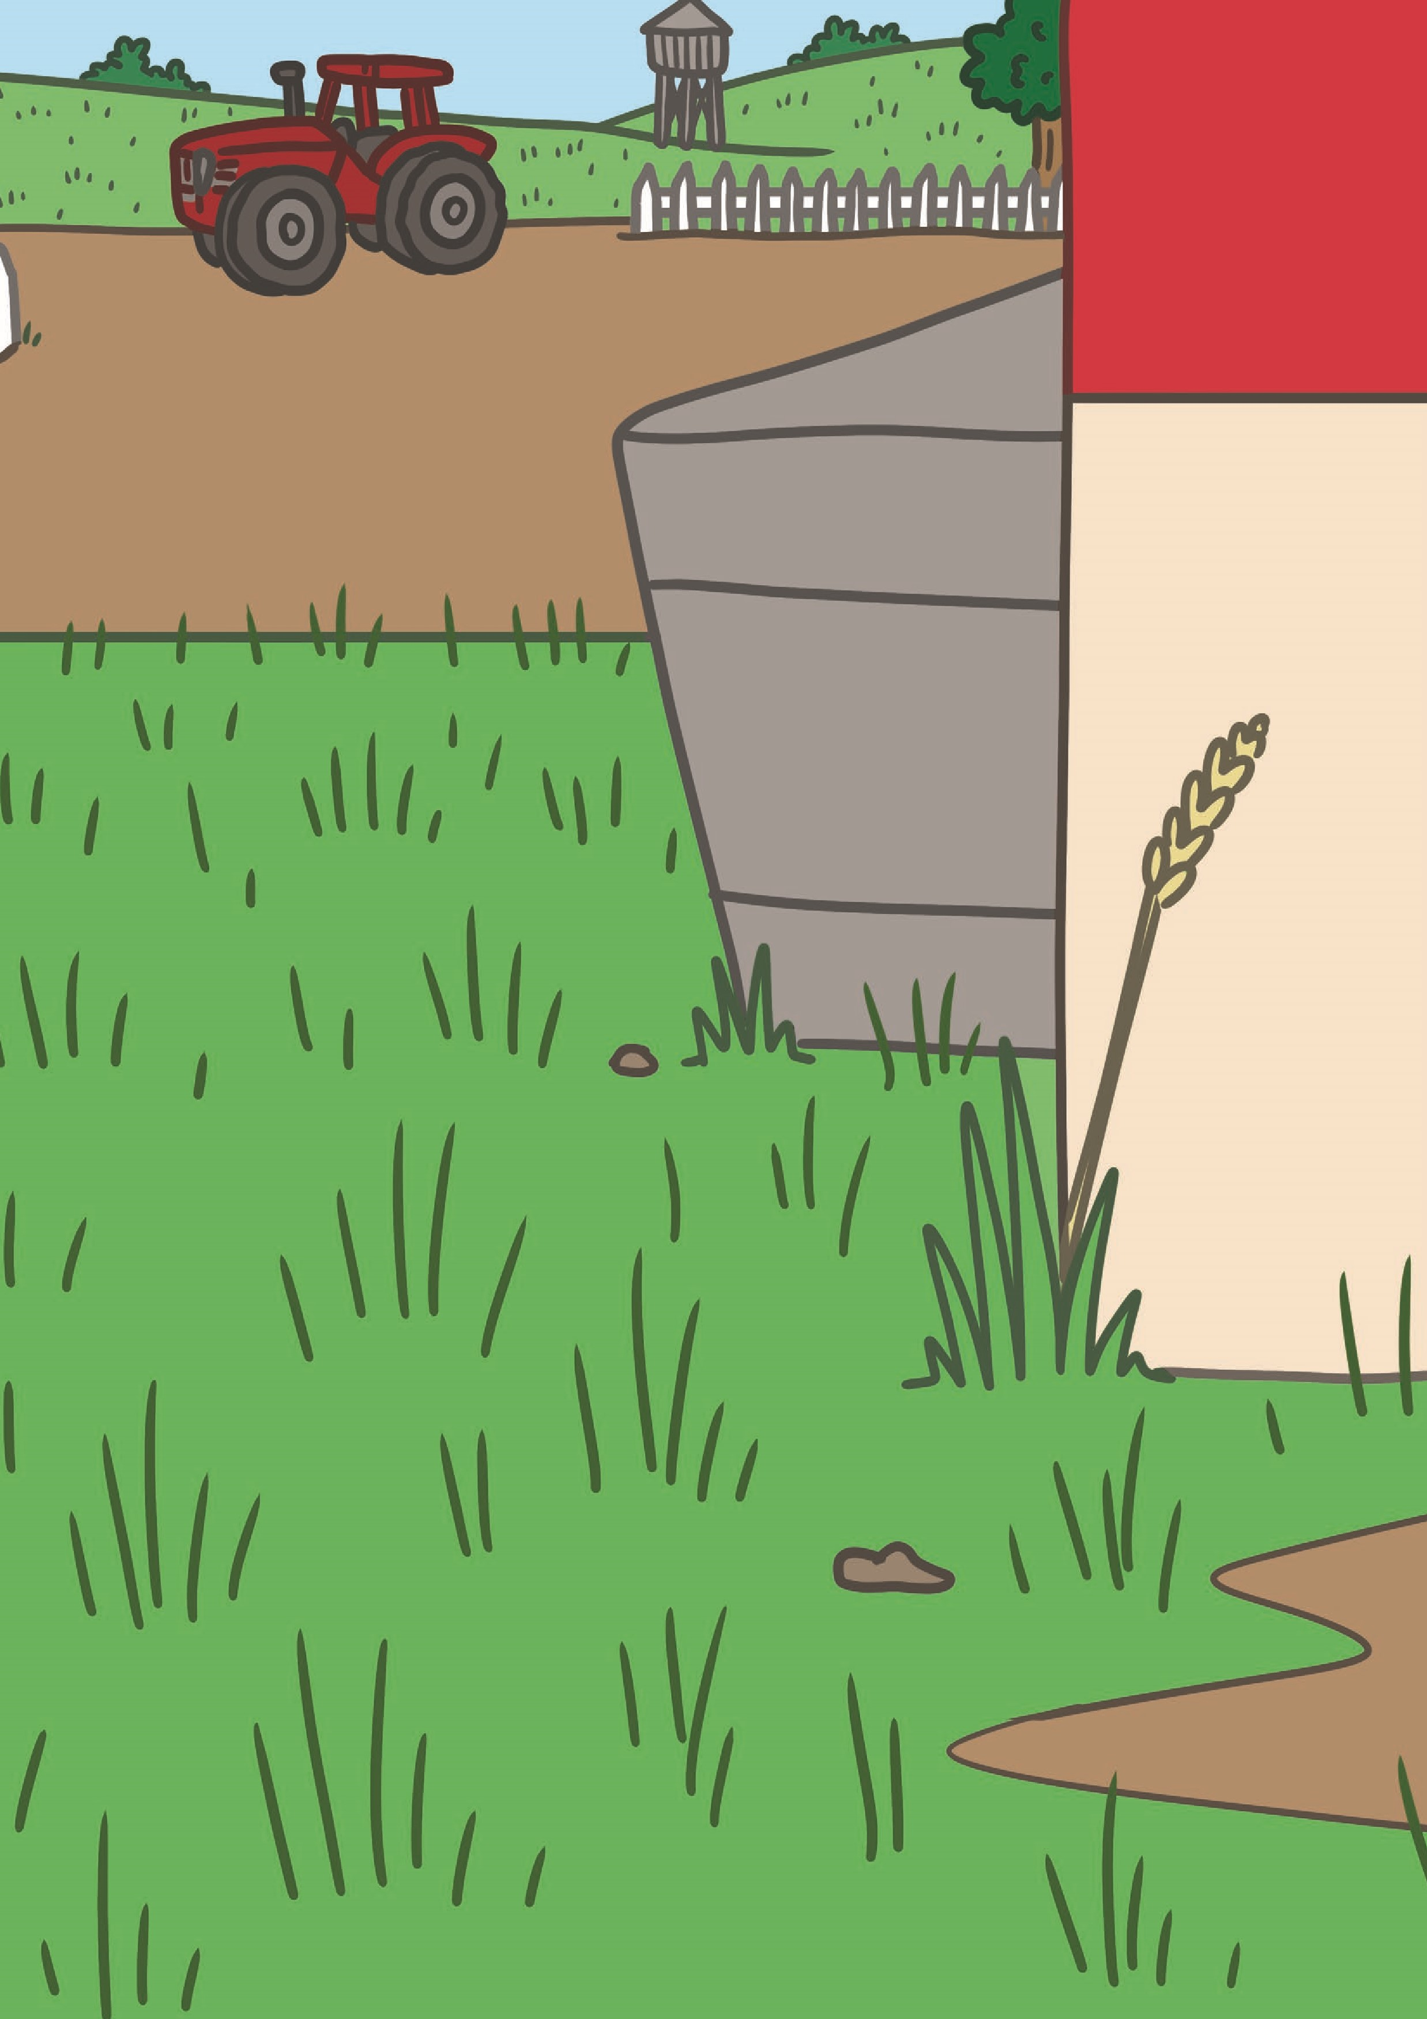


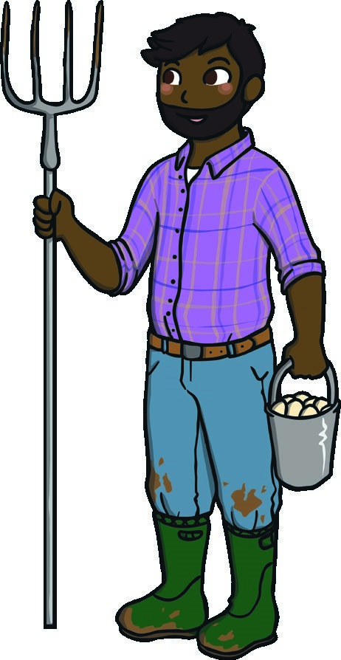
Thank You Farmer Song
(
Sing to the tune of ‘London’s Burning’.
)
Thank you farmer, thank you farmer,
For the food, for the food.
Harvest, harvest! Harvest, harvest!
It’s delicious! It’s delicious!
Thank you farmer, thank you farmer,
For the apples, for the apples.
Harvest, harvest! Harvest, harvest!
They’re delicious! They’re delicious!
Thank you farmer, thank you farmer,
For potatoes, for potatoes.
Harvest, harvest! Harvest, harvest!
They’re delicious! They’re delicious!

