Progression Step 3
Collective Worship
19th December
Mrs Houston



Entrance Hymn: The Advent Candle Song
The Advent Candle Song

Gather
Jonas: In the season of Advent, we await the coming of Christ on all the levels which we experience time: in the past — as a babe in the stable of Bethlehem; in the present — as grace in our souls; and in the future — as the Judge at the end of time.
Patrick: The Advent season is filled with preparation and expectation. Everyone is getting ready for Christmas — shopping and decorating, baking and cleaning. Too often, however, we are so busy with the material preparations that we lose sight of the real reason for our activity: the Word made flesh coming to dwell among us.

Bernice: As we begin our mass let us not forget to prepare a peaceful place in our hearts wherein our Saviour may come to dwell.
Gather
Sign of the Cross
Mrs Houston: In the name of the Father, and of the Son, and of the Holy Spirit.
All: Amen.
Greeting
Mrs Houston: The grace of our Lord Jesus Christ, and the love of God, and the communion of the Holy Spirit be with you all.
All: And with your spirit.

Advent Wreath Blessing

Mrs Houston: Let us pray (pause for silent prayer) Father, all powerful Lord of Light, bless our wreath of evergreens. May the increasing light of these candles brighten our minds and hearts to be steadfast in faith, joyful in hope and untiring in love, so that we are ready again to receive in true peace Jesus, the Light of the World, who lives and reigns with you, for ever and ever. Amen. (Leo to light the candle)

Penitential Rite:
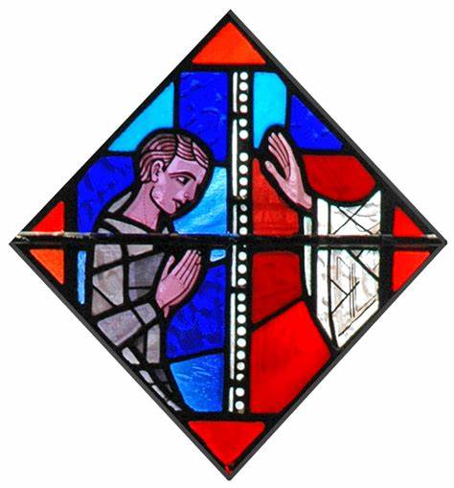
Mrs Houston: As we begin our Advent journey, we call to mind God’s gracious forgiveness of our sins: (pause) I confess….
ALL: I confess to almighty God
And to you, my brothers and sisters,
That I have greatly sinned,
In my thoughts and in my words,
In what I have done and in what I have failed to do,
Through my fault,
Through my most grievous fault;
Therefore I ask blessed Mary ever- Virgin,
All the Angels and Saints,
And you my brothers and sisters,
To pray for me to the Lord our God. Amen.

Mrs Houston: May almighty God have Mercy on us, forgive our sins, and bring us to Everlasting life.
All: Amen
Mrs Houston: Lord have Mercy
All: Lord have Mercy.
Mrs Houston: Christ have Mercy
All: Christ have mercy

Mrs Houston: Lord have Mercy
All: Lord have Mercy
The Word of God

First Reading from the Book of Isaiah (Is 2:1-5)
Tom: This is what Isaiah, son of Amoz,
saw concerning Judah and Jerusalem.
In days to come,
the mountain of the LORD’s house
shall be established as the highest mountain
and raised above the hills.
Francisco: All nations shall stream toward it;
many peoples shall come and say:
“Come, let us climb the LORD’s mountain,
to the house of the God of Jacob,
that he may instruct us in his ways,
and we may walk in his paths.”
Machan: For from Zion shall go forth instruction,
and the word of the LORD from Jerusalem.
He shall judge between the nations,
and impose terms on many peoples.
They shall beat their swords into plowshares
and their spears into pruning hooks;
one nation shall not raise the sword against another,
nor shall they train for war again.
O house of Jacob, come,
let us walk in the light of the Lord!

RESPONSORIAL PSALM
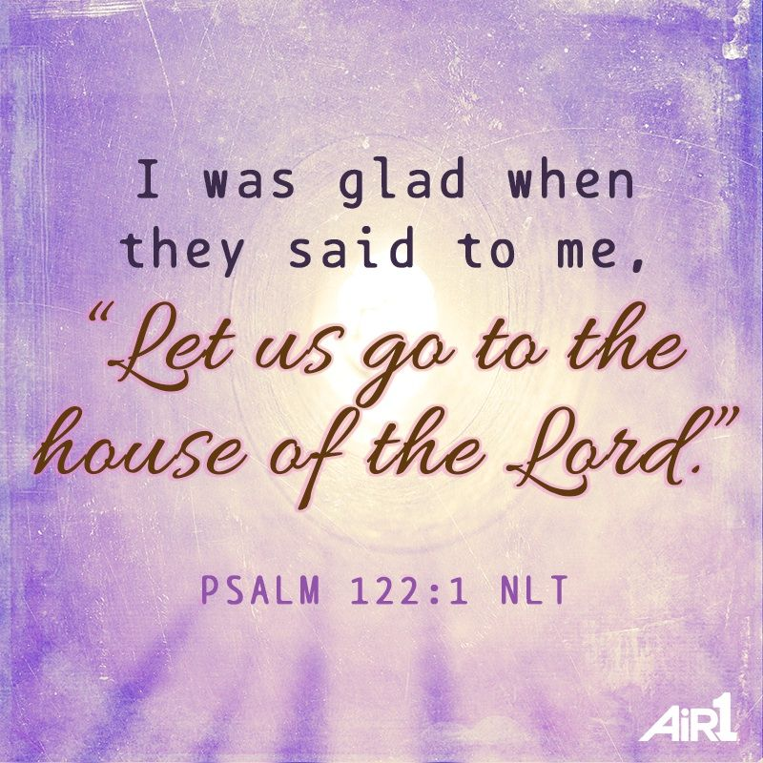
Ps 122: 1-2, 3-4, 4-5, 6-7, 8-9
Richa: The response is: Let us go rejoicing to the house of the Lord.
All: Let us go rejoicing to the house of the Lord.
Aron: I rejoiced because they said to me,
"We will go up to the house of the LORD."
And now we have set foot
within your gates, O Jerusalem.
R. Let us go rejoicing to the house of the Lord.
Sacchin: Jerusalem, built as a city
with compact unity.
To it the tribes go up,
the tribes of the LORD.
R.Let us go rejoicing to the house of the Lord.


Charlie: According to the decree for Israel,
to give thanks to the name of the LORD.
In it are set up judgment seats,
seats for the house of David.
R. Let us go rejoicing to the house of the Lord.
Phoebe: Pray for the peace of Jerusalem!
May those who love you prosper!
May peace be within your walls,
prosperity in your buildings.
R.Let us go rejoicing to the house of the Lord.
Mahin: Because of my brothers and friends
I will say, "Peace be within you!"
Because of the house of the LORD, our God,
I will pray for your good.
R.Let us go rejoicing to the house of the Lord.

The Word of God

Second Reading from the Book of Romans
Rom 13:11-14


Toby: Brothers and sisters:
You know the time;
it is the hour now for you to awake from sleep.
Stanley: For our salvation is nearer now than when we first believed;
the night is advanced, the day is at hand.
Let us then throw off the works of darkness
and put on the armour of light;
let us conduct ourselves properly as in the day,
not in drunkenness,
not in promiscuity and lust,
not in rivalry and jealousy.
Arlo: But put on the Lord Jesus Christ,
and make no provision for the desires of the flesh.

Gospel Procession – with sung Alleluia

All stand.

Nancy and Vernon to process with the Gospel

Alleluia – Psalms 85:8
San and Taylor: Alleluia, alleluia.
Show us Lord, your love;
and grant us your salvation.
Alleluia, allelui

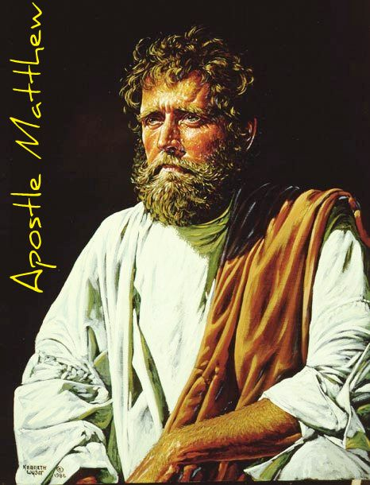
GOSPEL

Mrs Houston: The Lord be with you

All: And with your Spirit

Mrs Houston: A reading from the holy Gospel according to Matthew. (Mt 24:37-44)

All: Glory to you o Lord (Cross your head, heart and mouth)
Jesus said to his disciples:
“As it was in the days of Noah,
so it will be at the coming of the Son of Man.
In those days before the flood,
they were eating and drinking,
marrying and giving in marriage,
up to the day that Noah entered the ark.
They did not know until the flood came and carried them all away.
So will it be also at the coming of the Son of Man.
Two men will be out in the field;
one will be taken, and one will be left.
Two women will be grinding at the mill;
one will be taken, and one will be left.
Therefore, stay awake!
For you do not know on which day your Lord will come.
Be sure of this: if the master of the house
had known the hour of night when the thief was coming,
he would have stayed awake
and not let his house be broken into.
So too, you also must be prepared,
for at an hour you do not expect, the Son of Man will come.”
Response to the Word of God
Bidding Prayers (Prayers of Intercession)


Introduction to the bidding prayers

Mrs Houston: Because God is faithful and loving, we bring forward our intentions with confidence.

Sarah Rose: For all believers, that they may be found ready when the Lord comes in glory (pause for quiet prayer). Lord, hear us.
All: Clywed ein gweiddi / Lord graciously hear us

Cody – Capri: For our friends who find belief hard, that in this Year of Faith, God’s love may touch their hearts (pause for quiet prayer). Lord, hear us.
All: Clywed ein gweiddi / Lord graciously hear us

Kaeban: For those who live in fear, that they may find new courage in Christ (pause for quiet prayer). Lord, hear us.
All: Clywed ein gweiddi / Lord graciously hear us

Joen: For people burdened by addiction, that the liberation promised by the Lord may be theirs (pause for quiet prayer). Lord, hear us.
All: Clywed ein gweiddi / Lord graciously hear us

Jerom: For those who suffer, in mind or body, that they may experience God’s healing power (pause for quiet prayer). Lord, hear us.
All: Clywed ein gweiddi / Lord graciously hear us

Isabella: For all who have died that they may have peace and rest in the Kingdom (pause for quiet prayer). Lord, hear us.

All: Clywed ein gweiddi / Lord graciously hear us.

Charlie: In silence, we add our own petitions….
We ask Mary, our mother, to add her prayers to ours, as we say… Hail Mary …

Mrs Houston: Lord, you are a true friend to those who revere you: be our support in all our needs, we pray, through Christ our Lord.
All: Amen.Amen

Prayer

Mrs Houston: Holy One, this Advent season we wait in hope.
And we give in hope.
Hope for your coming reign;
Hope because of your presence with us even now.
Receive these generous offerings,
And use them for your work of healing and hope in our world.
Amen.

Closing Prayer

All: As we adore you, O God,
Who alone are Holy and wonderful in all your Saints,
We implore your grace,
So that coming to perfect Holiness in the fullness of your love,
We may pass from this pilgrim table to the banquet,
Of our heavenly homeland.
Through Christ our Lord.
All: Amen.

Go Forth

Mrs Houston: The Lord be with you
All: And with your spirit
Mrs Houston: May almighty God bless you…
All: Amen

Mrs Houston: Go in Peace to love and serve the Lord.
All: Thanks be to God.

Go Forth
Recessional Hymn
Waiting for Christmas



