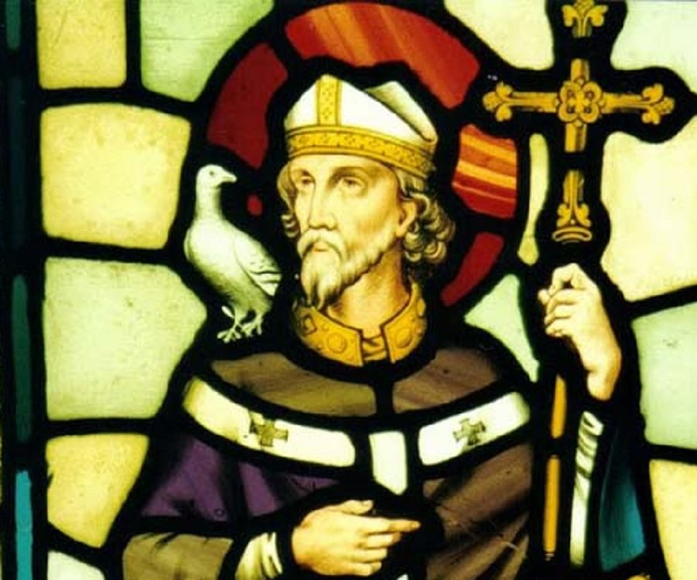

Saint David’s Day Mass 2024

Offeren Dydd Gŵyl Dewi 2024

Celebrant: Father Jose

Class: Dosbarth Gwynno Sant

Athrawes: Mrs Houston

Entrance Hymn :
Gather:

Entrance Hymn : God’s Spirit is in my heart
God’s Spirit Is In My Heart
He Has Called Me And Set Me Apart.
This Is What I Have To Do,
What I Have To Do
Chorus: He Sent Me To Give The Good News To The Poor
Tell Prisoners That They Are Prisoners No More
Tell Blind People That They Can See
And Set The Down Trodden Free
And Go Tell Everyone The News That The
Kingdom Of God Has Come
And Go Tell Everyone
The News That God’s Kingdom Has Come.
Just As The Father Sent Me So
I’m Sending You Out To Be,
My Witnesses Throughout The World,
The Whole Of The World
Chorus
Don’t Carry A Load In Your Pack,
You Don’t Need Two Shirts On Your Back
A Workman Can Earn His Own Keep,
Can Earn His Own Keep
Chorus
Don’t Worry What You Have To Say,
Don’t Worry Because On That Day
God’s Spirit Will Speak In Your Heart
Will Speak In Your Heart
Gospel Acclamation: (Sung)
Praise to you, O Christ, king of eternal glory!
Praise and honour to you, Lord Jesus!
Glory and praise to you, O Christ!
Glory to you, O Christ, you are the Word of God!
Bella (spoken): If you make my word your home, you will indeed be my disciples, and you will learn the truth, and the truth will set you free, says the Lord.
Praise to you, O Christ, king of eternal glory!
Praise and honour to you, Lord Jesus!
Glory and praise to you, O Christ!

Offetory Hymn – All that I am

All that I am, all that I do,
All that I'll ever have, I offer now to you.
All that I dream, all that I pray,
All that I'll ever make, I give to you today.
Take and sanctify these gifts
For your honor, Lord.
Knowing that I love and serve you
Is enough reward.
All that I am, all that I do,
All that I'll ever have I offer now to you.
Take and sanctify these gifts
For your honour, Lord.
Knowing that I love and serve you
Is enough reward.
All that I dream, all that I pray,
All that I'll ever make, I give to you today.

Communion Hymn
This is my Body

This is my body, broken for you,
bringing you wholeness, making you free,
take it and eat it, and when you do,
do it in love for me.
This is my blood poured out for you,
bringing forgiveness, making you free.
Take it and drink it, and when you do,
do it in love for me.
Back to my Father soon shall I go.
Do not forget me; then you will see
I am still with you, and you will know
you're very close to me.
Filled with my Spirit, how you will grow!
You are my branches; I am the tree.
If you are faithful, others will know
you are alive in me.
Love one another – I have loved you,
and I have shown you how to be free;
serve one another, and when you do,
do it in love for me.

Videos of Holy, Holy, Schubert Mass Lyrics
bing.com/videos

Holy Holy Sung

Holy, holy, holy, God almighty, Lord!
Holy, holy, holy, everywhere adored!
1. God without beginning, God, eternal One
reigns and rules forever all beneath the sun.
Holy, holy, holy, God almighty, Lord!
Holy, holy, holy, everywhere adored!
2. Power and love and wonder circling round God's throne,
praise our God most holy, Lord of Life alone.

GREAT AMEN
Lamb of God

https://www.youtube.com/watch?v=CAR110H9voQ

Closing Hymn
O Great Saint David

O great Saint David,
still we hear thee call us,
unto a life that knows no fear of death;
Yea, down the ages,
will thy words enthral us,
strong happy words:
‘Be joyful, keep the faith.’

On Cambria’s sons
stretch out thy hands in blessing:
For our dear land
thy help we now implore.
Lead us to God,
with humble hearts confessing
Jesus, Lord and King for evermore.

Christ was the centre rock
of all thy teaching,
God’s holy will—
the splendour of its theme.
His grace informed,
his love inflamed thy preaching;
Christ’s sway on earth,
the substance of thy dream.

On Cambria’s sons
stretch out thy hands in blessing:
For our dear land
thy help we now implore.
Lead us to God,
with humble hearts confessing
Jesus, Lord and King for evermore.

In early childhood,
choosing Jesus only,
thy fervour showed his yoke
was light and sweet!
And this for thee,
life’s journey was not lonely—
the path made plain
by prints of wounded feet.

On Cambria’s sons
stretch out thy hands in blessing:
For our dear land
thy help we now implore.
Lead us to God,
with humble hearts confessing
Jesus, Lord and King for evermore.

O glorious saint,
we wander in the dark;
with thee we seek
our trusted guide in Rome.
Help him to steer
on earth Saint Peter’s barque,
that we may safely reach
our heavenly home.

On Cambria’s sons
stretch out thy hands in blessing:
For our dear land
thy help we now implore.
Lead us to God,
with humble hearts confessing
Jesus, Lord and King for evermore.

