Criw Cymraeg
Bardic Ceremony / Flower Dance
Mis Mawrth Un 2024
- Costume: Long White Shirt and White Head Dress
- Crown
- Scroll
- Costumes for danceretc

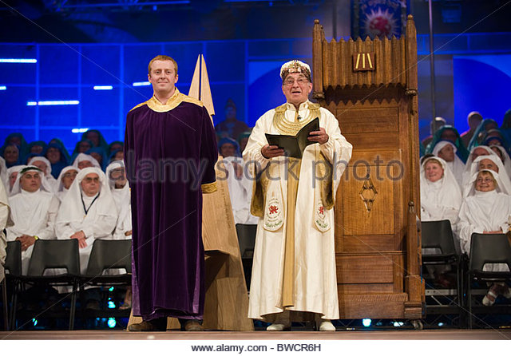

Eisteddfod Bard Ceremony
To be prepared and presented by Criw Cymraeg

Cast – Reader, Archdruid, 2 druids of the sword, 2 druids of the cloak, 2 musical druids, 1 druid of the crown, 1 poet (Chosse two for each part – one to say words in Welsh and One in English)

Props - White sheets for druids or welsh tops etc (x8), 2 swords, cloak, trumpets, chair, crown, scroll for poet

Reader 1: Introduction
Prynhawn da plant. Today we are celebrating our Eisteddfod, we thank Our Lord for all the gift and talents he has given us and pray that we will always do our best for him.

Gweddїwn:

Gadewch i ni wneud arwydd y groes.
Let us now make the sign of the cross in Welsh.

Yn enw Tad , a’r Mab a’r ysbryd Glan, Amen.

Gweddi Dydd Gŵyl Dewi  Diolch, diolch am Cymru,  diolch am wlad, am dir, am iaith.  Diolch, diolch am Iesu,  am ei gariad, am ei waith;  dyma weddi Dydd Gŵyl Dewi,  de a gogledd, cenwch gân:  boed i’r Cymry garu’r Iesu  cadwn Cymru’n Cymru lân. | St David's Day Prayer  Thank you, thank you for Wales,  Thank you for a country, for land, for language.  Thank you, thank you for Jesus,  For his love, for his work;  Here is the prayer of St David's Day, south and north, a song:  Let the Welsh Love Jesus

Let us now begin our bard ceremony

Druids enter to music ?????

Arch Druid:
Prynhawn da plant, we are druids and we have come to visit your school this afternoon in order to crown the crown poet. I am the Arch druid.
I will now introduce you to my companions.

These are the druids of the sword (Sword druids bow)
These are the druids of the cloak (Cloak druids bow)
These are the musical druids (Musical druids bow)
This is the druid of the crown (Druid of the crown bows)

Before we can begin our crowning ceremony we must be sure that everyone is present. The musical druids will play a tune and each house will raise their hands and answer ‘Yma’ in turn’. Barod?

Ty Teilo
Ty Winifred
Ty Dewi
Ty Morgan

Now I will call upon this year’s judge Mrs Riordan to give
us the name of the Crown Poem.

Judge gives adjudication (they will make the announcement of the winner)
(Winner stands as music is played, the cloak druids dress and fetch the Poet and they process him/her to the chair.)

Before the crowning can take place there must be peace in our land.
When I call out ‘A oes hedddwch?’ You will reply ‘Heddwch’

A oes heddwch? Heddwch
A oes heddwch? Heddwch

A oes heddwch? Heddwch

On each ‘A oes heddwch?’, sword druid pull sword out to edge of sheath. On hearing the reply ‘Heddwch’ it is replaced in its sheath.

Now that there is peace, the druid of the crown will crown the winner.
(Pause)
The poet druids will recite a poem in honour of the crown poet.

Bard:
A crown of thoughts, not of jewels
She/he has the gift of pen, not sword
And wealth which cannot be counted.
Cymru, land of bards here is your true son/daughter.

The crowned poet will now read their winning poem.
(poem will be read)

Archdruid: We call on the children in the reception class to
perform the flower dance. (reception children will dance)

Pause

Archdruid:
Now we will say our Eisteddfod pray, please repeat after me

All:
Yn enw Tad , a’r Mab a’r ysbryd Glan, Amen.

Lord, give us strength
And in strength understanding
And in understanding, understanding what is good,
And in understanding what is good, doing it.
And in doing it, Loving God
God in all His goodness.

Yn enw Tad , a’r Mab a’r ysbryd Glan, Amen

Archdruid:
Now let us stand and sing the Welsh National Anthem

(Pause whilst school sing)

Now we must take our leave. Or mission has been accomplished –
We have crowned your bard.

Exit druids to music.

