Saint David’s Day 2024
Dydd Dewi Sant 2004
Criw Cymraeg
External Competitions
Cystadlu Un Competition One:
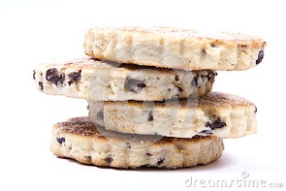
Cooking competition (All classes) - The children are asked to cook a Welsh traditional dish. This is to be judged by Criw Cymraeg, but I feel sure all staff will be there to help them in the decision making process! Please ensure that the container in which the cooked item is delivered in is clearly marked with your child’s name and their class so that they can be returned to you on the afternoon of the eisteddfod. Please bring in for the 28th February.
Cystadlu Dau / Competition Two: Criw Cymraeg
To design a new flag for Wales. To be judged and prizes to be awarded by Criw Cymraeg. (All classes) Three children from Progress Step 1, 2 and 3
Cystadlu Tri / Competition Three: (All classes)
To make a 3D model of either a leek or a daffodil. A certificate will be awarded four first, second and third. To be judged and presented by Criw Cymraeg.

Cystadlu Pedwar / Competition Four: (All classes)
Model Making of a Welsh dragon Welsh lady or Welsh love spoon. To be judged and prizes to be awarded by Criw Cymraeg for each class. A certificate will be awarded four first, second and third.

Cystadlu Pump / Competition Five:
To design a new rugby kit for the Welsh Rugby Team / Football Team. (All classes) To be judged and prizes to be awarded by Criw Cymraeg. A certificate will be awarded four first, second and third.
Cystadlu Chwech – Competition Six - Bardic Competition: Year Six children only.
In order for the poems not to be copied off the internet, this poetry writing task MUST be completed in class. (The assessor for the Bronze Award will recognise poems off the internet immediately.) To be judged by Criw Cymraeg.
Bardic Ceremony Preparation and flower dance: Prepared by Criw Cymraeg.
Diolch,
Criw Cymraeg

