BARDIC POEM
Dydd Dewi Sant 2024
Cystadlu Blwyddyn Chwech
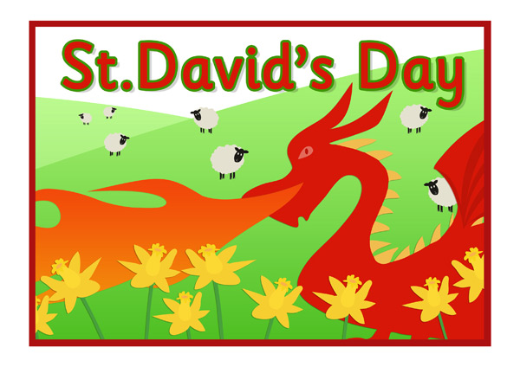
Mis Mawrth Un 2024

Dear Parents,
As part of the Saint David’s Day celebrations all children are expected to write a poem on the theme ‘Of Our City of Cardiff.’ The children can present their poem in a decorated hand written form or they can use their IT skills to present their poem. I t is very important that the children DO NOT use materials from the internet and the work produced is of their own creation. The winner should not include their name at the end of the poem but use a pseudo name – the class teacher will have the list of these names that parents should impart to the class teacher. All poems will be submitted to Criw Cymraeg via Mr Cobb, and they will choose the winner being unaware of whom the entries are. It is hoped that all parents will support their children in this task to celebrate Wales’s patron saint, Saint David. The new bard will be crowned in the Bardic Ceremony, also delivered by Criw Cymraeg.
Kind regards,
Criw Cymraeg

