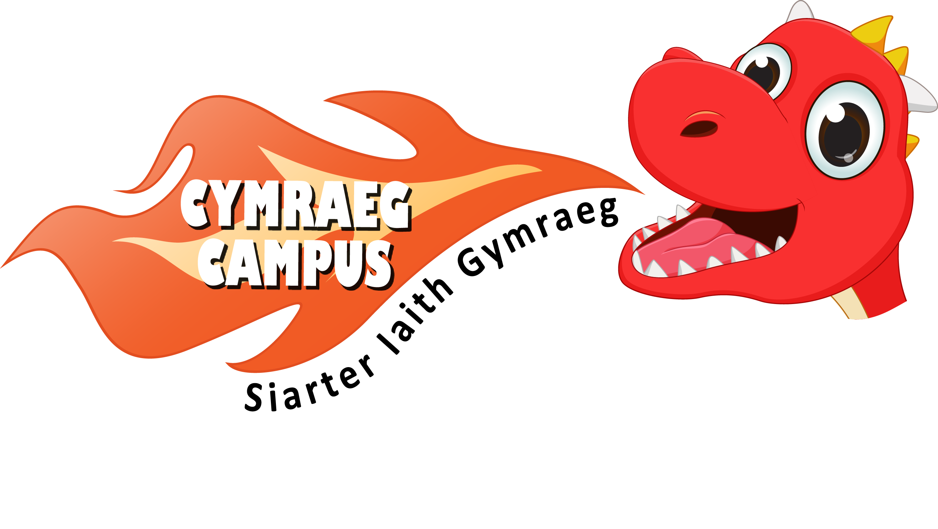
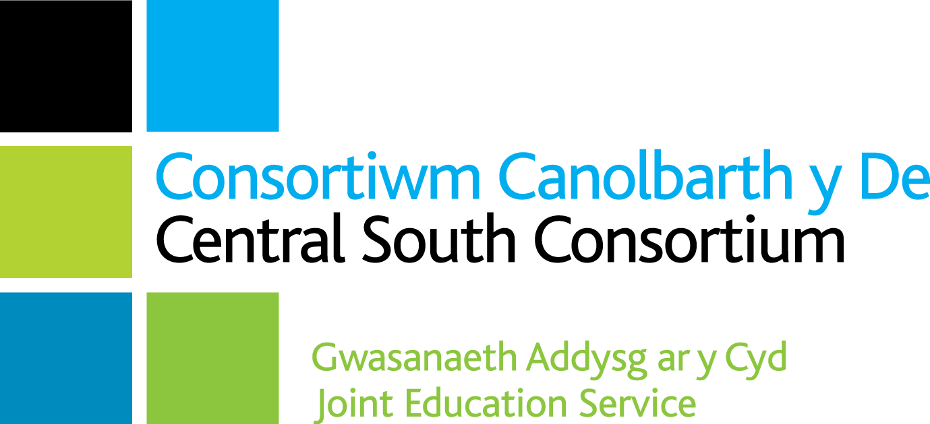
Adroddiad Siarter Iaith Cymraeg Campus
Siarter Iaith Cymraeg Campus Report

Ysgol / School: Ysgol Gynradd Gatholig Joseff Sant
Gwobr / Award: Efydd

Targed /Target | Meysydd llwyddiannus /Areas of success | Taro’r targed/Target met?
Un - Sefydlu ethos Gymreig weledol  Visual Welsh ethos | Strong Welsh ethos throughout the school. It is obvious that all stakeholders in St. Joseph’s R.C. Primary have invested in the Welsh language.  All classes have Welsh displays and Cwtch Cymraeg areas.  Purposeful Welsh phrases displayed consistently on displays across the curriculum.  The Criw Cymraeg choose agreed focussed targets and are responsible for the ‘Brawddeg yr wythnos’. This is shared with parents and pupils and modelled in weekly Welsh assemblies. The Criw Cymraeg take a proactive approach in measuring impact and progress in their weekly meetings. The school has developed a strong Welsh visual ethos in communal areas and corridors. Croeso posters and incidental Welsh are also displayed around the school. | Yes
Dau - Manteision dysgu’r Gymraeg  Advantages of Welsh | The Criw Cymraeg was clear about the advantages of learning Welsh. They encourage others through a consistent reward system. Criw Cymraeg has shared the importance of learning Welsh throughout weekly assemblies and with all stakeholders. The Criw carried out a wonderful, mature and professional presentation for the link governor and the verifier on verification day discussing targets, achievements and the advantages of siarad Cymraeg. Parents have been made aware of Cymraeg Campus targets through the school website, social media and the school newsletter. School effectively plans to develop Welsh culture and heritage. Mascots and puppets are used as a stimulus to promote Welsh oracy for both pupils and staff. | Yes
Tri - Y defnydd o’r Gymraeg yn achlysurol o fewn yr ystafell ddosbarth Incidental Welsh in the classroom | All classes display appropriate patterns and questions to promote incidental Welsh. Staff and pupils use incidental Welsh consistently.  Criw Cymraeg take an active role in monitoring the use of incidental Welsh.  The school has worked collaboratively to develop staff Welsh oracy skills. Incidental Welsh and appropriate patterns are used consistently through a variety of Helpwr Heddiw sessions. A highly successful Helpwr heddiw session was observed on verification day. Supportive resources have been distributed and effectively used to further develop Welsh oracy in the classroom. St. Joseph’s staff regularly attend CSC Welsh professional learning face to face events. Support staff are receiving Welsh professional learning in the new year based on ‘Dim sgiliau’ as well as Welsh yard games. | Yes
Pedwar - Y defnydd o’r Gymraeg yn achlysurol y tu allan i’r ystafell ddosbarth Incidental Welsh outside the classroom | Criw Cymraeg take an active role in training younger children to develop Welsh language games and the use of incidental language. Members of the Criw have a clear vision to further develop aspects and how to model activities. Peer to peer language is being developed through Helpwr Heddiw games played in classes and communal areas. The use of Welsh is also encouraged in the dinner hall. ‘Brawddeg yr wythnos’ is displayed around the school, both inside and outside the classrooms. Welsh yard games are played outside and led by the Criw. | Yes
Pump - Cymraeg yn y Gwasanaethau  Welsh Assemblies | A superb merit assembly was observed on verification day, nearly all of which was carried out through the medium of Welsh. Staff and pupils use Welsh naturally throughout. Criw Cymraeg introduce ‘Brawddeg yr wythnos’. Criw Cymraeg present Welsh certificates and stickers to the ‘Siaradwr yr wythnos’. The Criw Cymraeg, subject leaders and head teacher emphasised the positive impact this has had in enriching the Welsh ethos. The three progression steps have been presented with purposeful interactive elements in Welsh assemblies such as classes taking turns to perform e.g. songs, games, reading stories as well as Welsh prayers during collective worship. | Yes
Chwech - Apiau a gwefannau i fireinio’r dysgu a’r mwynhad  Welsh Apps and Websites | Pupils use a range of Welsh websites and apps trialled and recommended by the Criw Cymraeg. St. Joseph’s makes effective use of digital technology for Welsh language through use of Hwb, Dojo and the CSC website. iPads are used to gather oracy and reading evidence. Pupils choose to use Welsh apps and websites voluntarily. Evidence of this was seen throughout the school. Some extended written pieces are word processed. Pupils make great use of resources to code to enhance their Welsh oracy skills as well as their music skills. The school was visited by Welsh Assembly Government and pupils coded songs such as Heno Heno, Mae Hen wlad fy nhadau and Llundain yn llosgi. This was a particular strength of the extensive evidence observed. | Yes
Saith - Gweithgareddau cyfoethogi  Enrichment activities | The school celebrates significant dates such as Santes Dwynwen, Dydd Miwsig Cymru, Diwrnod Seren a Sbarc, Diwrnod Shw’mae and St. David’s Day. Fantastic videos are shared on social media of such events. Staff and pupils alike celebrate the school Eisteddfod to the full and are extremely proud of their Welsh heritage and culture. Pupils have gone on educational visits e.g. Morfa Bay, Castell Caerdydd, St Fagan’s, Bae Caerdydd, Tredegar house and Llangrannog to enhance the Welsh dimension. Welsh singing, dawnsio gwerin and cynefin (heritage) are deeply embedded in school life at St. Joseph’s. A Clwb Cymraeg is held after school to celebrate the pupils’ love of the language. | Yes
Wyth - Datblygu darllen  Developing Reading | All classes have a range of reading resources. Pupils use QR codes to read Welsh books whenever possible. The Criw Cymraeg is hoping to develop this further with the younger pupils in school. Pupils show good fluency and intonation when reading a range of age-appropriate reading materials. Older pupils have previously read Welsh stories to younger pupils. Welsh books have been included in GGR sessions. Pupils throughout the school are exposed to factual and fictional books as well as poetry. Activities such as word games, role play as well as regular GGR sessions enrich the pupils’ reading experience. Pupils confidently express their opinions about books they have read. | Yes
Naw - Cymraeg ar draws y Cwricwlwm  Welsh across the curriculum | Most displays contain purposeful and appropriate Welsh language patterns and questions.  Pupils are encouraged to use Welsh in other areas of the curriculum orally. Teachers use incidental Welsh as part of their PE warm up sessions, art, music and mathematics. Pupils can evaluate their work simply yn Gymraeg. Pupils spoke about their experience of speaking Welsh during different events throughout the year. Teachers take a proactive role in ensuring the Welsh dimension and appropriate incidental language is integrated in new topics. | Yes
Deg - Agwedd Gadarnhaol  Positive attitude to Welsh | All stakeholders demonstrate a highly positive attitude to Welsh.  The Criw Cymraeg at St. Joseph’s are obviously thoroughly enjoying their role and are eager to continue and develop this year and next. Members have a clear vision of the continued development of the Welsh culture and heritage in all aspects of school life. | Yes

Sylwadau Cyffredinol / General Comments
- Siarter Iaith Cymraeg Campus is driven by very strong leadership from the Welsh subject leader. The process is also supported highly effectively by the headteacher and all staff. The whole school approach at St. Joseph’s is evidently a strength.
- A highly enthusiastic Criw Cymraeg is instrumental in implementing, developing, and monitoring Siarter Iaith Cymraeg Campus. This ensures a strong pupil voice throughout the process.
- Extensive evidence has been collected for all ten targets digitally and there is very strong and attractive evidence clearly displayed and celebrated around the school.
- The progress of Cymraeg Campus is continually monitored by the Criw Cymraeg and is presented regularly to both staff and pupils.
- Whilst celebrating and taking pride in the school’s progress, the subject leader is eager to embed the good practice and continue to develop the Welsh ethos they have worked so hard to achieve. They hope to achieve the silver award soon.
Llongyfarchiadau i bawb yn Ysgol Gynradd Gatholig Joseff Sant, rydych chi’n llwyr haeddu gwobr efydd Siarter Iaith Cymraeg Campus.
Congratulations to everyone in St. Joseph’s R.C. Primary School, you richly deserve the Siarter Iaith Cymraeg Campus bronze award.

Prif Meysydd i’w Datblygu / Main Areas for Development
- The Criw Cymraeg to continue to monitor, encourage and lead the way on Welsh development.
- Continue to work on Target 9, Welsh across the curriculum.
- The Criw Cymraeg would like to invite parents and governors into school to promote the use of Welsh.
- The subject leader would like to play on the strengths of Welsh speaking staff for other teachers to observe.
- Strengthen the link with other schools such as Mynydd Bychan.
- Consider using Welsh in proposed community projects.

Dilyswyd gan/Verified by: Emma Davies

Dyddiad/Date: 13/12/2023

