Our Precious World
How and why should we protect the diversity of different environments?
Rainforests
Task 1
Introduction: Watch a PPT to introduce what the rainforests are.
GGR: The Rainforests of the World
LO: To begin to apply reading comprehension skills to interrogate texts about the rainforests of the world.
Task 2
Our Precious World
Diamond Ranking Collaborative Learning task – Literacy and Humanities (Geography)
Rainforests – What do you think are the issues that are the most serious affecting the rainforests of the world? Activity One Resource file

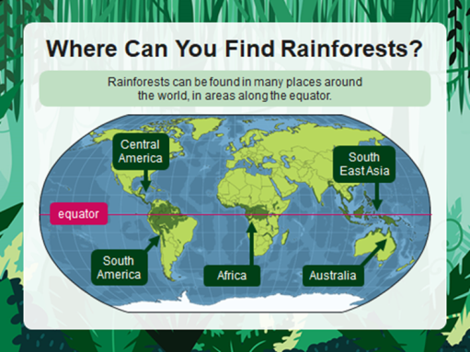
Task 3
Our Precious World

LO: To begin to learn how to Use keys to show geographical information.
Where are the rainforests of the world?
Name of Rainforest | Colour on the map

Task 4
Our Precious World
Rainforests of the World – Using an Atlas

LO: TO begin to use atlases as a source of information to learn about the rainforests of the world.
Label continents
Label rainforests
Label equator, Tropic of Cancer and Capricorn

1. Find and label these continents on your map:

• Africa

• Antarctica

• Asia

• Australia

• Europe

• North America

• South America

2. Find and label these rainforests on your map:

• Amazon Rainforest

• Congo River Basin Rainforest

• Daintree Rainforest

• Madagascar Rainforest

• Southeast Asian Rainforest

3. Label the three lines on the map to show:

• The Equator

• The Tropic of Cancer

• The Tropic of Capricorn

Our Precious World

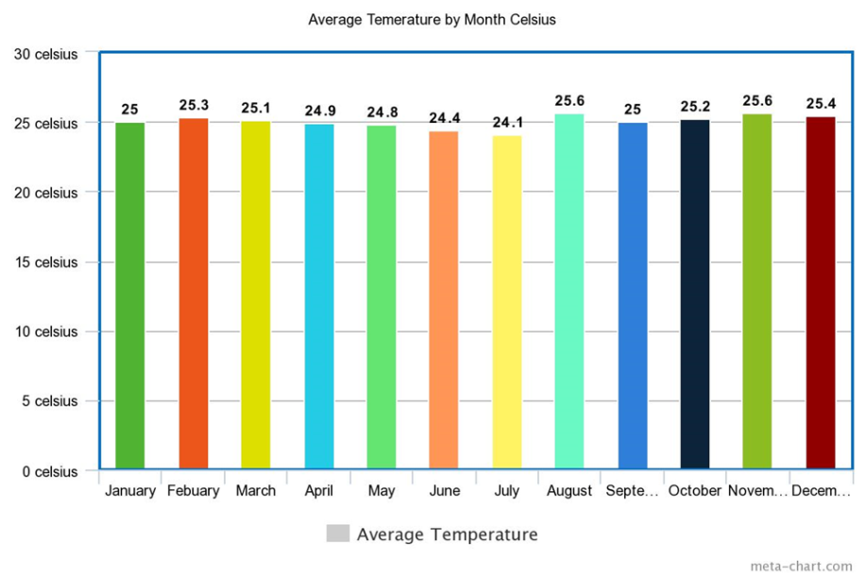
Rounding Data on the Monthly Temperatures in the Amazon Rainforest
LO: To apply learning on place value to round decimal data to the nearest whole number. To be able to extract specific data from a graph

LO: To apply learning on place value to round decimal data to the nearest whole number. To be able to extract specific data from a graph.

Our Precious World (Mathematics / Humanities)
Climate of Wales compared with that of the Amazon rainforest. How is it different?
Comparing the annual temperatures in Cardiff Wales and those of the Amazon Rainforests.
LO: To begin to plot data. To begin to draw comparisons between data. To begin to plot data using a provided asis.

Data Handling – Mathematics
Humanities – Environments / Habitats
Introduction: PPT Rainforest climate (See resources)
Average monthly temperatures for Cardiff
 | Jan | Feb | Mar | Apr | May | Jun | Jul | Aug | Sep | Oct | Nov | Dec
Cardiff | 8°C | 8°C | 10°C | 13°C | 16°C | 18°C | 20°C | 20°C | 18°C | 14°C | 11°C | 8°C

More able will round the decimals for the Amazon Rain Forest. Less able, the data will be rounded by the class teacher.
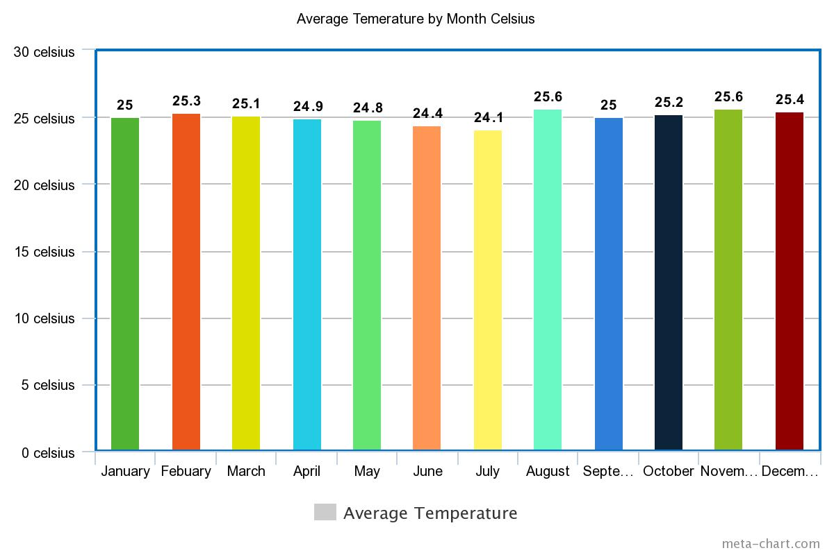

Precious Lands of the World
Analysing Data
Mathematics and humanities
LO: To be able to read and extract the correct data from a graph. To use number skills to make calclations from data.
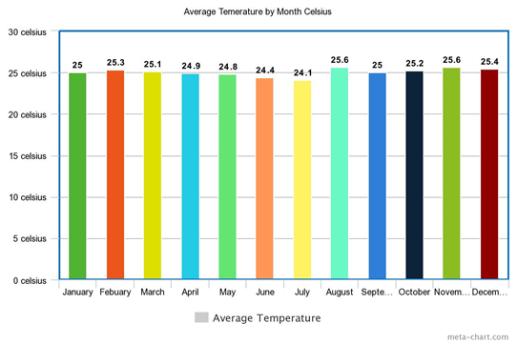

- In what month was the highest temperature recorded in the Amazon Raingores
- In what month was the lowest temperature recorded in the Amazon rainforest?
- What is the difference between the highest and lowest temperature in the Amazon Rainforest?
- Calculate the difference in temperature between the following months:
- January and December = degrees
- February and November = degrees
- March and September = degrees
- April and August = degrees
Average monthly temperatures for Cardiff
Jan Feb Mar Apr May Jun Jul Aug Sep Oct Nov Dec
8°C 8°C 10°C 13°C 16°C 18°C 20°C 20°C 18°C 14°C 11°C 8°C
- 1) In what month was the highest temperature recorded in the Cardiff?
- In what month was the lowest temperature recorded in the Cardiff?
- What is the difference between the highest and lowest temperature in the Cardiff?
- Calculate the difference in temperature between the following months:
- January and December = degrees
- February and November = degrees
- March and September = degrees
- April and August = degrees
Our Precious World
Deforestation – Mathematics and Humanities
LO: To apply understanding of coordinates to identify those areas where deforestation is taking place and impacting negatively on our world. To use map reaing and atlas skills to identify different countries.
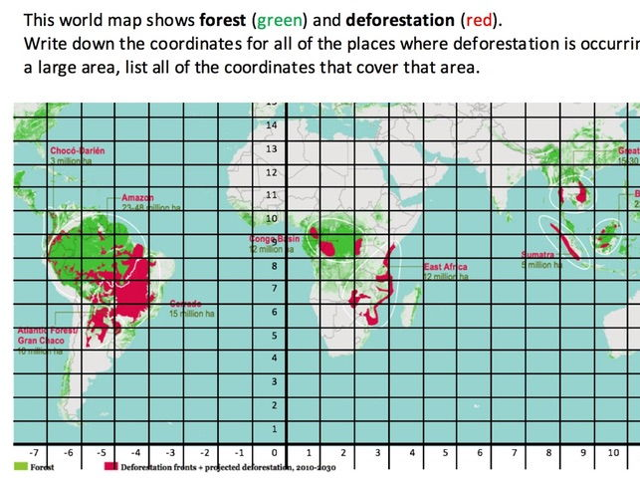

Name of country | Coordinates

Our Precious World
How are the Rainforests formed? Information technology research task.
LO: To be able to use a variety of resources to explain how the rainforests of the World are formed. To respond to my research in my own words.
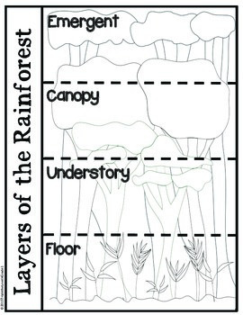

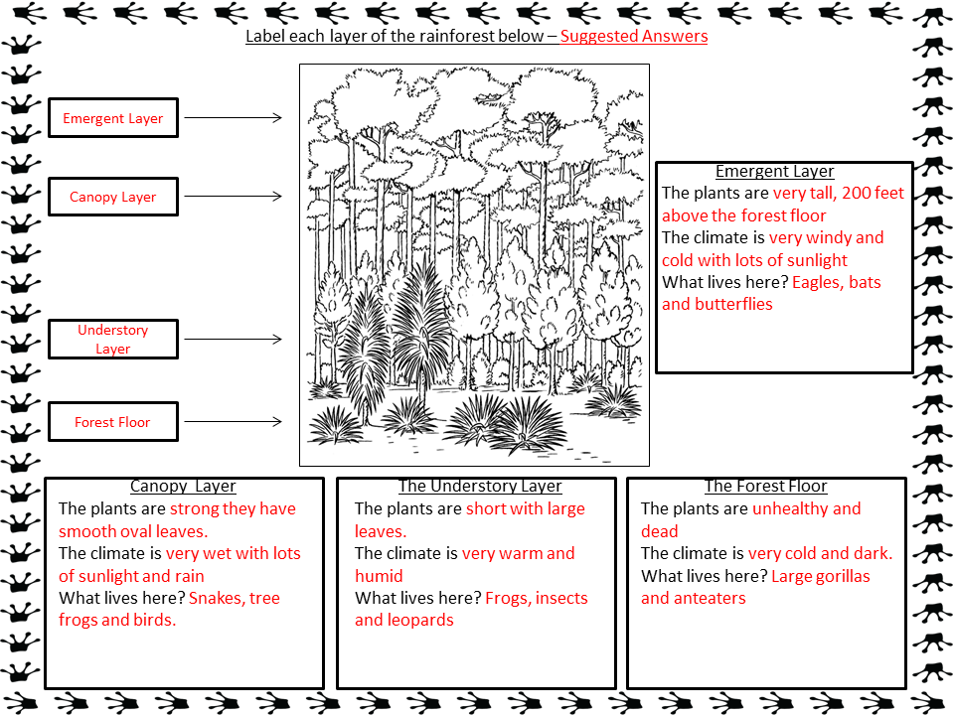

Our Precious World
Classifying Animals (Science)
LO: TO classify the animals of the rainforest
Introduction: Watch a PPT on the different groups of animals.

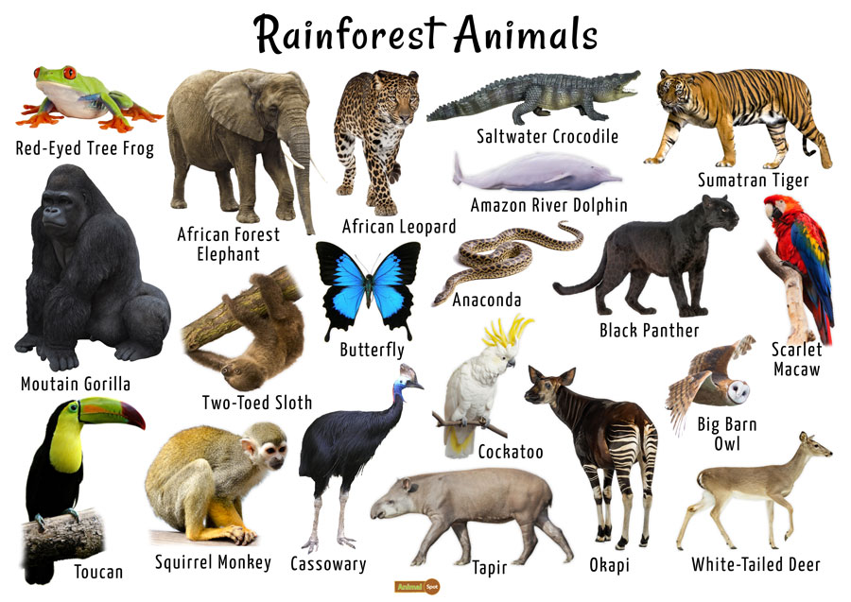
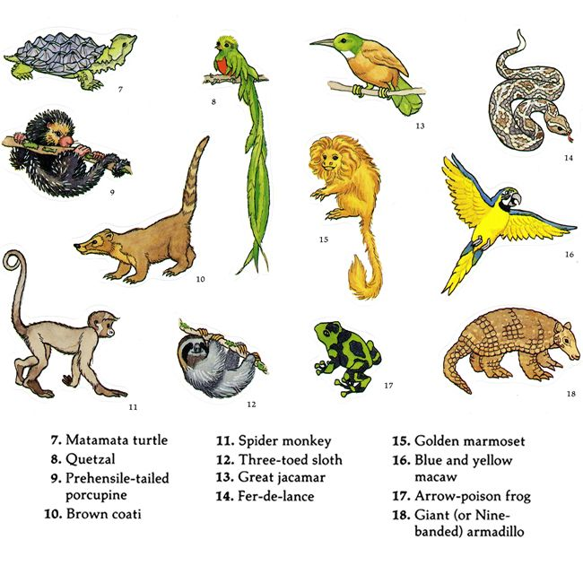
Extension: To use IT skills to research the rainforest animal that you most like. Ensure that you use a variety of resources to find out about your chosen animal. Remember you must respond to what you read in your own words.

Our Precious World
Deforestation
LO: To apply reading comprehensions skills to learn about what is meant by deforestation and what effect it is having on the rainforests of the world.
Watch PPT (Activity 8) on what deforestation means and what it is doing to the rainforests of the world

Our Precious World
GGR
Comparative Writing
LO: To use my reading comprehension skills to extract information from a text.
LO: To produce a piece of comparative writing.
LO: To use evidence to support opinions and draw conclusions.
Why do some people think it is necessary to cut down parts of the rainforest? What should we do?
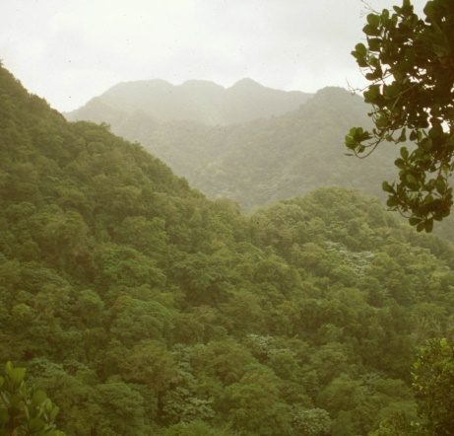
This is a Rainforest in Brazil, and there are plans to chop down a large section of these trees. Below are some reasons why people might be in favour of this happening.
- The rainforests cover a large area, and as population grows, people need somewhere to live. Cutting down trees can make room for new homes, roads and schools.
- The cleared areas could also be used for Hotels and other tourist attractions which would bring jobs and money to the local area.
- People who live in rainforests may clear small areas to grow food in.
- Wood from the trees which have been cut down can be used to build many different things such as homes and furniture
- It can be made into card and paper which has a variety of uses for everyone from toilet paper to birthday cards.
- Wood can be burned in fires to cook food, use as lights or to keep people warm.
- The wood timber and construction industries give jobs to many local people who would struggle to survive if they no longer had a job.

GGR
Comparative Writing.
LO: To use my reading comprehension skills to extract information from a text.
LO: To produce a piece of comparative writing.
LO: To use evidence to support opinions and draw conclusions.
Why do some people think it is necessary to cut down parts of the rainforest?
Why do some people think it is wrong to cut down parts of the rainforest? What should we do?

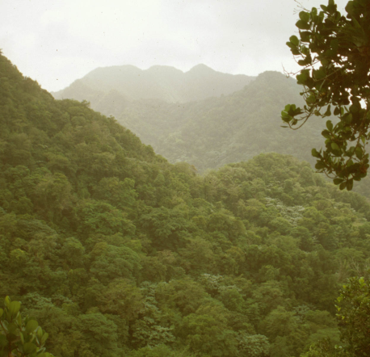
This is a Rainforest in Brazil, and there are plans to chop down a large section of these trees. Below are some reasons why people might be against this happening.

- People live in the rainforests and they may lose their homes and their way of life if trees around them are cut down. Being re-homed in a city wouldn’t be the same.
- Many different plants and animals exist only in rainforests, and if they no longer have a place to live their species is at risk of becoming extinct.
- 20% of the Oxygen we breathe in produced in the Amazon rainforest, and we need this Oxygen to survive.
- Many plants used in medicines have been found in rainforests. If we destroy the rainforests we could destroy life-saving medicines.
- There are other things which people can use for light and heat without having to burn wood on a fire. Electricity doesn’t fun out but trees might!

GGR – Classifying information.
Deforestation
LO: To classify information on deforestation as positive and negative.
What’s happening to rainforests?

Introduction

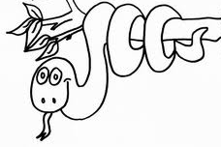
Rainforests are found in 80+ countries around the equator (where the sun’s hottest). They are homes to trees, plants, animals and local people. They are important in keeping the Earth’s climate as we know it. They do this by: a) releasing moisture into the atmosphere which forms rainclouds which are carried by the winds to other countries where they, for example ‘feed’ the crops b) removing carbon dioxide, storing the carbon in their trunks and releasing the oxygen that we breathe.

What’s happening to rainforests?

Every year about 13 million hectares of rainforest are lost worldwide – the same as 8.5 million football pitches a year, or 23,483 pitches a day! The images below show the extent of deforestation (cutting down and removal of forests) in Borneo, Asia as the rainforest size (shaded areas) decreases:
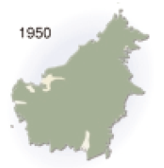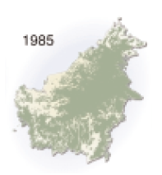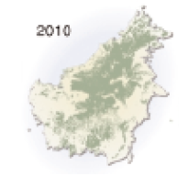

Why is this happening?

Around the world, rainforests are being cut down and burnt a process called ‘slash and burn’. But why is this occurring?

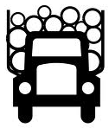
- Subsistence farming – local people may cut down parts of the rainforest in order to make land, for example, to grow food crops and graze cattle for personal or local consumption.

- Logging – trees cut down to provide wood for making paper, furniture or burning, for example. Hardwood, such as mahogany, is particularly good. Attempts to conserve forests are undermined by illegal logging.

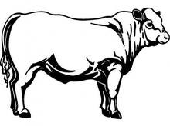
- Infrastructure building – governments may demolish parts of the rainforest in order to build road networks which aim to connect towns and villages and aim to improve the livelihoods of their people.

- Cattle farming – In order to make space to rear cattle, farmers cut down large parts of the rainforest. Why? Because cattle farming for the production of beef is big business! In Brazil, which is the world’s largest beef exporter, around 70% of the area deforested is now cattle pasture. Restaurants, such as McDonalds, rely on this meat for their hamburgers. But, Cattle ranching in Brazil is estimated to have emitted the equivalent of some 9 to 12 billion tons of CO2 over the last decade. This is a huge amount, roughly equivalent to two years’ worth of greenhouse gas emissions from the United States.

All bad? No. These activities can provide jobs for local people and boost the country’s economy through the selling abroad (export) of beef, for example.

What is the impact of this?

Losing the rainforests is a serious concern and could mean:

- Loss of many of the world’s plants and animals – some 137 species of plants, animals and insects are wiped out every day as a result of rainforest destruction.
- Local people lose their homes and cultures – indigenous people, such as Amazonian tribes, are forced to leave their homes following deforestation which can bring an end to their traditional way of life.
- The environment suffers - rainforest trees and plants remove carbon dioxide from the atmosphere, a main global warming gas, and release oxygen. Therefore removing trees, for example, affects climate change.

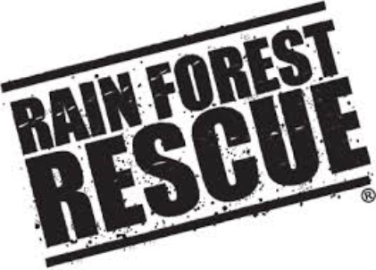

How can careful management protect the fragile rainforests?

Sustainable development involves meeting the needs of the current generation (you and me) without stopping future generations (your children) from meeting their needs. For example, if you cut down a rainforest and do not replant it, then your children will not be able to enjoy that rainforest when their time comes.

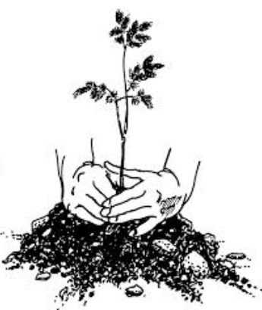
Campaigners, politicians and environmentalists have therefore come up with 4 strategies to try and protect the rainforest. These are the types of things that Prince Charles would approve of:

- Replace – when trees are cut down for their wood e.g. for Mahogany to make furniture, you replant the trees so they’ll grow again for future use

- Logging quotas – it would be impractical to ban all logging in all rainforests but by introducing limits on the amount of logging

- Protect – you could protect particularly fragile areas by introducing laws to protect certain areas e.g. by outlawing unsustainable logging/farming practises

- Alternatives - give local people alternative land to farm or ways of making money so they do not need to cut down the rainforests in order to create land on which to farm.

- State and explain 2 reasons why rainforests are important (4 marks)
- What is meant by ‘slash and burn’? (1)
- State and explain 3 reasons why rainforests are being destroyed (6)
- What does ‘deforestation’ mean? (1)
- Who might benefit from the removal of rainforests and why? (3)
- State and explain 3 negative impacts of rainforest removal (6)
- Explain 2 ways in which you could carefully manage a rainforest in order to sustainably protect it for future generations (4)
Our Precious World
Design Technology
LO: To design and make a T shirt to advertise what is happening to the rainforests of the World. Apply learning to inform your design.

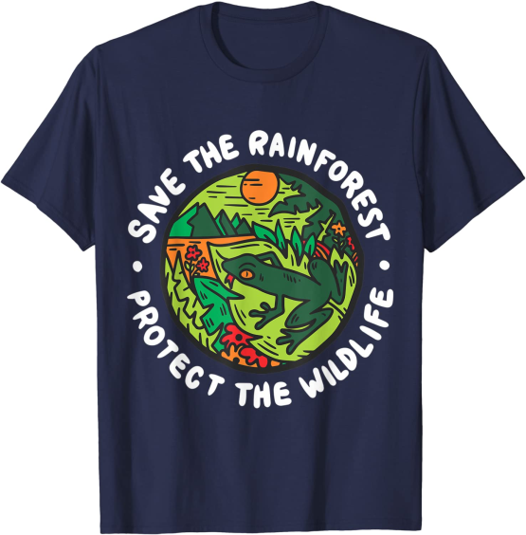

Deep in the Rainforest
Responding to Poetry
LO: To extract meaning from a poem. To be able to analyse a poem.
Deep in the rainforest, deep in the rainforest,

What did I see? What did I see?

I saw a parrot soaring up high

And a monkey swinging from tree to tree.

Deep in the rainforest, deep in the rainforest,

What did I hear? What did I hear?

I heard a tiger with a grumbling growl

And the whizzing sound of a hunter’s spear.

Deep in the rainforest, deep in the rainforest,

What did I smell? What did I smell?

I smelled the scent of a bright pink flower

And the hot damp smell of trees as well.

Deep in the rainforest, deep in the rainforest,

What did I feel? What did I feel?

I felt the spiky leaves on a bush

And the smoothness of banana peel.

Deep in the rainforest, deep in the rainforest,

What did I taste? What did I taste ?

I tasted many juicy fruits

And my sandwiches with cold meat paste.

Deep in the rainforest, deep in the rainforest,

What did I do? What did I do?

I crept along so quietly

I crept along so quietly

I crept along so quietly

And that’s when I bumped into YOU!

Responding to Poetry
Rainforest Poem
GGR
LO: To extract meaning from a poem. To be able to analyse a poem.
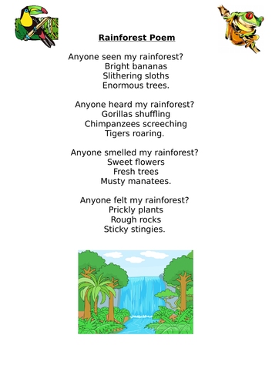

Responding to Poetry
Rainforest Poem A
GGR
LO: To extract meaning from a poem. To be able to analyse a poem.

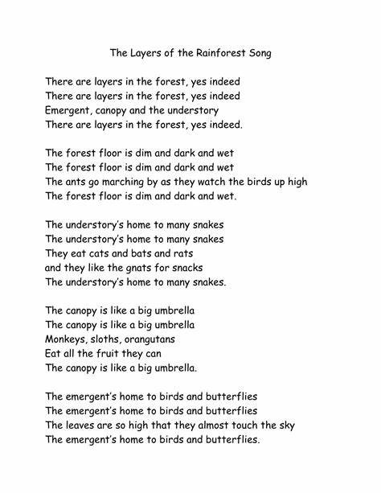

Our Precious World
Biodeversity
Map reading skills
LO: To use map reading skills to identify the location of plants that grow in the different rainforests of the world.

Plants of the Rainforests Draw a line from the plants below to their regions – use an atlas to help you find the places

