Archdiocese of Cardiff

Planning and Leading Worship
1. Introduction


Gweddïwn – Let Us Pray

A resource to support pupils in planning
and leading a daily act of worship

Contents  Planning and Leading Worship  1. Introduction | Page
Acknowledgements | 4
The Daily Act of Worship – An Introduction | 5
About the Resource | 7
Contents of the Resource | 10
Planning template for pupils | 11
Liturgical Calendar | 12
Special Days during the School Year | 13

Material to support pupils in the primary school in preparing
and leading the daily act of worship in the classroom.

A resource originally created by Laura Taylor under the auspices of the Archdiocese of Cardiff Department of Religious Education (Schools) in September 2011 and reviewed by a working party in February 2018.

Acknowledgements

With thanks to:
Laura Taylor, St Joseph’s Catholic Primary School, Penarth
Ciara Flynn, St Philip Evans Catholic Primary School, Cardiff
Katie Sherwood, St Philip Evans Catholic Primary School, Cardiff
Laura Davies, St Philip Evans Catholic Primary School, Cardiff
Rosie O’Donnell, Our Lady of the Angels Catholic Primary School, Cwmbran
Ceri Prosser, Our Lady of the Angels Catholic Primary School, Cwmbran
Sarah Euden, St Patrick’s Catholic Primary School, Newport
Catherine Dowding, St Michael’s Catholic Primary School, Newport
Fiona Rein, St Mary’s Catholic Primary School, Newport
Sarah Lewis, St Robert’s Catholic Primary School, Aberkenfig
Nicola Long, St Mary’s Catholic Primary School, Merthyr Tydfil
Clare Heathfield, St Bernadette’s Catholic Primary School, Cardiff
Mary McCarthy, Our Lady and St Michael’s Catholic Primary School, Abergavenny
Richard Sullivan, St Cadoc’s Catholic Primary School, Cardiff
Sue Miles, Christ the King Catholic Primary School, Cardiff
Helen Keegan, Christ the King Catholic Primary School, Cardiff
Gemma Carpanini, Ss Gabriel and Raphael Catholic Primary School, Tonypandy

The Daily Act of Worship

Introduction

Prayer is the means by which we are drawn into a deeper and more loving relationship with God and with all of God’s creation.

The legal requirement for schools
The legal requirement (Section 70 of the 1998 Education Act) is that ‘subject to the parental right of exclusion or other special arrangement each pupil in attendance at a community, foundation or voluntary school shall on each school day take part in an act of collective worship.’

The purpose of the daily act of worship and its benefits
It is a time to:
- Give honour and glory to God, to thank him, to listen to him, to ask for and receive forgiveness, to place our own needs and the needs of others into his hands.
- Be inspired by the Person of Jesus Christ through listening to his Word.
- Respond to and celebrate life.
- Reflect on spiritual and moral issues.
- Explore and express belief.
- Experience a sense of belonging and for the school community to develop a common ethos and shared values.
- Take time ‘to wonder at’, ‘to come to terms with’ and ‘to give worth to’
- Develop a sense of well-being and outreach to others.
- Develop skills such as reverence, reflection, interpretation and contemplation.

What is considered good practice?
- A ‘sacred space’ is created through a focal point, music, lighting etc. to remind us of the presence of God.
- Scripture, the Word of God, is given prominence.
- There is a clear theme and message. Opportunity is taken through the choice of themes for the pupils to become familiar with the traditions, customs and practice of the seasons and feasts of the Church and topics relevant to pupils’ lives are reflected upon in the context of the Word of God and the teachings of the Church.
- The process of Gathering, Listening (Word), Responding (Prayer and symbolic action), and Mission is a general guide to structure (see below).
- Silence is used effectively to allow time for thought, prayer and reflection.
- There is effective use made of music.
- It is a learning experience but the focus is on worship and not on teaching.
- Gathering and leaving is conducted appropriately.
- There is evidence of a variety of approaches: telling a story, describing a situation or event, using images, special objects, dance, drama, music etc.
- There is opportunity for individual and communal prayer in a variety of forms e.g. spontaneous, litany, intercession, meditation, traditional etc.
- Opportunity is taken to use liturgical responses and actions.
- It encourages thinking about the needs of others.
- It affirms relationships and provides the opportunity for the collective sharing of joys and sorrows.
- It helps to promote a common ethos and shared vision.
- Language used is suitable for the age group.
- There is a direct link between faith and everyday life.
- The act of worship is separated from administration.
- The senses are engaged.
- It affirms relationships and provides opportunity for the collective sharing of joy and sorrow.
- Adults are good role models.
- When practical, other adults/parents are invited to share (not simply observe) in the time of worship.
- Where pupils not only lead acts of worship but are skilled in preparing acts of worship.
- Where there is evidence of the planning and evaluation of provision.

The daily act of worship: a guide to the process

Gather Word (Listen) Response Going Forth

- Preparation: When, where, who, what? What resources will I need? Create a focus.
- Gather: How will we begin? How will I create an atmosphere of prayer?
- Word: What will be the scripture focus and decide how to present it.
- Response: What will we do in response to listening to God’s Word e.g. prayer and symbolic action.
- Going Forth: What will I do to help the pupils take the message away with them?

Monitoring and evaluating the daily act of worship
- Was the main emphasis on worshipping God?
- Have pupils been involved in the planning, preparation and leading of the act of worship?
- Was a ‘sacred space’ created using a prayer focus related to the theme, music, images, objects etc?
- Were pupils actively involved in the worship?
- Were a variety of approaches used e.g., story-telling, use of images, drama, music etc?
- Was a time of silence given for pupils to think, reflect and pray?
- Were the pupils respectful and reverent?
- Did the act of worship follow a liturgical structure e.g., Gathering, Listen, Response and Going Forth?
- Was prominence given to the Scriptures as the Word of God?
- Was the language used suitable for the year group?
- Was the worship linked to everyday life e.g. joys and sorrows, a special event, world matters etc?
- Was the Church’s liturgical year recognised and celebrated?
- Were the pupils encouraged to think about the needs of others?
- Were prayers from Catholic tradition used?

About the resource
Rationale
- There is an expectation that pupils plan and lead daily acts of worship.
- This is highlighted in the Cardiff Archdiocesan Inspection Framework (2010) through statements such as
1.4: to what extent pupils/students are acquiring skills in planning and leading prayer and worship.
- Pupils need support to understand the aspects that make up an act of worship and some examples of what could be created.

The Resource – aims
- To provide pupils with the tools to plan and lead a daily act of worship.
- To provide meaningful themes for the act of worship.
- To provide resources to ensure pupils know the traditional prayers of the Church that are expected of them at the primary age group.
- To provide Welsh prayers and phrases which could be used in the daily act of worship.
- To provide examples of pupils planning and leading the daily act of worship in the classroom setting.

The Resource – important notes
- This resource is a tool kit for staff and pupils. It should be used as best fits the needs of the school; changed, adapted and developed where necessary.
- The resource is most suitable for use in a classroom/group prayer setting, on occasions when there is not a school/key stage act of worship during the day.
- Excluding the time needed to give the pupils the opportunity to plan the act of worship, it should last approximately 10 minutes and can be shared with the pupils at any point during the school day.
- The resource provides pupils with ideas to choose from, in order to fulfil the requirements of an act of worship to ‘Gather’, listen to God’s ‘Word’, ‘Respond to the Word’ and allow pupils to take the message away with them – their ‘going forth’ or ‘mission’. It is hoped that as pupils develop in confidence with planning acts of worship, using the correct structure, they will begin to think of their own ways that they would like to e.g. gather or respond to the Word and additional cards can be made.
- It is the teacher’s responsibility at the outset, when using this resource, to provide pupils with the sacred space, setting and environment (e.g. the correct liturgical coloured cloth, a focal point etc) – this does not mean that the pupils cannot create the sacred space themselves, but this is something extra that needs to be taught. Teachers will find a suggested Gweddïwn ‘planning pack’ and ‘resource list’ in the planning and preparation folder of the resource.

The Resource – Before you begin!
- The main resource cards for Gather, Response to the Word and Going forth are generic for all acts of worship. These resources can be printed off the disk and laminated and cut into sections for longevity. These could be placed in envelopes, boxes or on an interactive display using e.g. Velcro, for the pupils to manoeuvre. It is at the teacher’s discretion whether they give all ‘cards’ to the pupils at once or a selection each time an act of worship is planned.
- There are also additional ‘Response to the Word’ cards for different seasons in the Church’s year.
- The appropriate ‘Word’ documents can then be either printed off or used on the computer for the pupils to choose. Alternatively, pupils may choose a scripture reading from the Bible or a resource such as God’s Story.

The Resource – how it could be used
- A group of 4 pupils could be selected to choose one or two cards from each of the ‘sections’, creating an act of worship under the headings:
    - Gather
    - Word
    - Response to the Word
    - Going Forth
- Pupils need time to plan the worship the day before to give teachers time to collect the resources chosen.
- The pupils/Teaching Assistant/Teacher (as scribe) complete the ‘Daily Act of Worship plan’ and evaluation, depending on the pupils’s age and ability.
- As the pupils develop in confidence, they can begin to create their own ideas for the Gather, Response and Going Forth sections which are linked to the chosen Word.
- At a convenient time during the school day, the teacher, along with the pupils leading the worship, sets the sacred space and invites the chosen group of pupils to lead the act of worship – of course, teachers may be called upon to read the ‘Word’ (depending on the age of the pupils), link sections together, ensure pupils are being prayerful etc. but the pupils chosen to plan the act of worship should have a sense of ownership. To support pupils in leading the worship more independently, additional support materials such as a prompt card, tick list and script were added to the resource in March 2018.
- Planned Acts of worship will be evident through the ‘Pupil Planning and Evaluation’ proforma, but use of photography, video, ‘photostory’, PowerPoint and others, could also be of advantage and photographs could be used in the classroom prayer area as a reminder of the acts of worship the pupils have planned. (Please see the folder entitled ‘Examples of Pupil Planned Prayer’ for a few examples of completed proformas and photographs.)

Additional Resources
- The Disk also contains printable traditional prayers which are important for pupils at each stage of the primary school setting to know. These also include responses and prayers said at Mass.
- Welsh prayers adapted from Canllaw Addoliad i Ysgolion Catholig (2011) are also available for use by pupils and teachers.
- A list of suggested hymns for each of the themes explored in the resource as well as QR codes for some of the suggestions.

Recommended Resources
Below is a list of recommended resources which have been used to create this resource:
  - God’s Story and Church’s Story Books and CD –ROM (2002), Rejoice Publications, Matthew James Publishing Ltd, Essex.
  - Canllaw Addoliad i Ysgolion Catholig (2011)– A Worship Resource for Catholic Schools, Archdiocese of Cardiff.
  - Praying with Pupils some ways and means (1995), Jenny Pate, Diocese of Lancaster, McCrimmon Publishing Co. Ltd, Essex
  - Spiritual Garments– A handbook for preparing liturgical assemblies in schools (2006), Julie McCann, Decani Music Ltd, Suffolk.
  - Guided Meditations for Pupils (2002), Jane Reehorst BVM, Harcourt Religion Publishers, Florida.
  - Jumping Fish - Pause for Reflection, Pause to Reflect on Values, Christian Symbols, Resourcing Easter, Resourcing Christmas, Resourcing Summer(2004) produced by Education Advisers for Dioceses in South West of England for The Church of England, Jumping Fish Publications, Gloucester.
  - Pupils of the Promise (1995), Sister Judith Russi, Hodder and Stoughton Educational, London.
  - Here I Am – A Religious Education programme for primary schools (2000) Department for Catholic Education and Formation, Bishops’ Conference of England and Wales, HarperCollins Publishers.
  - Come and See – A Catholic Primary Religious Education programme for Foundation and Key Stages 1 and 2 (2012); Victoria Hummell; Matthew James Publishing Ltd, Essex.

Contents of the resource

Introduction
- Daily act of worship template
- An overview of Gweddïwn – the resource
- The Daily act of worship – introduction
- Liturgical year poster
- List of special days in the school year.
- Examples of pupil planned prayer
Planning and Preparation
- Suggested Gweddïwn ‘planning pack’
- Suggested Gweddïwn resource list
- Gweddïwn planning prompt card
- Gweddïwn preparation tick list
- Gweddïwn script
- List of suitable hymns
- QR codes to hymns
- Posters of Welsh phrases which can be used in collective worship
Resource cards
- Gather
- Word
- Response to the Word (including prayer, symbolic action and ideas for responding to the Word outdoors as well as cards specific to the Church’s liturgical year such as Advent, Christmas, Lent, Holy Week, Easter and Pentecost and additional themes and feasts)
- Going forth (including cards which reflect the Catholic Pupil Profile)
Additional prayer materials
- Prayers for Nursery and Reception
- Prayers for Years 1 and 2
- Prayers for Key Stage 2
- Prayers in Welsh
- Other prayers

Date: | Class:  Names of the children who have planned and led the session:
Gather

Word

Response to the Word – Prayer/Symbolic Action

Going forth

What the children thought….

Liturgical Calendar
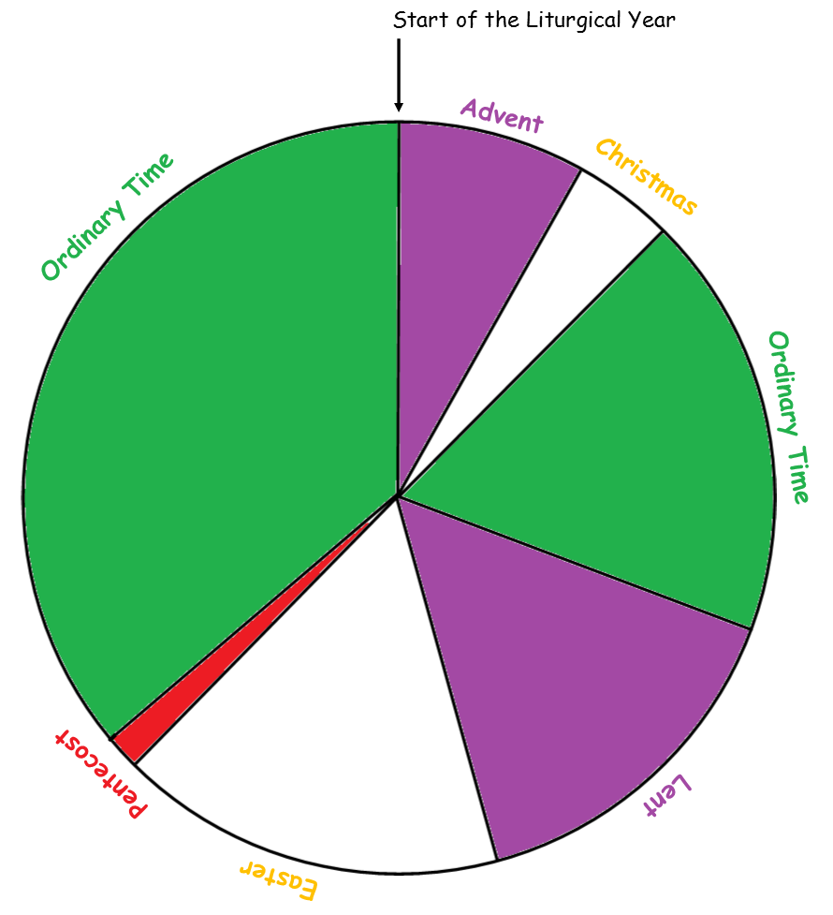
Ordinary Time
Lent and Holy Week
Advent
Penitential Services
All Souls
Funerals
Christmas
Epiphany
Easter
All Saints
Other Saints Days (Saints who are not martyrs)
Pentecost
Martyrs
Apostles
For further guidance, please check the ORDO section in your Diocesan Year Directory or visit www.liturgyoffice.org.uk/Calendar

Special Days during the School Year
Feasts and Special Days in the School Year

September

Date | Feast / Special Day
September 3rd | St Gregory the Great
September 8th | Nativity of Blessed Virgin Mary
September 8th | Nativity of Blessed Virgin Mary
September 9th | Education Sunday
September 14th | Exaltation of the Holy Cross
September 15th | Our Lady of Sorrows
September 21st | St Matthew (Evangelist)
September 24th | Our Lady of Ransom
September 27th | St Vincent de Paul
September 28th | St Wenceslaus
September 29th | Sts Michael, Gabriel and Raphael – Archangels
September 30th | St Jerome

October

October is the month of the Holy Rosary. We celebrate the feast of Our Lady of the Rosary on the 7th.
Teach the children how to use Rosary beads to count their prayers. Older children should know the prayers used in the Rosary and the names of the Mysteries.

Date | Feast / Special Day
1st Friday in October | CAFOD Harvest Fast Day
October 1st | St Thérèse of the Child Jesus
October 2nd | The Guardian Angels
October 4th | St Francis of Assisi
October 7th | Our Lady of the Rosary
October 9th | Blessed John Henry Newman
October 15th | St Teresa of Jesus (Avila)
October 16th | St Richard Gwyn
October 18th | St Luke (Evangelist)
October 25th | The Six Welsh Martyrs and Companions
October 28th | Sts Simon and JUde
October 31st | Vigil for All Saints Day.

November

November is our month for commemorating those who have died.

Date | Feast / Special Day
November 1st | All Saints Day
November 2nd | Commemoration of All the Faithful Departed  (All Souls Day)
November 3rd | St Winefride
November 6th | St Illtud
November 8th | All the Saints of Wales
November 9th | Dedication of the Lateran Basilica
November 14th | St Dyfrig
November 21st | Presentation of the Blessed Virgin Mary
November 22nd | St Cecilia
November 28th | ACN Red Wednesday
November 30th | St Andrew, Apostle
Last Sunday in Ordinary time | Christ the King

December

Advent is a time of expectation for the second coming of Christ at the end of time and preparation to celebrate the birth of Christ at Christmas.
Date | Feast / Special Day
December 3rd | St Francis Xavier
December 6th | St Nicholas
December 8th | Immaculate Conception of the Blessed Virgin Mary
December 10th | St John Roberts
December 13th | St Lucy
December 14th | St John of the Cross
December 27th | St John
December 28th | Holy Innocents

Liturgically, the Christmas season extends to the feast of the Baptism of the Lord, the Sunday after the Epiphany.

January

Date | Feast / Special Day
January 1st | Mary, Mother of God
January 6th | Epiphany
Sunday after the Epiphany | Baptism of our Lord
January 18th – 25th | Week of Prayer for Christian Unity
January 25th | Conversion of St Paul
January 28th | St Thomas Aquinas
January 31st | St John Bosco

February

Date | Feast / Special Day
February 2nd | Presentation of the Lord (Candlemas)
February 3rd | St Blaise
February 9th | St Teilo
February 11th | Our Lady of Lourdes
February 22nd | Chair of St Peter

Lent begins with Ash Wednesday and features in the second half of the Spring term. Prayer corners should now be very stark (e.g. no flowers) but with a focus to remind us that this is Lent (e.g. a cross of twigs, a crucifix etc) CAFOD Lent Fast Day is on the Friday of the first week in Lent..

March

Date | Feast / Special Day
March 1st | St David
Friday of the 1st Week in Lent | CAFOD Lent Fast Day
March 17th | St Patrick
March 19th | St Joseph
March 25th | The Annunciation

Easter – there should now be a sense of celebration and joy in the Resurrection. White and gold should be used as well as flowers, candles and banners and the word ‘Alleluia’ for decoration.

Important days include
      - Ascension Thursday
      - Pentecost Sunday.

April

Date | Feast / Special Day
April 23rd | St George
April 25th | St Mark (Evangelist)

May
May is the month dedicated to Our Lady.

Date | Feast / Special Day
May 1st | St Joseph the Worker
May 3rd | St Philip and St James (Apostles)
May 4th | Blessed Martyrs of England and Wales
May 13th | Our Lady of Fatima
May 14th | St Matthias
May 25th | St Bede the Venerable
May 31st | The Visitation of the Blessed Virgin Mary

June
Important days include:
    - Trinity Sunday (the Sunday after Pentecost),
    - The Body and Blood of Christ (Corpus Christi)
    - Sacred Heart of Jesus (the Friday after the Second Sunday of Pentecost)

Date | Feast / Special Day
June 20th | Sts Alban, Julius and Aaron
June 22nd | Ss John Fisher and Thomas More
June 24th | Nativity of St John the Baptist
June 29th | Sts Peter and Paul (Apostles)
June 29th | MISSION TOGETHER – Day of Many Colours

July

Date | Feast / Special Day
July 11th | St Benedict
July 12th | St John Jones
July 23rd | Sts Philip Evans and John Lloyd
July 26th | Ss Joachim and Anne

