Archdiocese of Cardiff

Planning and Leading Worship
2. Planning and Preparation


Gweddïwn – Let Us Pray

A resource to support pupils in planning
and leading a daily act of worship

Contents  Planning and Leading Worship  2. Planning and Preparation | Page
Gweddïwn Script | 4
Gweddïwn Prompts | 5
Gweddïwn Ticklist for pupils | 6
Suggested hymns | 7
Welsh in Collective Worship | 9
Planning Pack list | 10
Resources list | 11

Gweddïwn Script
Gather
“Today we will be thinking about _____”
“We will gather today by______”

“Mae’n amser Gweddi. It’s time to pray.”

“Please make the sign of the cross.”
Or
“Gadwech I ni wneud arwydd y groes.”

Say a prayer you know.
Word
“Now we will listen to the word of God.”

“A reading from the Gospel of______”
Everyone: “Glory to you, O Lord.”
or
“A reading from the book of______”

(Read the word)
“The Gospel of the Lord”
Everyone: “Praise to you Lord Jesus Christ.”
or
“The word of the Lord”
“Everyone: Thanks be to God.”
Respond
“Today’s reading was about…”

“Let us think about what this means to us.”

“Next we will…” (read out the action on the card)
Going Forth
“Let us go in the peace of Christ.”

Everyone: “Diolch I ti O Dduw.”
(Everyone will make the sign of the cross.)
Gweddïwn Prompts
Gather
Share how you will gather.
What will you say to welcome other children?
How will you share the theme/focus of the Gweddïwn?

“Mae’n amser Gweddi. It’s time to pray.”

“Please make the sign of the cross.” Or “Gadwech I ni wneud arwydd y groes.”

What traditional prayer or psalm will you say together?
Word
How will you acclaim the Gospel if you are using a Gospel reading? (Stand up, sing, Bible procession)

How will you show the Bible is a special book? (if you are not reading from the Gospel)

“A reading from the Gospel of______”
Everyone: “Glory to you, O Lord.”
or
“A reading from the book of______”

(Read the word)
“The Gospel of the Lord”
Everyone: “Praise to you Lord Jesus Christ.”
or
“The word of the Lord”
“Everyone: Thanks be to God.”
Respond
How will you explain what has been read?
How will you reflect on the word?

How will you share the response to the word?
Going Forth
How will you share your Mission to other children?
What should they do? Why should they do it?
How will you leave the sacred space prayerfully?

“Let us go in the peace of Christ.”

Everyone: “Diolch I ti O Dduw.”

(Everyone will make the sign of the cross.)

Gweddïwn Ticklist
What I need to do | I’ve done it!
- Have we chosen how to gather, the word, how to respond and how to go forth?
- Have we created a sacred space (e.g. candles, cloth, music, statues, does everything work?)
- Does everyone in the group have something to do?
- Do we have everything we need for each part? (e.g. prayer stones, instruments, bible, water, music)
- Do we understand what the scripture means so we can tell others
- Do we know what to say? Have we prepared our script?
- Have we shown our plan to our teacher?

Suggested Hymns:
Some QR codes are available on the website
The numbers below refer to the Laudate hymnbook. For details of other resources contact
r.e.assist@rcadc.org

Theme | Suggested hymns
Domestic Church – Family | Circle Song (Share the Light)  I am special (Share the Light)  Let us build a house (no. 458)  Everyday God (Bernadette Farrell)  O God you search me and you know me (no. 779)  Father I place into your hands (no. 971)  O the word of my Lord (no. 979)  I will never forget you (no. 796)  Be still and know I am with you (no. 968)
Sacraments of Initiation – Baptism and Confirmation | There is someone who knows me (Share the Light)  You have called us by our name (no. 476)  Because the Lord is my shepherd (no. 948)  O Living Water (no. 931)  Brother, sister, let me serve you (no. 924)  Christ be beside me (no. 910)  You are salt of the earth (no. 854)  Longing for light (no. 883)  I, the Lord of sea and sky (no. 865)  Will you come and follow me (no. 877)  Come, Lord Jesus, come (no. 873)
Mary | As I kneel before You (no. 360)  My soul is filled with joy (no. 339)  Holy virgin by God’s decree (no. 366)  Magnificat (Taizé, no. 335)  Hail Mary (CJM Music)
November | Bless the Lord my soul (no. 813)  For all the saints (no. 371)  For all the saints who showed your love (no. 387)  O Lord my God (no. 721)
Advent | Christ be our light (no. 883)  Like a sea without a shore (no. 84)  O Come O Come Emmanuel (Enya)  Stay awake; be ready (no. 72)  Wait for the Lord (no. 88)  Promised Lord (no. 103)  The King of glory comes (no. 107)  The angel Gabriel (no. 113)  When the angel came to Mary (no. 114)
Christmas  Christmas continued | Away in a manger (no. 137)  Silent Night (no. 136)  Once in royal David’s city (no. 128)  O little town of Bethlehem (no. 127)  Infant holy (no. 138)  Come to the manger (no. 139)  O come all ye faithful (no. 159)  Go, tell it on the mountain (no. 164)  We three kings (no. 170)
Local Community | We are the Church (Christopher Walker)  Many are the light beams (no. 823)  Awake from you slumber (no. 824)  One bread, one body (no 832)  Here in this place (no. 475)  Let us build a house (no. 458)  Jubilaté, everybody (no. 471)  We come to share our story (no. 473)  You have called us (no. 476)  Laudaté omnes gentes (no. 478)
Teachings of Jesus | Listen to Jesus (Share the Light)  O the word of my Lord (no. 979)  Praise to you O Christ (no. 200)  Your words are spirit and life (no. 980)  Word of justice, alleluia (no. 64)
Eucharist | God’s greatest gift (Share the Light)  This is my body (no. 627)  Though we are many (Share the Light)  Take our bread we ask you (no. 605)  Bread of life (no. 631)  Taste and see (no 618)  Jesus, Lamb of God (no. 635)
Lent and Holy Week | From heaven you came (no. 749)  Led by the Spirit (no. 180)  Come back to me (no. 842)  Amazing Grace (no. 846)  Praise to you, Christ our saviour (no. 200)  We behold the splendour of God (no. 210)  As the deer pants (no. 965)  Where you there (no. 225)  Jesus, remember me (no. 253)
Easter | I danced in the morning (no. 765)  Alleluia, raise the Gospel (Bernadette Farrell)  This is the day (no. 465)  Alleluia, alleluia, give thanks (no. 268)  Sing to the mountains (no. 282)
Pentecost | The Spirit lives to set us free (no. 771)  God’s Spirit is in my heart (no. 864)  Spirit of the Living God (no. 306)  All over the world, the Spirit is moving (no. 984)  Spirit of God (no. 309)  Everyday God (‘Earth’s creator’) Bernadette Farrell
Mission  Mission continued | I will be with you (no. 866)  Follow me, Follow me (no. 863)  I, the Lord of sea and sky (no. 865)  Come, Lord Jesus, Come (no. 873)  Will you come and follow me (no. 877)  A new commandment (no. 920)  You have called us by our name (no. 476)  Make me a channel of your peace (no. 898)  Share the light (Share the Light)  Sing and Shout for Joy (Share the Light)  We sing your glory (Share the Light)  Walk with me O my Lord (no. 966)  Alleluia! Raise the Gospel (Bernadette Farrell)  You are salt of the earth (no. 854)  God’s spirit is in my heart (no. 864)  I will be with you (no. 866)  You shall go out with joy (no. 878)
June – month of the Sacred Heart | He’s got the whole world in his hands (no. 973)  Do not be afraid (no. 972)  Father, I place (no. 971)  O the love of my Lord (no. 967)  Be still, and know I am with you (no. 968)  Walk with me (no. 966)  As the deer pants (no. 965)  You who dwell (no. 952)  Because the Lord is my shepherd (no. 948)
Trinity | Father in my life I See (no. 317)  Everyday God (‘Earth’s creator’) Bernadette Farrell
Forgiveness | The Peace of God (Share the Light)  God of mercy (Share the Light)  Amazing Grace (no. 846)  God forgave my sin (no. 849)  Lay your hands (no. 432)  Come back to me (no. 842)  O Lord, all the world belongs (no. 847)
Universal Church | He’s got the whole world in his hands (no. 973)  All things bright and beautiful (no. 685)  One more step along the road I go  Thank you God for the gift of creation (Bernadette Farrell)  Many are the light beams (no. 823)  City of God (no. 824)  One bread, one body (no. 832)
Prayer at the beginning and end of the day | ‘We Shall Praise Your Name’ Twenty-five Biblical Prayers based on the Liturgy of the Hours. Published by OCP. Contains simple refrains, psalms, canticles, litanies, intercessions. Learn a sung greeting to open a liturgy, repeat a simple refrain throughout a season, sing a simple blessing.

Welsh in Collective Worship

The Canllaw resource contains a wealth of material. Use a complete template or
include simple phrases.
e.g. Mae’n amser gweddi. It's prayer time.

Planning Pack List

- White material
- Green material
- Purple material
- Red material
- Gather cards
- Response cards
- Go Forth cards
- Gweddïwn board (if applicable)
- Clip board
- Planning sheet
- White board pen
- Writing pen

To plan / deliver Gweddïwn children need access to:

- Music (iPad / similar)
- Paper
- Card
- Kett Resources (if applicable)
- Water
- Art / Craft Resources
- Clay
- Instruments

Resources List

Large Electric Candles  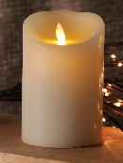 | Votive Electric Candles   | Rosary  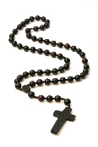
Cross  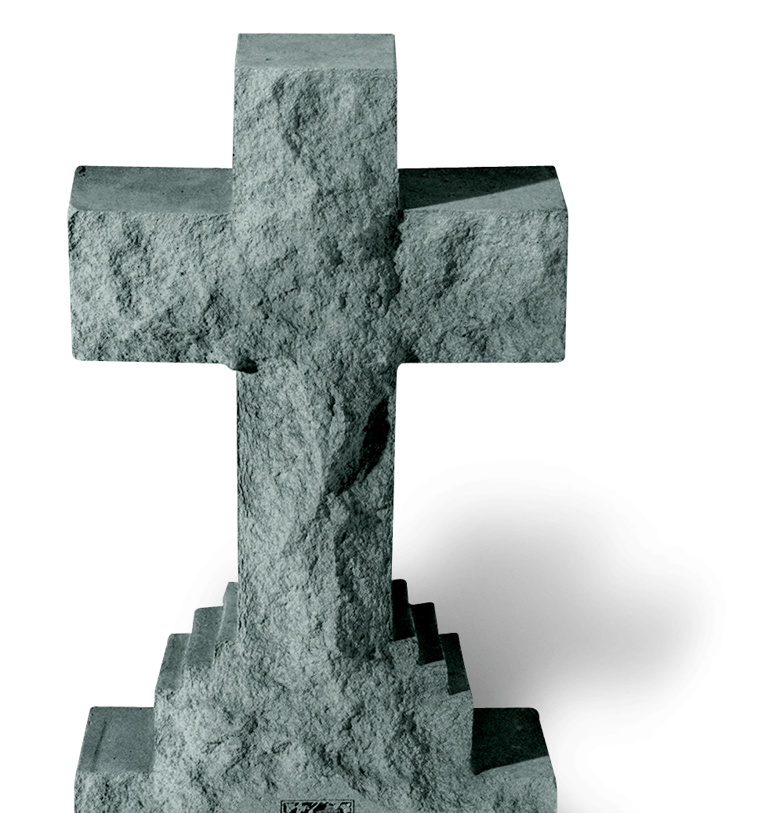 | Crucifix  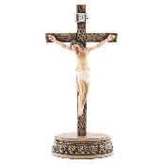 | Decorative Materials  
Sea shells  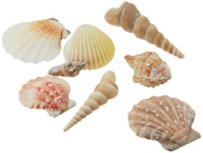 | Glass Stones   | Small Stones  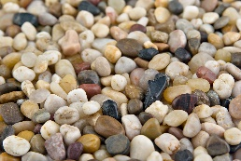
Large Stones   | Flowers  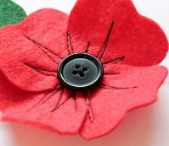 | Pictures  
Statues  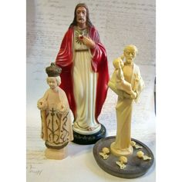 | Incense   | Pot pourri  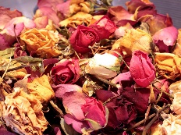
Bells / Triangle   | Meditation Chime  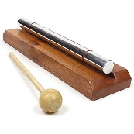 | Singing Bowl  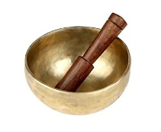
Plant Seeds   | Feathers   | Marbles  
Branches / Tree  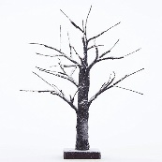 | Heart Shape Stone   | Leaves  

