Geddiwn – Dosbarth Gwynno 2023 – 2024 – Date: OCT 2023 Gweddiwn Group Members: Myles, Jacob and Iwinowsa
Gather: Introduction
Play reflective music as you gather in a circle.
Myles: Please sit in a circle, light our candles and remember that Jesus is the light of the world. Take it in turns to place our candles in the middle of our prayer focus (Gweddiwn Leader to make one rotation of the sing bowl between each child sitting)

Iwinosa: Mae’n amser gweddi. It’s prayer time.
Gadewch i ni wneud arwydd y groes:
Jacob: Let’s make the sign of the cross: Yn enw’r Tad a’r Mab a’r Ysbryd Glân, Amen.
Myles: Dwylo ynghyd, llygaid ar gau.
Hands together, eyes closed.
Iwinosa: Let us pray:

Gather: Opening Prayer
Jacob: Repeat after ‘This is Jesus the light of the World’ (Take your place in the circle.)
Child repeats. ‘This is Jesus the light of the World’ holding a candle As each child takes a place in the prayer circle. Separate each child with a rotation of the sing bowl.

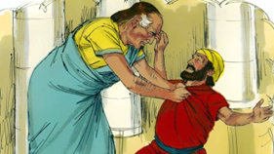
The Word of God

Myles: Llygaid ar gau a dwylo unhyd
iwinosa Close your eyes and imagine you are on a walk.
jacob: Picture the beauty of the place where you are walking.
Myles: Imagine that God joins you on the journey.
Iwinosa: What would you tell God?
jacob: What might God say to you? Listen now to God’s Word.
Introduction to the Reading.
Myles: The Lord be with you.
All children: And with your Spirit
Iwinosa: A reading from the Holy Gospel of Luke
All: Glory to you o Lord
^{“21 “}Then Peter came to him and asked, “Lord, how often should I forgive someone who sins against me? Seven times?”
²² “No, not seven times,” Jesus replied, “but seventy times seven!
²³ “Therefore, the Kingdom of Heaven can be compared to a king who decided to bring his accounts up to date with servants who had borrowed money from him. ²⁴ In the process, one of his debtors was brought in who owed him millions of dollars. ²⁵ He couldn’t pay, so his master ordered that he be sold—along with his wife, his children, and everything he owned—to pay the debt.
²⁶ “But the man fell down before his master and begged him, ‘Please, be patient with me, and I will pay it all.’ ²⁷ Then his master was filled with pity for him, and he released him and forgave his debt.
²⁸ “But when the man left the king, he went to a fellow servant who owed him a few thousand dollars. He grabbed him by the throat and demanded instant payment.
²⁹ “His fellow servant fell down before him and begged for a little more time. ‘Be patient with me, and I will pay it,’ he pleaded. ³⁰ But his creditor wouldn’t wait. He had the man arrested and put in prison until the debt could be paid in full.
³¹ “When some of the other servants saw this, they were very upset. They went to the king and told him everything that had happened. ³² Then the king called in the man he had forgiven and said, ‘You evil servant! I forgave you that tremendous debt because you pleaded with me. ³³ Shouldn’t you have mercy on your fellow servant, just as I had mercy on you?’ ³⁴ Then the angry king sent the man to prison to be tortured until he had paid his entire debt.
³⁵ “That’s what my heavenly Father will do to you if you refuse to forgive your brothers and sisters from your heart.”
Pause The Gospel of the Lord.
All: Praise to you Lord Jesus Christ.

Response to the Word of God
.
Gweddiwn Leader:Jesus you are so good. All Repeat
Gweddiwn Leader:Help us to grow in goodness. All Repeat
Gweddiwn Leader:Jesus you are so kind. All Repeat
Gweddiwn Leader:Help us to grow in kindness. All Repeat
Gweddiwn Leader:Jesus you are so caring. All Repeat
Gweddiwn Leader:Help us to grow in caring. All Repeat
Gweddiwn Leader:Jesus you are so loving. All Repeat
Gweddiwn Leader:Help us to grow in loving All Repeat
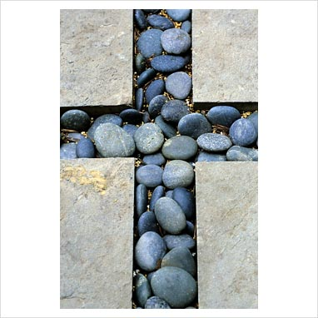

Mission/Going Forth
Pause - (Take a few seconds to close eyes – five rotations of the sing bowl.)

Jacob: Be an example of Jesus today – help someone in need, share with someone, be kind and patient, look after our world. Remember to live by our Christian Virtues and honour our Lord. (Take a few seconds to close eyes – five rotations of the sing bowl.)
Yn enw’r Tad, a’r Mab, a’r Ysbryd Glân.Amen.
Closing Prayer
- Our Father
- School Prayer
- God our father
- My God
- Hail Mary
- Yn enw’r Tad, a’r Mab, a’r Ysbryd Glân.Amen.

Gweddiwn
Myles, Jacob and Iwinosa


Response to the Word of God
.
Gweddiwn Leader:Jesus you are so good. All Repeat
Gweddiwn Leader:Help us to grow in goodness. All Repeat
Gweddiwn Leader:Jesus you are so kind. All Repeat
Gweddiwn Leader:Help us to grow in kindness. All Repeat
Gweddiwn Leader:Jesus you are so caring. All Repeat
Gweddiwn Leader:Help us to grow in caring. All Repeat
Gweddiwn Leader:Jesus you are so loving. All Repeat
Gweddiwn Leader:Help us to grow in loving All Repeat

