Geddiwn – Dosbarth Gwynno 2023 – 2024 – Date: OCT 2023 Gweddiwn Group Members: Mia, Natan and Shindara
Gather: Introduction
Play reflective music as you gather in a circle.
Mia: Pick up an object (a pebble, shell, glass bead, candle, shape) and place it around a candle before silently finding a space in the circle. (Gweddiwn Leader to make one rotation of the sing bowl between each child places object into a cross formation)

Natan: Mae’n amser gweddi. It’s prayer time.
Gadewch i ni wneud arwydd y groes:
Let’s make the sign of the cross:
All Children: Yn enw’r Tad a’r Mab a’r Ysbryd Glân, Amen.
Shindara: Dwylo ynghyd, llygaid ar gau.
Hands together, eyes closed.
Mia: Let us pray:
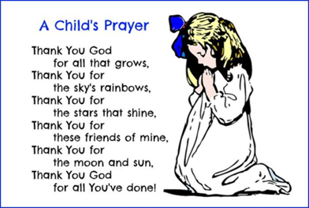
Gather: Opening Prayer
Natan: One Rotation of sing bowl after each line of the prayer
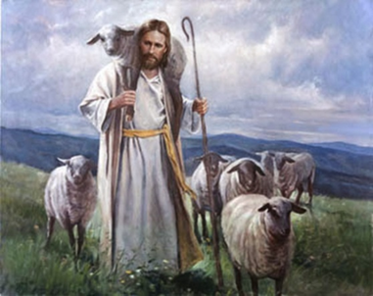
The Word of God

Michelle: Llygaid ar gau a dwylo unhyd
Fraser: Close your eyes and imagine you are on a walk.
Harlow: Picture the beauty of the place where you are walking.
Michelle: Imagine that God joins you on the journey.
Fraser: What would you tell God?
Harlow: What might God say to you? Listen now to God’s Word.

Introduction to the Reading.
Michelle: The Lord be with you.
All children: And with your Spirit
Fraser: A reading from the Holy Gospel of Luke
All: Glory to you o Lord

“Truly, truly, I say to you, he who does not enter the sheepfold by the door but climbs in by another way, that man is a thief and a robber. ² But he who enters by the door is the shepherd of the sheep. ³ To him the gatekeeper opens. The sheep hear his voice, and he calls his own sheep by name and leads them out. ⁴ When he has brought out all his own, he goes before them, and the sheep follow him, for they know his voice. ⁵ A stranger they will not follow, but they will flee from him, for they do not know the voice of strangers.” ⁶ This figure of speech Jesus used with them, but they did not understand what he was saying to them.
⁷ So Jesus again said to them, “Truly, truly, I say to you, I am the door of the sheep. ⁸ All who came before me are thieves and robbers, but the sheep did not listen to them. ⁹ I am the door. If anyone enters by me, he will be saved and will go in and out and find pasture. ¹⁰ The thief comes only to steal and kill and destroy. I came that they may have life and have it abundantly.
Pause The Gospel of the Lord.
All: Praise to you Lord Jesus Christ.

Response to the Word of God
Gweddiwn Leader:
Jesus you are so good. All: Help us to grow in goodness.
Jesus you are so kind. All: Help us to grow in kindness.
Jesus you are so caring. All: Help us to grow in caring.
Jesus you are so loving. All: Help us to grow in loving.
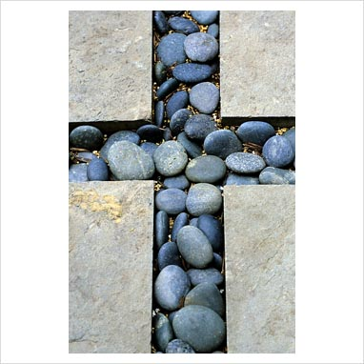
Amen

Mission/Going Forth
Pause - (Take a few seconds to close eyes – five rotations of the sing bowl.)
Mia: Remember to use good manners all day! Treat all staff, pupils and dinner staff with respect and remember all these different people do for us every day to make our lives happier and make us a Christian and respectful community. (Take a few seconds to close eyes – five rotations of the sing bowl.)

Yn enw’r Tad, a’r Mab, a’r Ysbryd Glân.Amen.
Closing Prayer
- Our Father
- School Prayer
- God our father
- My God
- Hail Mary

Yn enw’r Tad, a’r Mab, a’r Ysbryd Glân.Amen.

Gweddiwn
Mia, Natan and Shindara


Response to the Word of God
Gweddiwn Leader:
Jesus you are so good. All: Help us to grow in goodness.
Jesus you are so kind. All: Help us to grow in kindness.
Jesus you are so caring. All: Help us to grow in caring.
Jesus you are so loving. All: Help us to grow in loving.
Amen

