Geddiwn – Dosbarth Gwynno 2023 – 2024 – Date: OCT 2023 Gweddiwn Group Members: Jeron Adhi and Aaron
Gather: Introduction
Play reflective music as you gather in a circle.
Jeron. ‘This is Jesus the light of the World’ holding a candle As each child takes a place in the prayer circle. Separate each child with a rotation of the sing bowl.

Adhi: Mae’n amser gweddi. It’s prayer time.
Gadewch i ni wneud arwydd y groes:
Let’s make the sign of the cross:
All Children: Yn enw’r Tad a’r Mab a’r Ysbryd Glân, Amen.
Aaron: Dwylo ynghyd, llygaid ar gau.
Hands together, eyes closed.
Jeron: Let us pray:

Gather: Opening Prayer
Adhi sing bowl after each line of the prayer.


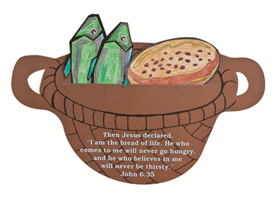
The Word of God

Michelle: Llygaid ar gau a dwylo unhyd
Fraser: Close your eyes and imagine you are on a walk.
Harlow: Picture the beauty of the place where you are walking.
Michelle: Imagine that God joins you on the journey.
Fraser: What would you tell God?
Harlow: What might God say to you? Listen now to God’s Word.

Introduction to the Reading.
Michelle: The Lord be with you.
All children: And with your Spirit
Fraser: A reading from the Holy Gospel of Luke
All: Glory to you o Lord
When Jesus heard what had happened, he withdrew by boat privately to a solitary place. Hearing of this, the crowds followed him on foot from the towns. When Jesus landed and saw a large crowd, he had compassion on them and healed their sick. As evening approached, the disciples came to him and said, “This is a remote place, and it’s already getting late. Send the crowds away, so they can go to the villages and buy themselves some food.” “We have here only five loaves of bread and two fish,” they answered. “Bring them here to me,” he said. And he directed the people to sit down on the grass. Taking the five loaves and the two fish and looking up to heaven, he gave thanks and broke the loaves. Then he gave them to the disciples, and the disciples gave them to the people. They all ate and were satisfied, and the disciples picked up twelve basketfuls of broken pieces that were left over. The number of those who ate was about five thousand men, besides women and children.
Pause The Gospel of the Lord.
All: Praise to you Lord Jesus Christ.

Response to the Word of God
Gweddiwn Leader: Jesus you showed love and care for your friends.
Help us to be like you. Amen

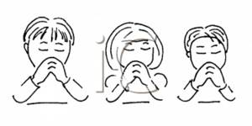

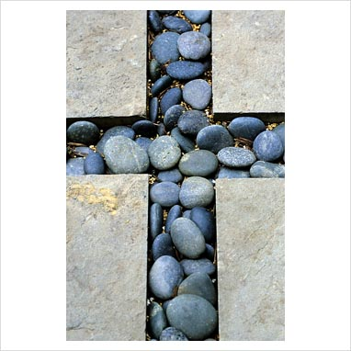

Mission/Going Forth
Pause - (Take a few seconds to close eyes – five rotations of the sing bowl.)

Adhi: Is there someone whom you need to forgive? How could you show that person that you have forgiven them? Remember our Christian Virtues and follow Christ’s teachings. (Take a few seconds to close eyes – five rotations of the sing bowl.)
Yn enw’r Tad, a’r Mab, a’r Ysbryd Glân.Amen.
Closing Prayer
- Our Father
- School Prayer
- God our father
- My God
- Hail Mary
Yn enw’r Tad, a’r Mab, a’r Ysbryd Glân.Amen.

Gweddiwn
Jeron, Adhi and Aaron

Response to the Word of God
Gweddiwn Leader: Jesus you showed love and care for your friends.
Help us to be like you. Amen

