Geddiwn – Dosbarth Gwynno 2023 – 2024 – Date: OCT 2023 Gweddiwn Group Members: Michelle, Fraser and Harlow
Gather: Introduction
Play reflective music as you gather in a circle.
- Michelle: As you join our prayer circle please say, in turn: ‘Help me to be a child of the light’ as you gather in a circle.
Child repeats: ‘Help me to be a child of the light’ (Gweddiwn Leader to make one rotation of the sing bowl between each child sitting)

Fraser: 2. Mae’n amser gweddi. It’s prayer time.
Gadewch i ni wneud arwydd y groes:
Let’s make the sign of the cross:
All Children: Yn enw’r Tad a’r Mab a’r Ysbryd Glân, Amen.
Fraser: Dwylo ynghyd, llygaid ar gau.
Hands together, eyes closed.
Frase: Let us pray:
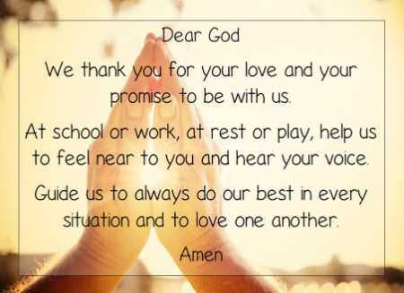
Gather: Opening Prayer
Harlow: One Rotation of sing bowl after each line of the prayer.

The Word of God

Michelle: Llygaid ar gau a dwylo unhyd
Fraser: Close your eyes and imagine you are on a walk.
Harlow: Picture the beauty of the place where you are walking.
Michelle: Imagine that God joins you on the journey.
Fraser: What would you tell God?
Harlow: What might God say to you? Listen now to God’s Word.

Introduction to the Reading.
Michelle: The Lord be with you.
All children: And with your Spirit
Fraser: A reading from the Holy Gospel of Luke
All: Glory to you o Lord

The Bible says, one day Jesus went to the temple and sat down near the place where the offerings were given. He sat and watched the people as they came by and put in their offerings. Many rich people, dressed in fine robes, came by and put in a lot of money. Then a poor widow came by and put in just two small coins.
Jesus called His disciples to Him and said, "This woman has given more than anyone. The others gave out of their wealth, but this woman gave all that she had."
You see, Jesus is more interested in what is in the heart of the giver than He is in the size of their gift.
Pause The Gospel of the Lord.
All: Praise to you Lord Jesus Christ.

Response to the Word of God
Gweddiwn Leader: God of all new life, give us all we need each day to become new and better people.
Gweddiwn Leader: Help us to be more like Jesus your son for you made us and know and love us.
Amen.



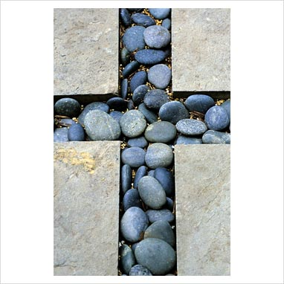

Mission/Going Forth
Pause - (Take a few seconds to close eyes – five rotations of the sing bowl.)

Michelle: make an effort Tell your mum/dad you love her/him. Do not take for granted this love and be grateful for this gift every day. (Take a few seconds to close eyes – five rotations of the sing bowl.)
Yn enw’r Tad, a’r Mab, a’r Ysbryd Glân.Amen.
Closing Prayer
- Our Father
- School Prayer
- God our father
- My God
- Hail Mary
Yn enw’r Tad, a’r Mab, a’r Ysbryd Glân.Amen.

Gweddiwn
Michelle, Fraser and Harlow



