Geddiwn – Dosbarth Gwynno 2023 – 2024 – Date: OCT 2023 Gweddiwn Group Members: Sophia, Max, Sebastian
Gather: Introduction
Play reflective music as you gather in a circle.
: Repeat after ‘This is Jesus the light of the World’ (Take your place in the circle.)

Max: We will pass around a bowl of water. Reverently dip in your finger and make a good sign of God’s love. All Children: Yn enw’r Tad, a’r Mab, a’r Ysbryd Glân.Amen.

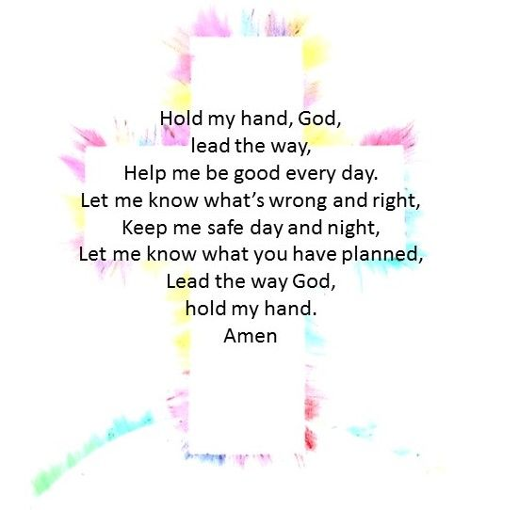
Gather: Opening Prayer
Sebastian: One Rotation of sing bowl after each line of the prayer.

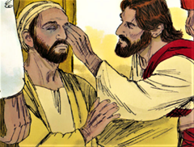
The Word of God

Sophia: Llygaid ar gau a dwylo unhyd
Max: Close your eyes and imagine you are on a walk.
Sebastian: Picture the beauty of the place where you are walking.
Sophia: Imagine that God joins you on the journey.
Max: What would you tell God?
Sebastian: What might God say to you? Listen now to God’s Word.

Introduction to the Reading.
Gweddiwn Leader: The Lord be with you.
All children: And with your Spirit
Gweddiwn Leader: A reading from the Holy Gospel of Luke
All: Glory to you o Lord
Luke 18:35-43 - As he drew near to Jericho, a blind man was sitting by the roadside begging. And hearing a crowd going by, he inquired what this meant. They told him, "Jesus of Nazareth is passing by." And he cried out, "Jesus, Son of David, have mercy on me!" And those who were in front rebuked him, telling him to be silent. But he cried out all the more, "Son of David, have mercy on me!" And Jesus stopped and commanded him to be brought to him. And when he came near, he asked him, "What do you want me to do for you?" He said, "Lord, let me recover my sight." And Jesus said to him, "Recover your sight; your faith has made you well." And immediately he recovered his sight and followed him, glorifying God. And all the people, when they saw it, gave praise to God.

Pause The Gospel of the Lord.
All: Praise to you Lord Jesus Christ.

Response to the Word of God
Gweddiwn Leader: Repeat after me:
Gweddiwn Leader:

If I, your Lord and Teacher, have washed your feet,
then surely you must wash one another’s feet.
If there is this love among you,
all will know that you are my disciples.
I give you a new commandment:
Love one another as I have loved you.
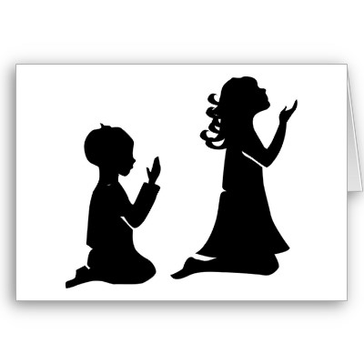

Gweddiwn
Sophia, Max and Sebastian

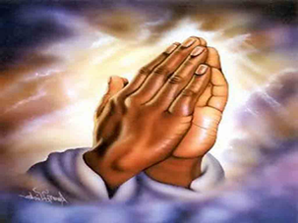

Response to the Word of God
Gweddiwn Leader: Repeat after me:
Gweddiwn Leader:

If I, your Lord and Teacher, have washed your feet,
then surely you must wash one another’s feet.
If there is this love among you,
all will know that you are my disciples.
I give you a new commandment:
Love one another as I have loved you.

