Geddiwn – Dosbarth Gwynno 2023 – 2024 – Date: OCT 2023 Gweddiwn Group Members: Samfrancis, Joanna and Frankie
Gather: Introduction
Play reflective music as you gather in a circle.
Samfrancis: Please sit in a circle, light our candles and remember that Jesus is the light of the world. Take it in turns to place our candles in the middle of our prayer focus (Gweddiwn Leader to make one rotation of the sing bowl between each child sitting)
Gather: Sign of the Cross:
Joanna: Mae’n amser gweddi. It’s prayer time.
Gadewch i ni wneud arwydd y groes:
Let’s make the sign of the cross:
All Children: Yn enw’r Tad a’r Mab a’r Ysbryd Glân, Amen.
Joanna: Dwylo ynghyd, llygaid ar gau.
Hands together, eyes closed.
Joanna: Let us pray:

Gather: Opening Prayer
Frankie One Rotation of sing bowl after each line of the prayer.

The Word of God

Alona: Llygaid ar gau a dwylo unhyd
Ryan: Close your eyes and imagine you are on a walk.
Armin: Picture the beauty of the place where you are walking.
Alona: Imagine that God joins you on the journey.
Ryan: What would you tell God?
Armin: What might God say to you? Listen now to God’s Word

Introduction to the Reading.
Alona: The Lord be with you.
Ryan: And with your Spirit
Armin: A reading from the Holy Gospel of Matthew
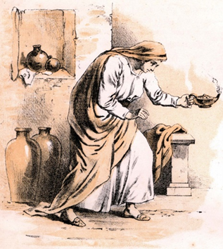
All: Glory to you o Lord
“Or suppose a woman has ten silver coins and loses one. Doesn’t she light a lamp, sweep the house and search carefully until she finds it? And when she finds it, she calls her friends and neighbours together and says, ‘Rejoice with me; I have found my lost coin.’ In the same way, I tell you, there is rejoicing in the presence of the angels of God over one sinner who repents” (Luke 15:8-10)
Pause The Gospel of the Lord.
All: Praise to you Lord Jesus Christ.

Response to the Word of God
Gweddiwn Leader: Repeat after me:
Gweddiwn Leader:

If I, your Lord and Teacher, have washed your feet,
then surely you must wash one another’s feet.
If there is this love among you,
all will know that you are my disciples.
I give you a new commandment:
Love one another as I have loved you.
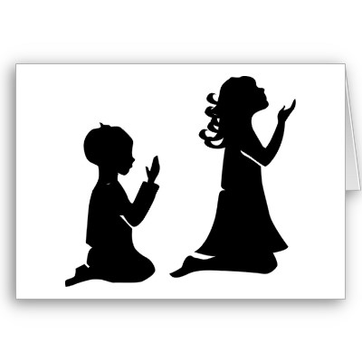

Mission/Going Forth
Pause - (Take a few seconds to close eyes – five rotations of the sing bowl.)

Frankie: Remember before you go to sleep to thank God for your day and say sorry for the times you have not lived out his message. Think about the Christian Virtues that mean the most to you at this time. (Take a few seconds to close eyes – five rotations of the sing bowl.)
Yn enw’r Tad, a’r Mab, a’r Ysbryd Glân.Amen.
Closing Prayer
- Our Father
- School Prayer
- God our father
- My God
- Hail Mary
Yn enw’r Tad, a’r Mab, a’r Ysbryd Glân.Amen.

Gweddiwn
Samfrancis, Joanna and Frankie



Response to the Word of God
Gweddiwn Leader: Repeat after me:
Gweddiwn Leader:

If I, your Lord and Teacher, have washed your feet,
then surely you must wash one another’s feet.
If there is this love among you,
all will know that you are my disciples.
I give you a new commandment:
Love one another as I have loved you.

