Geddiwn – Dosbarth Gwynno 2023 – 2024 – Date: OCT 2023 Gweddiwn Group Members: Alona, Armin and Ishaq
Gather: Introduction
Play reflective music as you gather in a circle.
Alona: Sit in a circle in silence and think about your breathing. (Gweddiwn Leader to make one rotation of the sing bowl between each child sitting)

Armin: Breathe in God’s peace. Pause(Gweddiwn Leader to make one rotation of the sing bowl between each child sitting)
Ishaq: Breathe out any worries. Pause (Gweddiwn Leader to make one rotation of the sing bowl between each child sitting)
Alona: Be still inside and out. Pause (Gweddiwn Leader to make one rotation of the sing bowl between each child sitting)

Gather: Sign of the Cross:
Armin: We will pass around a bowl of water. Reverently dip in your finger and make a good sign of God’s love. All Children: Yn enw’r Tad, a’r Mab, a’r Ysbryd Glân.Amen.
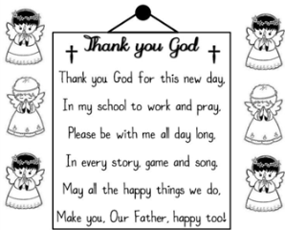
Gather: Opening Prayer
Ishaq: Father God I thank you for this new day. I thank you that you love me and are with me today. Amen.

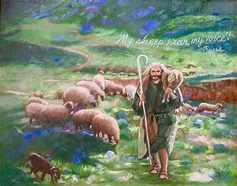
The Word of God

Alona: Llygaid ar gau a dwylo unhyd
Ryan: Close your eyes and imagine you are on a walk.
Armin: Picture the beauty of the place where you are walking.
Alona: Imagine that God joins you on the journey.
Ryan: What would you tell God?
Armin: What might God say to you? Listen now to God’s Word

Introduction to the Reading.
Alona: The Lord be with you.
Ryan: And with your Spirit
Armin: A reading from the Holy Gospel of Matthew
All: Glory to you o Lord
Once, Jesus told a story about sheep and shepherds. He said, “Anyone who tries to sneak into a sheep pen is a thief, but the one who goes through the gate is the shepherd. The gatekeeper opens the gate for him, and the sheep know his voice. He calls his own sheep by name and leads them out. The sheep follow him because they know his voice, and they won’t follow a stranger. They will run away from him because they don’t know his voice.” But the people didn’t understand what Jesus was talking about.
So Jesus said, “I am the gate for the sheep. Everyone who came before me were thieves and robbers, but the sheep didn’t listen to them. Whoever enters through me will be saved and will be able to come in and go out and find pasture. A thief comes only to steal, kill, and destroy. I came so that everyone could have life, and have it fully. I am the good shepherd. A good shepherd would die to save his sheep, but a hired hand wouldn’t care about them and would run away.
I know my sheep, and they know me, just as the Father knows me and I know the Father. I will die to save my sheep. I have other sheep that are not in this pen, and I must bring them too. They will hear my voice, and there will be one flock with one shepherd. The reason the Father loves me is that I lay down my life, but I will take it up again. No one takes it from me, but I give it up myself. I have the authority to give it up, and I have the authority to take it back. This is what my Father has commanded me to do.”
Pause The Gospel of the Lord.
All: Praise to you Lord Jesus Christ.

Response to the Word of God
Gweddiwn Leader: Repeat after me:
Gweddiwn Leader: Jesus you are so good. Repeat
Gweddiwn Leader: Help us to grow in goodness. Repeat
Gweddiwn Leader: Jesus you are so kind. Repeat
Gweddiwn Leader: Help us to grow in kindness. Repeat
Gweddiwn Leader: Jesus you are so caring. Repeat
Gweddiwn Leader: Help us to grow in caring. Repeat
Gweddiwn Leader: Jesus you are so loving. Repeat
Gweddiwn Leader: Help us to grow in loving. Repeat
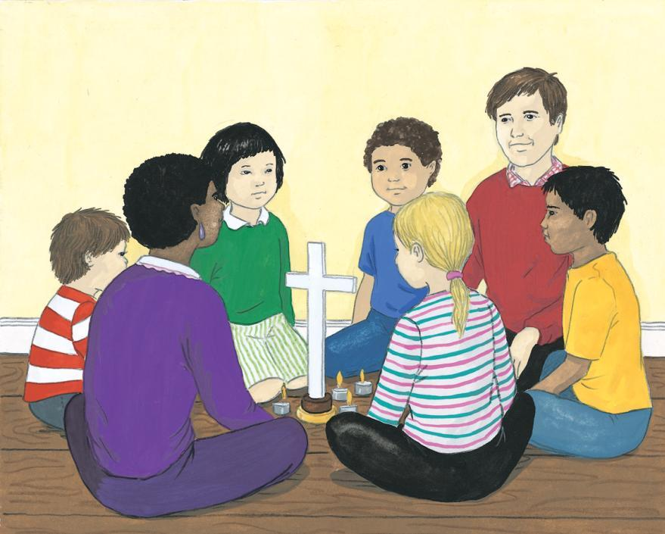

Mission/Going Forth
Pause - (Take a few seconds to close eyes – five rotations of the sing bowl.)
Alona: In your mind say a prayer for someone in need. Find time in the day to privately pray for someone or people who are in need. (Take a few seconds to close eyes – five rotations of the sing bowl.)
Yn enw’r Tad, a’r Mab, a’r Ysbryd Glân.Amen.
Closing Prayer
- Our Father
- School Prayer
- God our father
- My God
- Hail Mary
Yn enw’r Tad, a’r Mab, a’r Ysbryd Glân.Amen.

Gweddiwn
Armin Orla and Ishaq


