Geddiwn – Dosbarth Gwynno 2023 – 2024 – Date: OCT 2023 Gweddiwn Group Members: Bella, Ffion and Ryan
Gather: Introduction
Play reflective music as you gather in a circle.
Bella: As you join our prayer circle please say, in turn: ‘Help me to be a child of the light’ as you gather in a circle.
Child repeats: ‘Help me to be a child of the light’ (Gweddiwn Leader to make one rotation of the sing bowl between each child sitting)

Gather: Sign of the Cross:
Ffion: Mae’n amser gweddi. It’s prayer time.
Gadewch i ni wneud arwydd y groes:
Let’s make the sign of the cross:
All Children: Yn enw’r Tad a’r Mab a’r Ysbryd Glân, Amen.
Ffion: Dwylo ynghyd, llygaid ar gau.
Hands together, eyes closed.
Ryan: Let us pray:


Gather: Opening Prayer

Ryan: Father God, please be with me today in everything I will face. Help me to learn well at school. I pray that I would be a good friend to those around me today. All: Amen

The Word of God

Genevieve: Llygaid ar gau a dwylo unhyd
Kaelynn: Close your eyes and imagine you are on a walk.
David: Picture the beauty of the place where you are walking.
Genevieve: Imagine that God joins you on the journey.
Kaelynn: What would you tell God?
David: What might God say to you? Listen now to God’s Word

Introduction to the Reading.
Genevieve: The Lord be with you.
Kaelynn: And with your Spirit
David: A reading from the Holy Gospel of Matthew
All: Glory to you o Lord

Story of the Talent
Bella: Jesus tells the story of a rich man who has three slaves. He gives each slave an amount of money, referred to as talents and possibly talents of gold, based upon that man's ability to steward and care for the money.
Ryan: The first steward is given 5 talents, the second is given two talents and the third is given one. The master told them to care for his money and the first two servants used the talents to trade and gain profit.
Ffion: They returned to their master with double the talents! The third servant was fearful and hid the one talent he was trusted with, returning just one talent to his master. The master scolded him saying that he should have invested the money and received interest.
Pause The Gospel of the Lord.
All: Praise to you Lord Jesus Christ.

Response to the Word of God
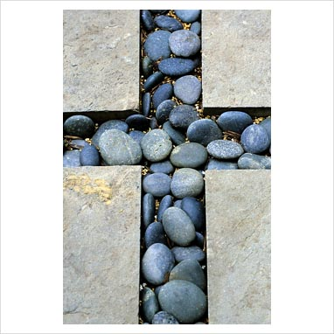
Gweddiwn Leader: Take a pebble in your hand. Think about someone that you would like to ask Jesus to help.

Gweddiwn Leader: Place it beneath a cross. As you place it say ‘Dear Jesus, I would like to ask you to help…..’
When you have all placed your stone/pebble/bead repeat the following prayer:
Gweddiwn Leader: Dear Jesus/ Help all the people we have named/ and anyone else who is sad or suffering today/ to know that you are with them/ and love them very much/ Amen.

Mission/Going Forth
Pause - (Take a few seconds to close eyes – five rotations of the sing bowl.)
BellA: Make a promise to follow the message of Jesus and to follow our Christian Virtues and to follow jesus’s commandment to love one another as I have loved you. (Take a few seconds to close eyes – five rotations of the sing bowl.)
Yn enw’r Tad, a’r Mab, a’r Ysbryd Glân.Amen.
Closing Prayer
- Our Father
- School Prayer
- God our father
- My God
- Hail Mary
Yn enw’r Tad, a’r Mab, a’r Ysbryd Glân.Amen.

Gweddiwn
Bella, Ffion and Ryan


