Geddiwn – Dosbarth Gwynno 2023 – 2024 – Date: OCT 2023 Gweddiwn Group Members: David, Kaelynn and Genevieve
Gather: Introduction
Play reflective music as you gather in a circle.
David: Pick up an object (a pebble, shell, glass bead, candle, shape) and place it around a candle before silently finding a space in the circle. (Gweddiwn Leader to make one rotation of the sing bowl between each child places object into a cross formation)
Gather: Sign of the Cross:
Kaelynn: We will pass around a bowl of water. Reverently dip in your finger and make a good sign of God’s love. All Children: Yn enw’r Tad, a’r Mab, a’r Ysbryd Glân.Amen.

Gather: Opening Prayer
- Genevieve: Father God I thank you for this new day. I thank you that you love me and are with me today. Amen


The Word of God

Genevieve: Llygaid ar gau a dwylo unhyd
Kaelynn: Close your eyes and imagine you are on a walk.
David: Picture the beauty of the place where you are walking.
Genevieve: Imagine that God joins you on the journey.
Kaelynn: What would you tell God?
David: What might God say to you? Listen now to God’s Word

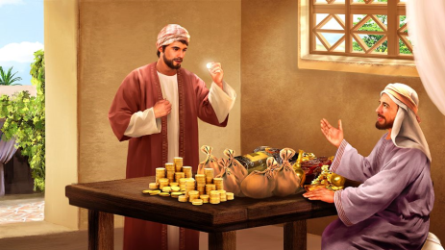
Introduction to the Reading.
Genevieve: The Lord be with you.
Kaelynn: And with your Spirit
David: A reading from the Holy Gospel of Matthew
All: Glory to you o Lord

- (Matthew 24:42). Story of the Talent
Genevieve: Jesus tells the story of a rich man who has three slaves. He gives each slave an amount of money, referred to as talents and possibly talents of gold, based upon that man's ability to steward and care for the money.
Kaelynn: The first steward is given 5 talents, the second is given two talents and the third is given one. The master told them to care for his money and the first two servants used the talents to trade and gain profit.
David: They returned to their master with double the talents! The third servant was fearful and hid the one talent he was trusted with, returning just one talent to his master. The master scolded him saying that he should have invested the money and received interest.
Pause The Gospel of the Lord.
All: Praise to you Lord Jesus Christ.

Response to the Word of God
Gweddiwn Leader: Jesus came to show us how to love each other.
What can you do to be more like Jesus?


Gweddiwn Leader: Say an ‘Our Father’ asking God to help us to be more like Jesus.
ALL: Our Father
Mission/Going Forth
Genevieve: Let us come together as a class community to reflect on what we will hold on to from our Gweddiwn.
Pause - (Take a few seconds to close eyes – five rotations of the sing bowl.)
Kaelynn: We will pass around a bowl of water. Reverently dip in your finger and make a good sign of God’s love. All Children: Yn enw’r Tad, a’r Mab, a’r Ysbryd Glân.Amen.
Our Father
School Prayer
God our father
O My God
Hail Mary
Yn enw’r Tad, a’r Mab, a’r Ysbryd Glân.Amen.

Gweddiwn
David, Kaelynn and Genevieve



