Gather: Step One – Choose one – INTRODUCTION TO THE GWEDDIWN
Play reflective music as you gather in a circle.
- Gweddiwn Leader: Pick up an object (a pebble, shell, glass bead, candle, shape) and place it around a candle before silently finding a space in the circle. (Gweddiwn Leader to make one rotation of the sing bowl between each child places object into a cross formation)

- Gweddiwn Leader: As you join our prayer circle please say, in turn: ‘Help me to be a child of the light’ as you gather in a circle.
Child repeats: ‘Help me to be a child of the light’ (Gweddiwn Leader to make one rotation of the sing bowl between each child sitting)

- Gweddiwn Leader: Sit in a circle in silence and think about your breathing. (Gweddiwn Leader to make one rotation of the sing bowl between each child sitting)

Gweddiwn Leader: Breathe in God’s peace. Pause(Gweddiwn Leader to make one rotation of the sing bowl between each child sitting)
Gweddiwn Leader: Breathe out any worries. Pause(Gweddiwn Leader to make one rotation of the sing bowl between each child sitting)
Gweddiwn Leader: Be still inside and out. Pause (Gweddiwn Leader to make one rotation of the sing bowl between each child sitting)

- Gweddiwn Leader: Please sit in a circle, light our candles and remember that Jesus is the light of the world. Take it in turns to place our candles in the middle of our prayer focus (Gweddiwn Leader to make one rotation of the sing bowl between each child sitting)

- Gweddiwn Leader: Repeat after ‘This is Jesus the light of the World’ (Take your place in the circle.)

- Child repeats. ‘This is Jesus the light of the World’ holding a candle As each child takes a place in the prayer circle. Separate each child with a rotation of the sing bowl.

- Gweddiwn Leader: Please repeat the mantra: Lord stay with me. All children say this taking their place in the prayer circle. As each child takes a place in the prayer circle. Separate each child with a rotation of the sing bowl.

GATHER TWO: MAKING THE SIGN OF THE CROSS – CHOOSE ONE

1 Gweddiwn leader: We will pass around a bowl of water. Reverently dip in your finger and make a good sign of God’s love. All Children: Yn enw’r Tad, a’r Mab, a’r Ysbryd Glân.Amen.

2. Gweddiwn Leader: Mae’n amser gweddi. It’s prayer time.
Gadewch i ni wneud arwydd y groes:
Let’s make the sign of the cross:
All Children: Yn enw’r Tad a’r Mab a’r Ysbryd Glân, Amen.
Gweddiwn Leader: Dwylo ynghyd, llygaid ar gau.
Hands together, eyes closed.
Gweddïwn Leader: Let us pray:

GATHER STEP THREE: OPENING PRAYER – Choose One

- Gweddiwn Leader: Father God I thank you for this new day. I thank you that you love me and are with me today. Amen

- Gweddiwn Leader: Father God, please be with me today in everything I will face. Help me to learn well at school. I pray that I would be a good friend to those around me today. Amen

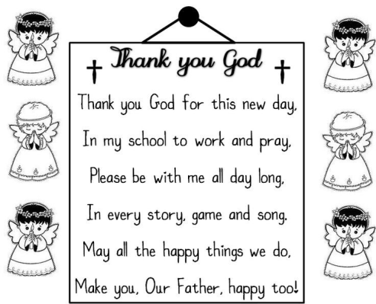
- Gweddiwn Leader: Father God I thank you for this new day. I thank you that you love me and are with me today. Amen.


- Gweddiwn Leader: One Rotation of sing bowl after each line of the prayer.

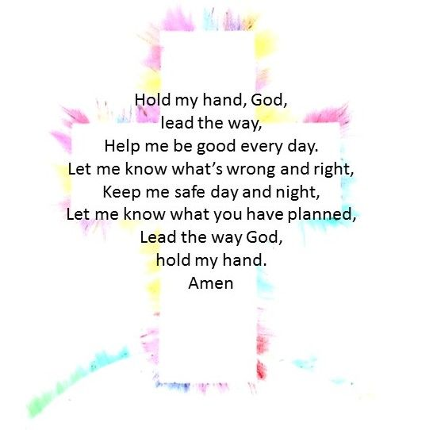

6 Gweddiwn Leader: One Rotation of sing bowl after each line of the prayer.


7 Gweddiwn Leader: One Rotation of sing bowl after each line of the prayer.

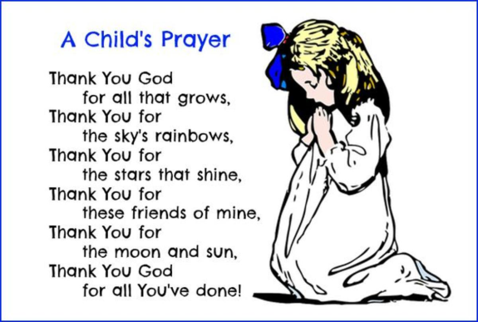
8 Gweddiwn Leader: One Rotation of sing bowl after each line of the prayer.



9) Gweddiwn Leader: One Rotation of sing bowl after each line of the praye

10) Gweddiwn Leader: One Rotation of sing bowl after each line of the prayer.


11) Gweddiwn Leader: One Rotation of sing bowl after each line of the prayer


The Word of God

Gweddiwn Leader: Llygaid ar gau a dwylo unhyd
Gweddiwn Leader: Close your eyes and imagine you are on a walk.
Gweddiwn Leader: Picture the beauty of the place where you are walking.
Gweddiwn Leader: Imagine that God joins you on the journey.
Gweddiwn Leader: What would you tell God?
Gweddiwn Leader: What might God say to you? Listen now to God’s Word

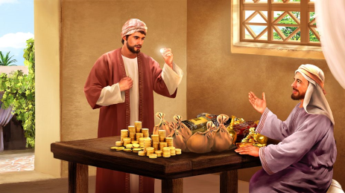
Introduction to the Reading.
Gweddiwn Leader: The Lord be with you.
All children: And with your Spirit
Gweddiwn Leader: A reading from the Holy Gospel of Matthew
All: Glory to you o Lord

- (Matthew 24:42). Story of the Talent
Gweddiwn Leader: Jesus tells the story of a rich man who has three slaves. He gives each slave an amount of money, referred to as talents and possibly talents of gold, based upon that man's ability to steward and care for the money.
Gweddiwn Leader: The first steward is given 5 talents, the second is given two talents and the third is given one. The master told them to care for his money and the first two servants used the talents to trade and gain profit.
Gweddiwn Leader: They returned to their master with double the talents! The third servant was fearful and hid the one talent he was trusted with, returning just one talent to his master. The master scolded him saying that he should have invested the money and received interest.
Pause The Gospel of the Lord.
All: Praise to you Lord Jesus Christ.

2. The Word of God
Gweddiwn Leader: Llygaid ar gau a dwylo unhyd
Gweddiwn Leader: Close your eyes and imagine you are on a walk.
Gweddiwn Leader: Picture the beauty of the place where you are walking.
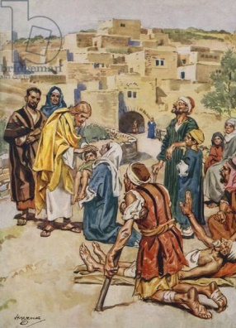
Gweddiwn Leader: Imagine that God joins you on the journey.
Gweddiwn Leader: What would you tell God?
Gweddiwn Leader: What might God say to you? Listen now to God’s Word

Introduction to the Reading.
Gweddiwn Leader: The Lord be with you.
All children: And with your Spirit
Gweddiwn Leader: A reading from the Holy Gospel of Luke
All: Glory to you o Lord
On the way to Jerusalem he was passing along between Samaria and Galilee. And as he entered a village, he was met by ten lepers, who stood at a distance and lifted up their voices, saying, "Jesus, Master, have mercy on us." When he saw them he said to them, "Go and show yourselves to the priests." And as they went they were cleansed. Then one of them, when he saw that he was healed, turned back, praising God with a loud voice; and he fell on his face at Jesus' feet, giving him thanks. Now he was a Samaritan. Then Jesus answered, "Were not ten cleansed? Where are the nine? Was no one found to return and give praise to God except this foreigner?" And he said to him, "Rise and go your way; your faith has made you well." (Luke 17:11-19)
Pause The Gospel of the Lord.
All: Praise to you Lord Jesus Christ.

3. The Word of God
Gweddiwn Leader: Llygaid ar gau a dwylo unhyd
Gweddiwn Leader: Close your eyes and imagine you are on a walk.
Gweddiwn Leader: Picture the beauty of the place where you are walking.
Gweddiwn Leader: Imagine that God joins you on the journey.
Gweddiwn Leader: What would you tell God?
Gweddiwn Leader: What might God say to you? Listen now to God’s Word

Introduction to the Reading.
Gweddiwn Leader: The Lord be with you.
All children: And with your Spirit
Gweddiwn Leader: A reading from the Holy Gospel of John
All: Glory to you o Lord

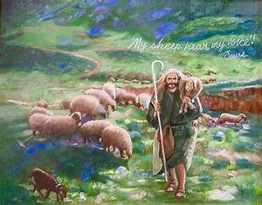
Once, Jesus told a story about sheep and shepherds. He said, “Anyone who tries to sneak into a sheep pen is a thief, but the one who goes through the gate is the shepherd. The gatekeeper opens the gate for him, and the sheep know his voice. He calls his own sheep by name and leads them out. The sheep follow him because they know his voice, and they won’t follow a stranger. They will run away from him because they don’t know his voice.” But the people didn’t understand what Jesus was talking about.
So Jesus said, “I am the gate for the sheep. Everyone who came before me were thieves and robbers, but the sheep didn’t listen to them. Whoever enters through me will be saved and will be able to come in and go out and find pasture. A thief comes only to steal, kill, and destroy. I came so that everyone could have life, and have it fully. I am the good shepherd. A good shepherd would die to save his sheep, but a hired hand wouldn’t care about them and would run away.
I know my sheep, and they know me, just as the Father knows me and I know the Father. I will die to save my sheep. I have other sheep that are not in this pen, and I must bring them too. They will hear my voice, and there will be one flock with one shepherd. The reason the Father loves me is that I lay down my life, but I will take it up again. No one takes it from me, but I give it up myself. I have the authority to give it up, and I have the authority to take it back. This is what my Father has commanded me to do.”
Pause The Gospel of the Lord.
All: Praise to you Lord Jesus Christ.
4. The Word of God
Gweddiwn Leader: Llygaid ar gau a dwylo unhyd
Gweddiwn Leader: Close your eyes and imagine you are on a walk.
Gweddiwn Leader: Picture the beauty of the place where you are walking.
Gweddiwn Leader: Imagine that God joins you on the journey.
Gweddiwn Leader: What would you tell God?
Gweddiwn Leader: What might God say to you? Listen now to God’s Word

Introduction to the Reading.
Gweddiwn Leader: The Lord be with you.
All children: And with your Spirit
Gweddiwn Leader: A reading from the Holy Gospel of Luke
All: Glory to you o Lord
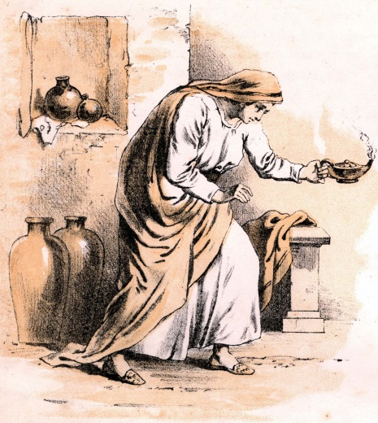
“Or suppose a woman has ten silver coins and loses one. Doesn’t she light a lamp, sweep the house and search carefully until she finds it? And when she finds it, she calls her friends and neighbours together and says, ‘Rejoice with me; I have found my lost coin.’ In the same way, I tell you, there is rejoicing in the presence of the angels of God over one sinner who repents” (Luke 15:8-10)
Pause The Gospel of the Lord.
All: Praise to you Lord Jesus Christ.

- The Word of God
Gweddiwn Leader: Llygaid ar gau a dwylo unhyd
Gweddiwn Leader: Close your eyes and imagine you are on a walk.
Gweddiwn Leader: Picture the beauty of the place where you are walking.
Gweddiwn Leader: Imagine that God joins you on the journey.
Gweddiwn Leader: What would you tell God?
Gweddiwn Leader: What might God say to you? Listen now to God’s Word

Introduction to the Reading.
Gweddiwn Leader: The Lord be with you.
All children: And with your Spirit
Gweddiwn Leader: A reading from the Holy Gospel of Luke
All: Glory to you o Lord
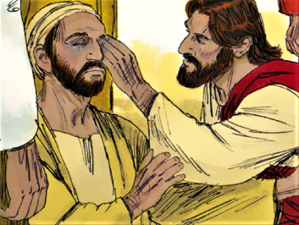
Luke 18:35-43 - As he drew near to Jericho, a blind man was sitting by the roadside begging. And hearing a crowd going by, he inquired what this meant. They told him, "Jesus of Nazareth is passing by." And he cried out, "Jesus, Son of David, have mercy on me!" And those who were in front rebuked him, telling him to be silent. But he cried out all the more, "Son of David, have mercy on me!" And Jesus stopped and commanded him to be brought to him. And when he came near, he asked him, "What do you want me to do for you?" He said, "Lord, let me recover my sight." And Jesus said to him, "Recover your sight; your faith has made you well." And immediately he recovered his sight and followed him, glorifying God. And all the people, when they saw it, gave praise to God.

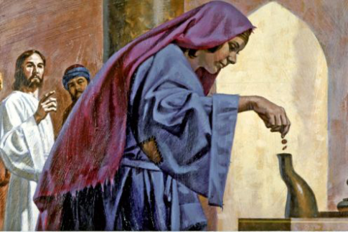
6. The Word of God
Gweddiwn Leader: Llygaid ar gau a dwylo unhyd
Gweddiwn Leader: Close your eyes and imagine you are on a walk.
Gweddiwn Leader: Picture the beauty of the place where you are
walking.
Gweddiwn Leader: Imagine that God joins you on the journey.
Gweddiwn Leader: What would you tell God?
Gweddiwn Leader: What might God say to you? Listen now to God’s
Word
Introduction to the Reading.
Gweddiwn Leader: The Lord be with you.
All children: And with your Spirit
Gweddiwn Leader: A reading from the Holy Gospel of Mark
All: Glory to you o Lord
The Bible says, one day Jesus went to the temple and sat down near the place where the offerings were given. He sat and watched the people as they came by and put in their offerings. Many rich people, dressed in fine robes, came by and put in a lot of money. Then a poor widow came by and put in just two small coins.
Jesus called His disciples to Him and said, "This woman has given more than anyone. The others gave out of their wealth, but this woman gave all that she had."
You see, Jesus is more interested in what is in the heart of the giver than He is in the size of their gift.
Pause The Gospel of the Lord.
All: Praise to you Lord Jesus Christ.

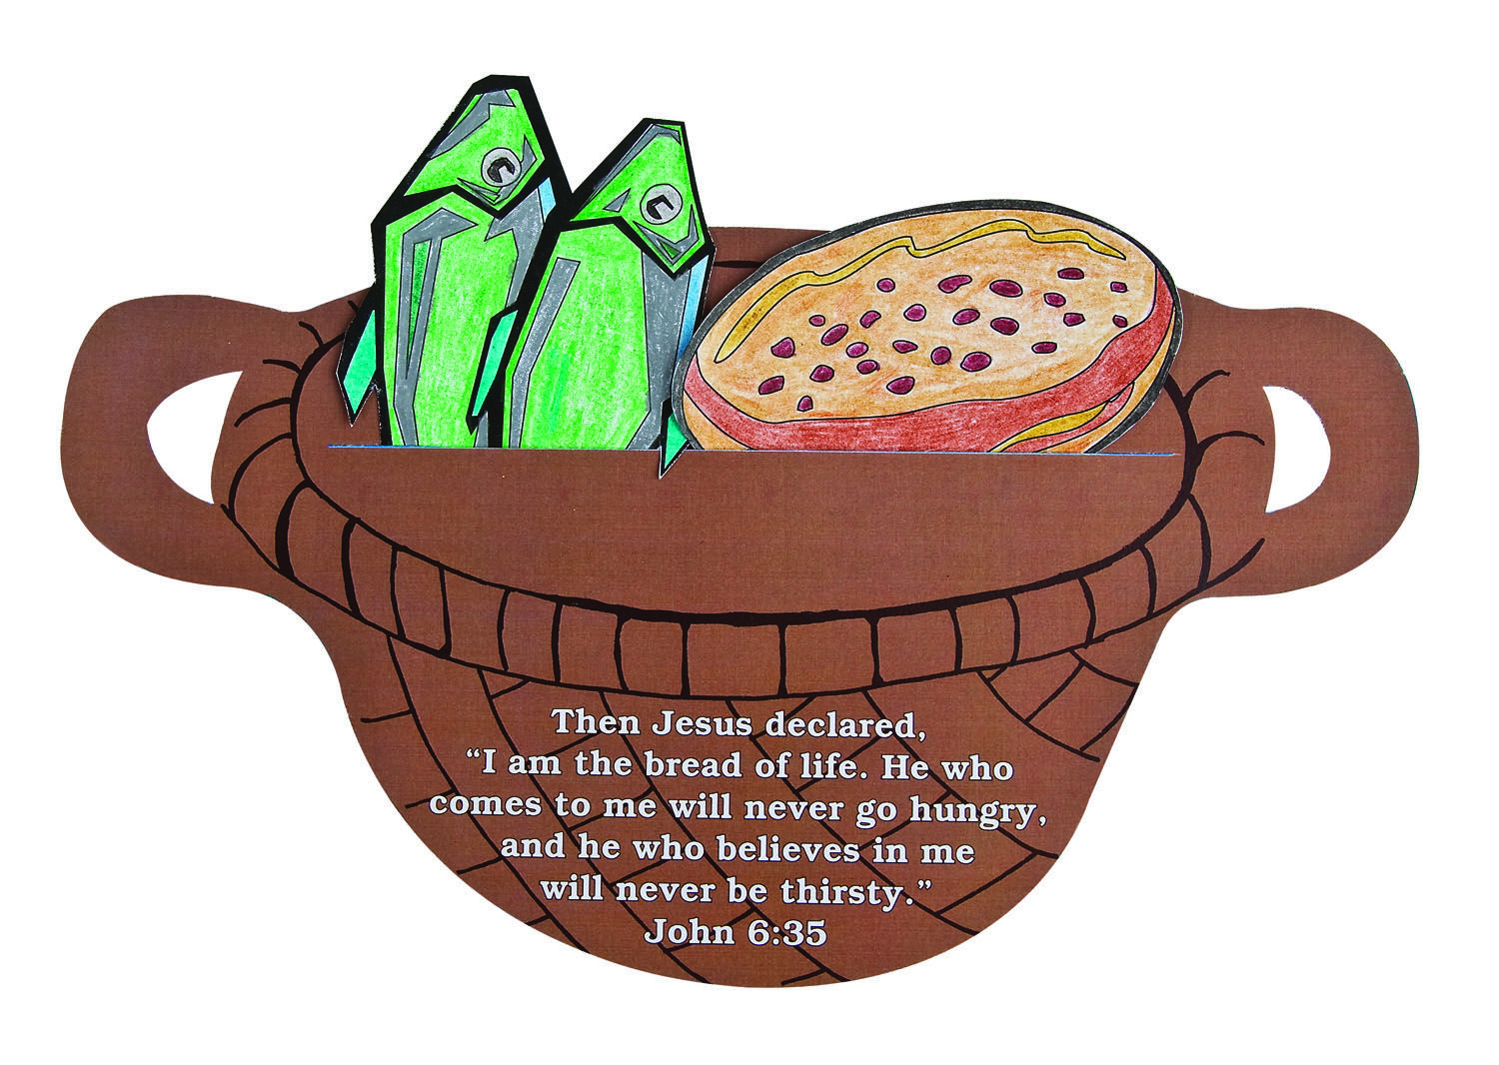
7.The Word of God
Gweddiwn Leader: Llygaid ar gau a dwylo unhyd
Gweddiwn Leader: Close your eyes and imagine you are on a walk.
Gweddiwn Leader: Picture the beauty of the place where you are
walking.
Gweddiwn Leader: Imagine that God joins you on the journey.
Gweddiwn Leader: What would you tell God?
Gweddiwn Leader: What might God say to you? Listen now to God’s
Word
Introduction to the Reading.
Gweddiwn Leader: The Lord be with you.
All children: And with your Spirit
Gweddiwn Leader: A reading from the Holy Gospel of Matthew
All: Glory to you o Lord

When Jesus heard what had happened, he withdrew by boat privately to a solitary place. Hearing of this, the crowds followed him on foot from the towns. When Jesus landed and saw a large crowd, he had compassion on them and healed their sick. As evening approached, the disciples came to him and said, “This is a remote place, and it’s already getting late. Send the crowds away, so they can go to the villages and buy themselves some food.” “We have here only five loaves of bread and two fish,” they answered. “Bring them here to me,” he said. And he directed the people to sit down on the grass. Taking the five loaves and the two fish and looking up to heaven, he gave thanks and broke the loaves. Then he gave them to the disciples, and the disciples gave them to the people. They all ate and were satisfied, and the disciples picked up twelve basketfuls of broken pieces that were left over. The number of those who ate was about five thousand men, besides women and children.
Pause The Gospel of the Lord.
All: Praise to you Lord Jesus Christ.
8.The Word of God
Gweddiwn Leader: Llygaid ar gau a dwylo unhyd
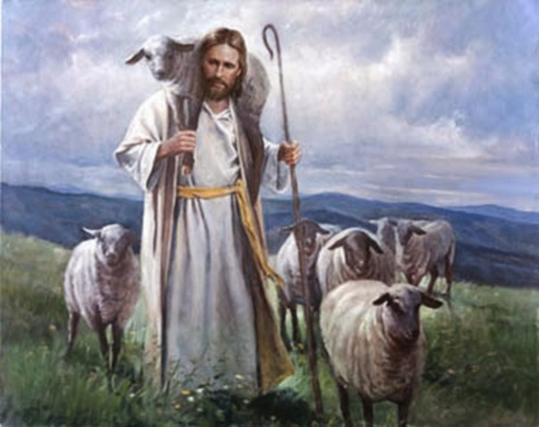
Gweddiwn Leader: Close your eyes and imagine you are on a walk.
Gweddiwn Leader: Picture the beauty of the place where you are
walking.
Gweddiwn Leader: Imagine that God joins you on the journey.
Gweddiwn Leader: What would you tell God?
Gweddiwn Leader: What might God say to you? Listen now to God’s
Word
Introduction to the Reading.
Gweddiwn Leader: The Lord be with you.
All children: And with your Spirit
Gweddiwn Leader: A reading from the Holy Gospel of John
All: Glory to you o Lord

“Truly, truly, I say to you, he who does not enter the sheepfold by the door but climbs in by another way, that man is a thief and a robber. ² But he who enters by the door is the shepherd of the sheep. ³ To him the gatekeeper opens. The sheep hear his voice, and he calls his own sheep by name and leads them out. ⁴ When he has brought out all his own, he goes before them, and the sheep follow him, for they know his voice. ⁵ A stranger they will not follow, but they will flee from him, for they do not know the voice of strangers.” ⁶ This figure of speech Jesus used with them, but they did not understand what he was saying to them.
⁷ So Jesus again said to them, “Truly, truly, I say to you, I am the door of the sheep. ⁸ All who came before me are thieves and robbers, but the sheep did not listen to them. ⁹ I am the door. If anyone enters by me, he will be saved and will go in and out and find pasture. ¹⁰ The thief comes only to steal and kill and destroy. I came that they may have life and have it abundantly.
Pause The Gospel of the Lord.
All: Praise to you Lord Jesus Christ.

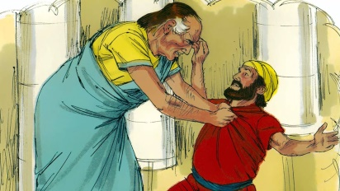
9.The Word of God
Gweddiwn Leader: Llygaid ar gau a dwylo unhyd
Gweddiwn Leader: Close your eyes and imagine you are on a walk.
Gweddiwn Leader: Picture the beauty of the place where you are
walking.
Gweddiwn Leader: Imagine that God joins you on the journey.
Gweddiwn Leader: What would you tell God?
Gweddiwn Leader: What might God say to you? Listen now to God’s
Word
Introduction to the Reading.
Gweddiwn Leader: The Lord be with you.
All children: And with your Spirit
Gweddiwn Leader: A reading from the Holy Gospel of Matthew
All: Glory to you o Lord
^{21 “}Then Peter came to him and asked, “Lord, how often should I forgive someone who sins against me? Seven times?”
²² “No, not seven times,” Jesus replied, “but seventy times seven!
²³ “Therefore, the Kingdom of Heaven can be compared to a king who decided to bring his accounts up to date with servants who had borrowed money from him. ²⁴ In the process, one of his debtors was brought in who owed him millions of dollars. ²⁵ He couldn’t pay, so his master ordered that he be sold—along with his wife, his children, and everything he owned—to pay the debt.
²⁶ “But the man fell down before his master and begged him, ‘Please, be patient with me, and I will pay it all.’ ²⁷ Then his master was filled with pity for him, and he released him and forgave his debt.
²⁸ “But when the man left the king, he went to a fellow servant who owed him a few thousand dollars. He grabbed him by the throat and demanded instant payment.
²⁹ “His fellow servant fell down before him and begged for a little more time. ‘Be patient with me, and I will pay it,’ he pleaded. ³⁰ But his creditor wouldn’t wait. He had the man arrested and put in prison until the debt could be paid in full.
³¹ “When some of the other servants saw this, they were very upset. They went to the king and told him everything that had happened. ³² Then the king called in the man he had forgiven and said, ‘You evil servant! I forgave you that tremendous debt because you pleaded with me. ³³ Shouldn’t you have mercy on your fellow servant, just as I had mercy on you?’ ³⁴ Then the angry king sent the man to prison to be tortured until he had paid his entire debt.
³⁵ “That’s what my heavenly Father will do to you if you refuse to forgive your brothers and sisters from your heart.”

Pause The Gospel of the Lord.
All: Praise to you Lord Jesus Christ.
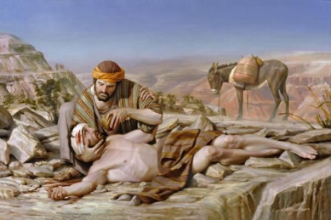
10.The Word of God
Gweddiwn Leader: Llygaid ar gau a dwylo unhyd
Gweddiwn Leader: Close your eyes and imagine you are on a walk.
Gweddiwn Leader: Picture the beauty of the place where you are
walking.
Gweddiwn Leader: Imagine that God joins you on the journey.
Gweddiwn Leader: What would you tell God?
Gweddiwn Leader: What might God say to you? Listen now to God’s
Word
Introduction to the Reading.
Gweddiwn Leader: The Lord be with you.
All children: And with your Spirit
Gweddiwn Leader: A reading from the Holy Gospel of Matthew
All: Glory to you o Lord
Once upon a time, a Jew was passing through a road carrying his goods with him, then suddenly some thieves came to him and they beat the Jew very much and looted all his belongings. That Jew was badly wounded. He was so injured that he could not even get up. After some time a Jewish priest passed by him. He was a religious man who worshipped God. That priest should have helped the wounded Jew lying there. But he left from there. After this, the priest’s assistant passed from there, who was a Jew. He also did not help the injured person. Children, if we were there, we would have been sad to see that injured person and would have tried to help him in any way. Then a Samaritan came who lived in Palestine. The Samaritans and Jews considered each other enemies. Their enmity was very old. But still, that good Samaritan supported the wounded Jew.
First of all, he bandaged the injured Jew’s wound and then took it in his donkey and took it from there. The Samaritan took him to a place where he could be safe. The Samaritan then arranged a man who will take care of the man and also paid for his treatment. After the story was over, Jesus asked the person, “So now tell me who is your neighbour?”
Now in compulsion, the person had to take the name of Samaritan whom he considered his enemy.
“All the Samaritans and every person who is wounded, who is in sorrow, they are all our neighbours.” The man said to Jesus.
Now that person had understood what he had to do.
Pause The Gospel of the Lord.
All: Praise to you Lord Jesus Christ
Mission/Going Forth
Gweddiwn Leader: : Let us come together as a class community to reflect on what we will hold on to from our Gweddiwn.
Pause - (Take a few seconds to close eyes – five rotations of the sing bowl.)

Gweddiwn Leader: Make a promise to follow the message of Jesus. (Take a few seconds to close eyes – five rotations of the sing bowl.)

Gweddiwn Leader: In your mind say a prayer for someone in need. Find time in the day to privately pray for someone or people who are in need. (Take a few seconds to close eyes – five rotations of the sing bowl.)

Gweddiwn Leader: Remember before you go to sleep to thank God for your day and say sorry for the times you have not lived out his message. (Take a few seconds to close eyes – five rotations of the sing bowl.)

Gweddiwn Leader: Invite someone who is lonely to play with you at playtime or lunchtime. (Take a few seconds to close eyes – five rotations of the sing bowl.)

Gweddiwn Leader: make an effort Tell your mum/dad you love her/him. Do not take for granted this love and be grateful for this gift every day. (Take a few seconds to close eyes – five rotations of the sing bowl.)

Gweddiwn Leader: Is there someone whom you need to forgive? How could you show that person that you have forgiven them? Remember our Christian Virtues and follow Christ’s teachings. (Take a few seconds to close eyes – five rotations of the sing bowl.)

Gweddiwn Leader: Remember to use good manners all day! Treat all staff, pupils and dinner staff with respect and remember all these different people do for us every day to make our lives happier and make us a Christian and respectful community. (Take a few seconds to close eyes – five rotations of the sing bowl.)

Gweddiwn Leader: Remember before you go to sleep to thank God for your day and say sorry for the times you have not lived out his message. Always remember that God our father loves us, he forgives us when we say sorry from our hearts and remember to live out our Christian Virtues which are the basis of God our father’s teachings. (Take a few seconds to close eyes – five rotations of the sing bowl.)



Say please and thank you!

