Welsh Bronze Award January 2024
Gwobr Efydd Cymru Mis Ionawr 2024
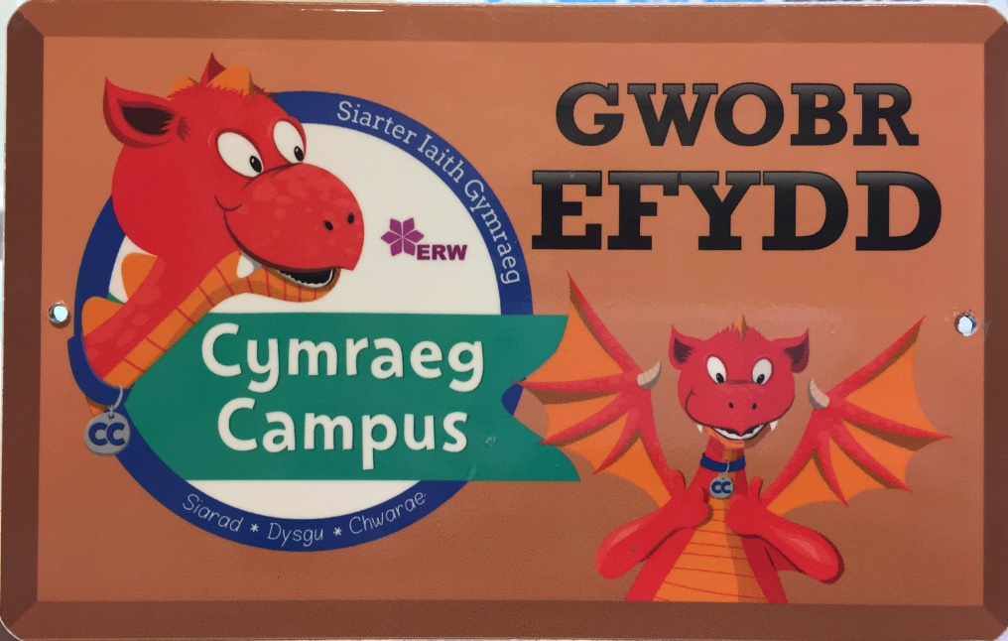
We did it! / Mi wnaethom ni fe!

We have been awarded the Welsh Bronze Award for creating a Campus Cynraeg in Ysgol Joseff Sant. We have attached the report we have received. As we have collected so much evidence and our Criw Cymraeg presentations to the external assessor Mrs Emma Davies was so well received, we have been advised to go for the Silver Award just before Easter. There is a lot of work to do, but we want to take our school forward and show how Welsh is such an important part of Saint joseph’s School environment and with regards to teaching and learning.
We are delighted, and thank all children and staff for making this possible.
Criw Cymraeg

