Main Theme/Context: Wales and the Wonderful World - FIJI
Class: St Cadoc 2

Religion  -Spread the Word  -Rules  -Treasures | Expressive Arts  -Create a cultural artefact  -Creating art inspired by the cultures of Wales and Fiji | Health and Well-being  -Athletics and Ball Skills  -The Cycle of Life
Humanities  -Compare and contrast Fijian geography, history, food, sport and culture with that of Wales | Language Literacy and Communication- English  -Travel Brochures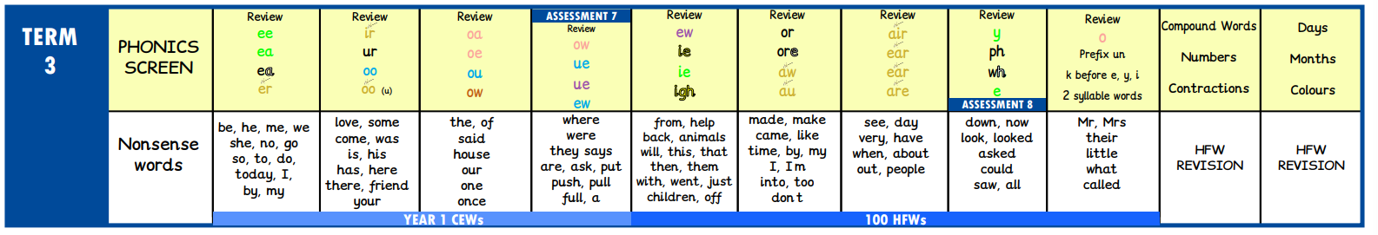 | Language Literacy and Communication- Welsh  -Covered by Miss Beynon
Mathematics and Numeracy  -Multiplication and Division  -2, 5, 10 and 3 timestables  -Reasoning (Word Problems) | Science and Technology  -Materials and DT | Proposed Trips/Visitors  -

