Main Theme/Context: Newsflash
Class: St Cadoc

Religion  Come and See  Beginnings  The experience of ‘family’ in society today is varied, with many joys and sorrows. Whatever the experience, family still remains the first place for growth and development, the basic social unit. What does the word ‘family’ mean to you? What people do you associate with ‘family’? What joys and sorrows do you remember of family life?  Signs and Symbols  Our lives are marked by many different experiences of being welcomed into new situations and groups. We recognise the importance of welcome, of feeling comfortable with new situations and belonging to new groups. We belong to families, to work places and to social groupings. What experiences of belonging can you recall in the family, at work or in leisure time? Are these good experiences? Are there any difficulties? What difference does ‘belonging’ make in your life? | Expressive Arts  KAPOW & Nativity  Drawing – Telling a Story  Developing knowledge of drawing materials to explore mark making with charcoal and experiment with creating texture. Creating and exploring experimental mark-making to replicate textures from touch. Drawing a favourite soft toy from observation, adding texture by applying mark-making skills. Developing new character illustrations, applying skills with line and mark making to add expression and detail. Making concertina books to illustrate with scenes for characters using mark making drawing techniques.  The Nativity Play this year will be a joint production. | Health and Well-being  TenTen & GetSet4PE  Created and Loved by God  Created and Loved by God explores the individual. Rooted in the teaching that we are created by God out of love and for love, it helps children to develop an understanding of the importance of valuing themselves as the basis for personal relationships.  Fundamentals  As in all units, pupils develop physical, social, emotional and thinking whole child objectives. Pupils will develop the fundamental skills of balancing, running, changing direction, jumping, hopping and skipping. Pupils will be given opportunities to work with a range of different equipment. Pupils will be asked to observe and recognise improvements for their own and others' skills and identify areas of strength. Pupils will be given the opportunity to work collaboratively with others, taking turns and sharing ideas.
Humanities  Football World Cup | Language Literacy and Communication- English  Monster Phonics  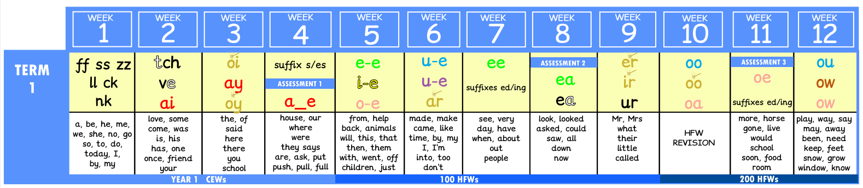  Extended Writing | Language Literacy and Communication- Welsh  Welsh will be cover by M.Beynon, covering the basics of the language and conversational sentences.
Mathematics and Numeracy  Complete Maths  Numbers and Counting  Money and Time  Arithmetic to 20 | Science and Technology | Proposed Trips/Visitors  Tbd  Tbd

