Beth wy ti’n eisiau?
What do you want?
Ga i pasta os gwelwch yn dda.
Can I have pasta please?
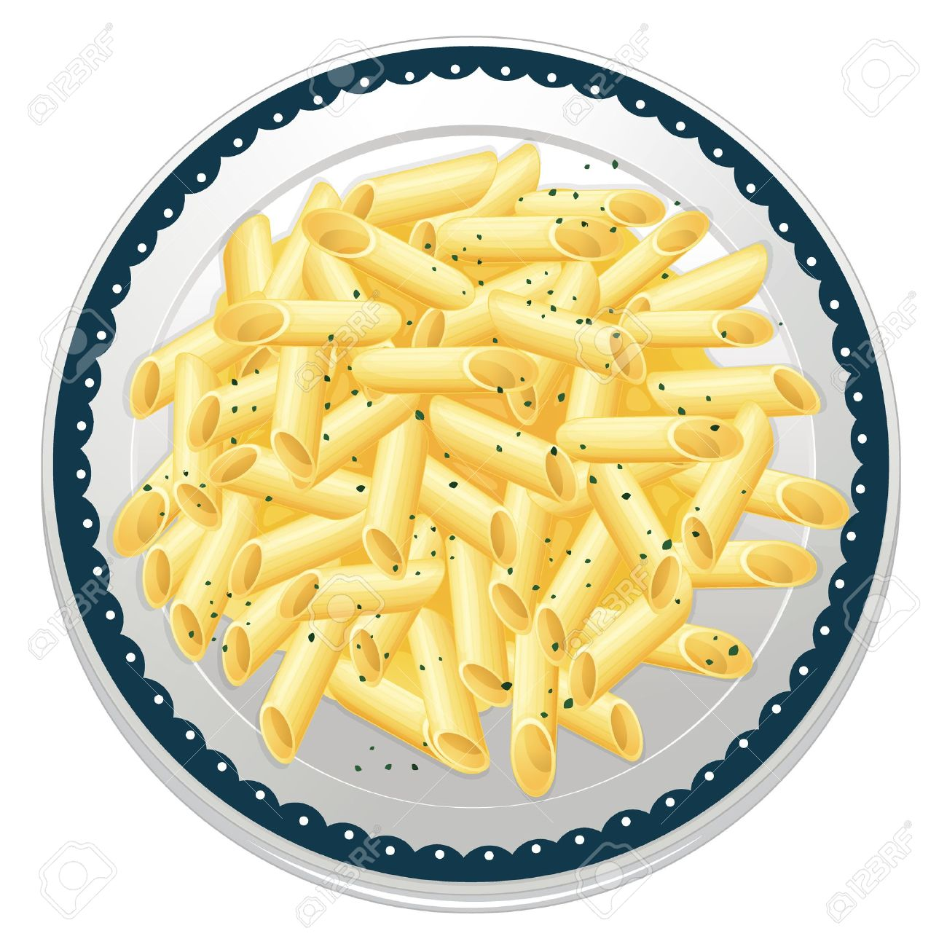
Beth wy ti’n eisiau?
What do you want?
Ga i selsig os gwelwch yn dda.
Can I have sausage please?
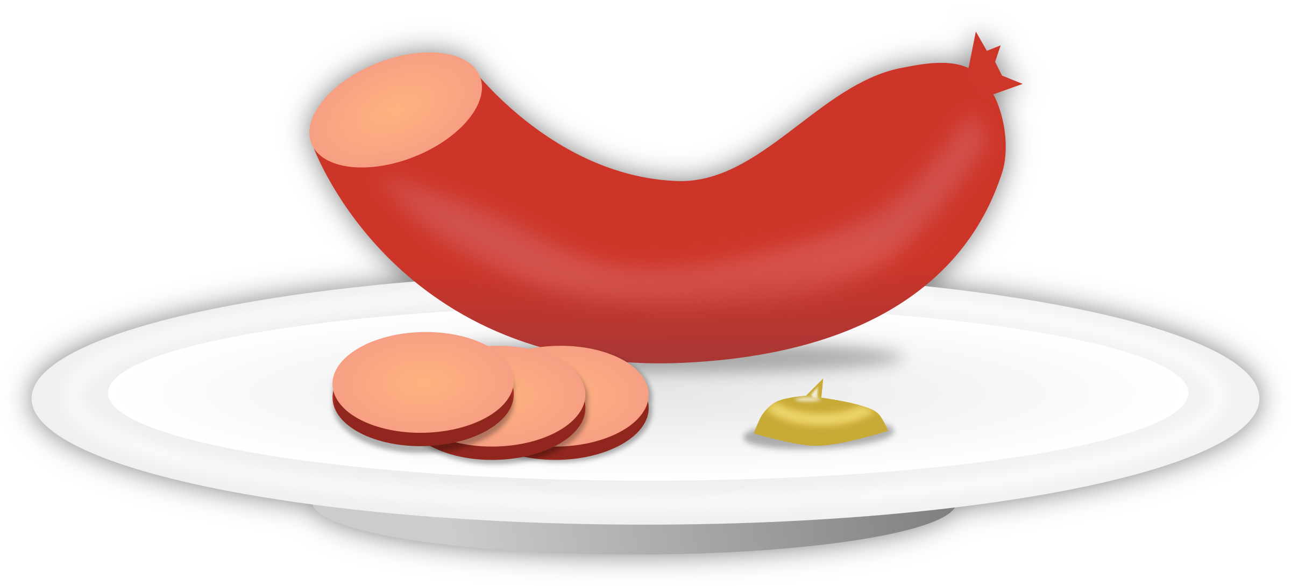
Beth wy ti’n eisiau?
What do you want?
Ga i grefi os gwelwch yn dda.
Can I have gravy please?
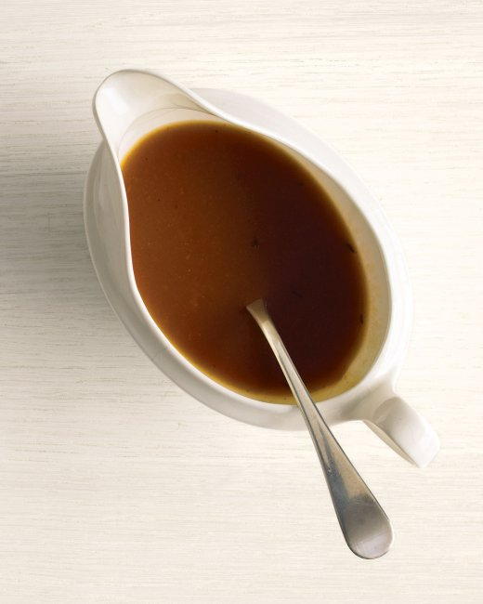
Beth wy ti’n eisiau?
What do you want?
Ga i cyrri os gwelwch yn dda.
Can I have curry please?
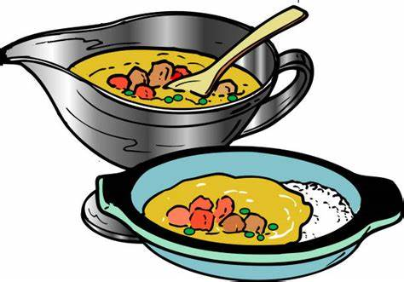

Beth wy ti’n eisiau?
What do you want?
Ga i teisen os gwelwch yn dda.
Can I have cake please?


Beth wy ti’n eisiau?
What do you want?
Ga i cwstard os gwelwch yn dda.
Can I have custard please?
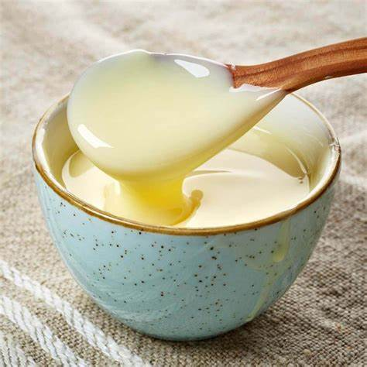
Beth wy ti’n eisiau?
What do you want?
Ga i byrger os gwelwch yn dda.
Can I have burger please?

Beth wy ti’n eisiau?
What do you want?
Ga i sglodion os gwelwch yn dda.
Can I have potatoes please?

Beth wy ti’n eisiau?
What do you want?
Ga i ffa pob os gwelwch yn dda.
Can I have baked beans please?
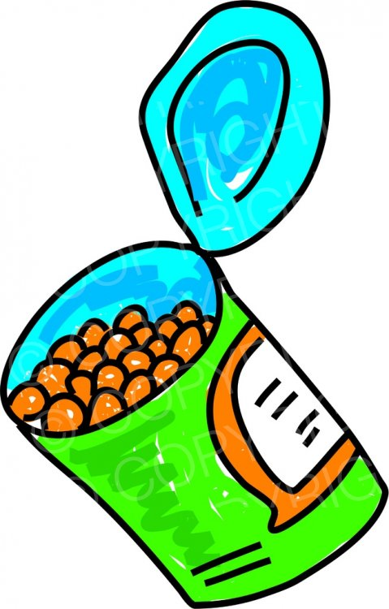
Beth wy ti’n eisiau?
What do you want?
Ga i huffen ia os gwelwch yn dda.
Can I have ice cream please?


Beth wy ti’n eisiau?
What do you want?
Ga i iogwrt os gwelwch yn dda.
Can I have yoghurt please?

Beth wy ti’n eisiau?
What do you want?
Ga i caws os gwelwch yn dda.
Can I have cheese please?
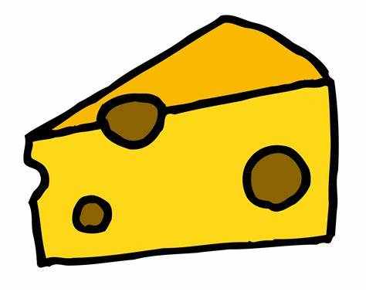
Beth wy ti’n eisiau?
What do you want?
Ga i pys os gwelwch yn dda.
Can I have peas please?
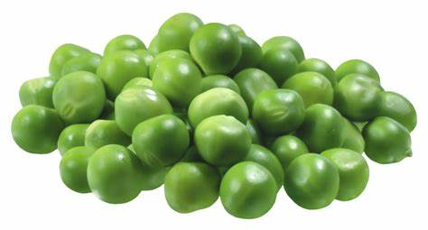
Beth wy ti’n eisiau?
What do you want?
Ga i jeli os gwelwch yn dda.
Can I have jelly please?
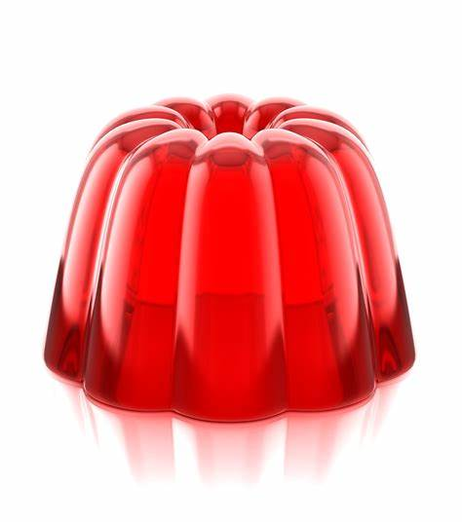
Beth wy ti’n eisiau?
What do you want?
Ga i salad os gwelwch yn dda.
Can I have salad please?
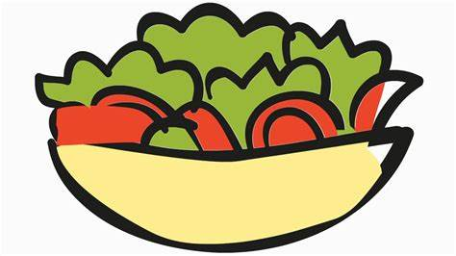
Beth wy ti’n eisiau?
What do you want?
Ga i tatws os gwelwch yn dda.
Can I have potatoes please?


