Aims of Criw Cymraeg

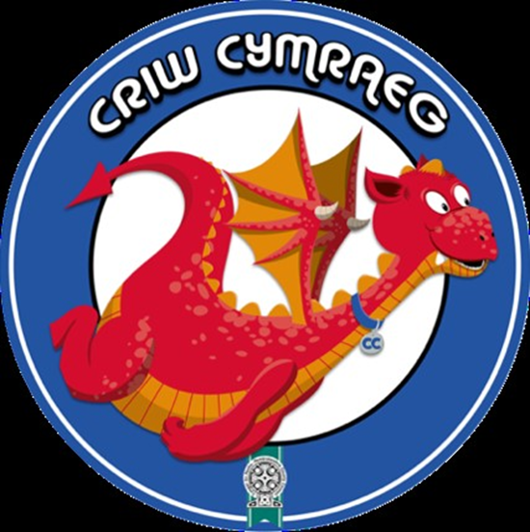
- To award Welsh speakers of the week through Welsh medium assemblies.
- Our aim is to continue to make our school a place where made by previous leaders of Criw Cymraeg.
- To maintain the posters for asking for dinner in Welsh. To support dinner staff in this role.
- To provide updated video evidence of children asking for dinner in Welsh.
- To provide SWOGS with Welsh phrases to be used on corridors. Book of phrases to be made and Criw Cymraeg laniards.
- To add to previous action plans for Criw Cymraeg.
- To take a lead role through the medium of Welsh in th weekly Welsh Assembly.
- To participate and encourage children to play Welsh games at playtime.
- To be an example using Welsh in the corridors and the classroom environment.
- To identify where Welsh across the curriculum is evidenced in books and contributed to a Criw Cymraeg folder.
- To work with the eacher leader on how to continue and encourage a school environment where teachers and children speak to each other though the medium of Welsh.
- To monitor that displays around the school are labelled in English and Welsh.
- To lead the Bardic Ceremony for Saint David’s Day.
- To photograph Welsh performances in the Saint Joseph’s Eisteddfod.
- To monitor the targets we have achieved as a school for the targets set by the authority for Welsh awards and identify those we have not achieved and set them as targets for this year.
- Place Welsh targets in the main corridor colouring those squares where as a Cymraeg Campus school we have achieved these targets. There are ten in total.
- To photograph and video evidence from the weekly Welsh assembly led by teachers and Criw Cymraeg using the Welsh Assembly PPT created by previous Criw cymraeg members.
- To gather evidence of music and art with a Welsh focus.
- To create a new website for our school website.
- To upload evidence of Welsh oracy, writing, reading and learning in context that relates to a Welsh culture.
- To be part of the judging of the winner for the Welsh Bardic Poem.
- To be responsible for announcing the new Welsh phrase of the week in the Welsh medium assembly.
- To give prizes for winners through the medium of Welsh in our annual eisteddfod.
- To prepare presentations for visitors to our school so that they can appreciate our role in creating a Cymraeg Campus in our school as previous Cymraeg campus groups have done.
- To create a website page to demonstrate actions taken by Criw Cymraeg.

