The Benefits of Learning Welsh


Y Byddion Dysgu Cymraeg

It keeps your brain fit and healthy.
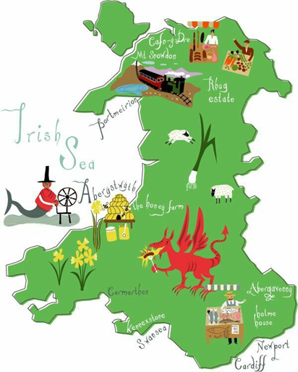
The Benefits of Learning Welsh
Y Byddion Dysgu Cymraeg

It may help you to learn other skills easier, like playing an instrument.
The Benefits of Learning Welsh
Y Byddion Dysgu Cymraeg

It increases the amount of time you can concentrate for.

The Benefits of Learning Welsh
Y Byddion Dysgu Cymraeg
When you can speak two languages it is easier for your brain to learn more.
The Benefits of Learning Welsh
Y Byddion Dysgu Cymraeg

People who speak two languages can go on to learn many more.

The Benefits of Learning Welsh
Y Byddion Dysgu Cymraeg
It improves your memory so you can remember more information.
The Benefits of Learning Welsh
Y Byddion Dysgu Cymraeg
Speaking Welsh helps you to understand the street and place names around you-lots have special meanings that you may otherwise have missed!
The Benefits of Learning Welsh
Y Byddion Dysgu Cymraeg
It gives you a sense of belonging to Wales and its history.

