Context for Learning
Technology, Literacy, Music and Composition Project
Dosbarth Gwynno
Progress Step Three
Year Four
Athrawes: Mrs Houston

Learning Intentions:
The two areas of learning will be used to conduct a project in which children learn to read a musical score, perform the score and then use IT skills such as presenting and evaluating their learning using PPT. (PPT was the children’s choice and is a basic form of recording learning, but they could NOT access the internet and their description and evaluation of learning are based on their experience of the learning within their lessons – no copying and pasting would apply therefore, the use of PPT as a vehicle for explaining and evaluating their learning is therefore appropriate.

Compose a song for Rights respecting Schools. A composition that can be drafted and edited as a literacy task. One that can be read as a score and performed as a singing and ‘orchestra’ task and one that can be coded using the micro – bit platform (A music and literacy writing frame attached to this document to support children in this process is provided.)

How could micro - bit be improved in relation to this learning opportunity for teachers?

Presently the children are provided with a single octave, if there was an octave and a half available then the potential of this platform would significantly increase.

Learning Tasks
Introduce children to the treble clef stave.
Children learn that music is recorded on five lines and four spaces with some noted being below and above the stave.

Introduce notes of the scale of c. Use tuned percussion to play the scale of c in an ascending and descending order.

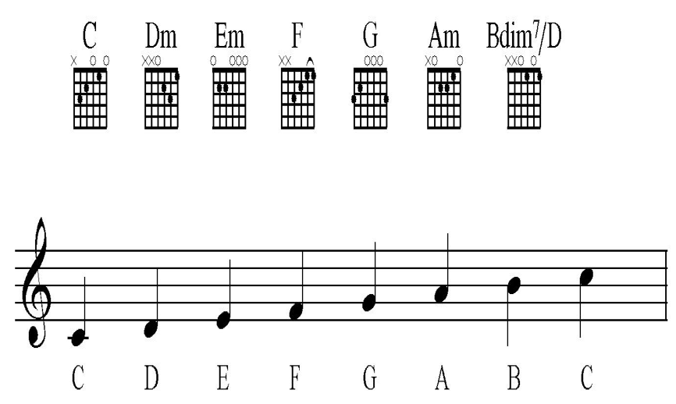

Technology: The scale is the first task children are required to input using their coding skills.

Music: The children were then introduced to the rhythmic value of notes. Clapping our different beats then ensued. The children were very quick picking this up. The quaver was also added to the information below.

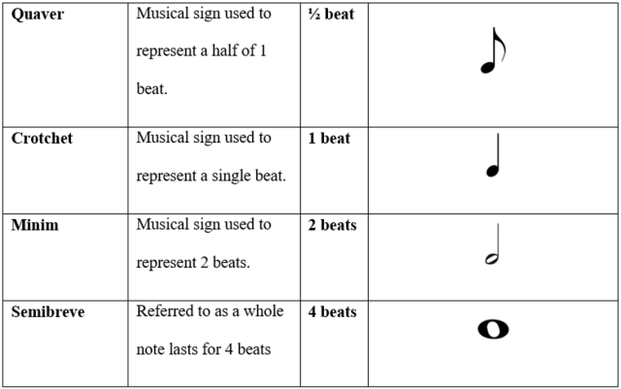

Music: The children were presented with a very simple score in 2 / 4 time using the nursery rhyme, ‘London’s Burning.’

Music: We began by identifying the notes and writing the notes on the whiteboard and using the value of notes from previous learning. Example is ¾ time but it was adapted to 2/4 time and the key of c to make it easier. Picture included in this file.

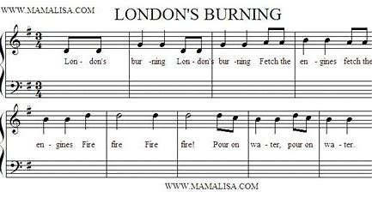

Creative Arts - Music
Children participated in the following musical activities:

- Beating out the rhythm with their hands on the desk.
Using hand movements to indicate whether notes went up and down and then extending the process to beaters. (Videos attached in this file)
- Introduce the children to the musical term ‘UNISON; where they sing ‘London’s Burning’ as a group. Video attached.
- Perform the song as a round – discuss harmony – the sound created.
- Reading from a score: To perform as a class on tuned percussion, (Glockenspiels)

Technology
Task One: Use micro – bit to code the scale of c
Task Two: use micro – bit to code London’s Burning
Task Three: Use PPT to explain and evaluate learning. (children cannot copy from internet sources as learning is based on actual learning within the classroom.
Task Four: To use hyper - links in their PPT to use videos of their performances from performing from a score.

NEXT STEPS

To choose a Welsh folk song to have a link to apply the learning skills indicated in the above learning explanation. Song to be chosen ‘Heno Heno’. Children will use the above processes described above.

Visit by the Technology Advisor
Lesson
Children will follow the same process as described above. They will focus on the Welsh National Anthem and the lesson will begin with the same process described.
Children will perform the score. (Prepared in advance.)
However, the children will be required to apply their coding skills to present ‘Hen Wlad fy’n hadau’ without teacher direction so our ‘‘visitor’ can observe the children working collaboratively and independently from the classroom teacher.

Literacy, Technology and Creative Arts

COMPOSITION
The final task in this project will be to compose a song for ‘Rights Respecting Schools.’ This will combine the AoLE of Music, Technology and Literacy.

Children will commence the project with looking at the key words associated with Rights Respecting Schools

Make a mind map of these key words relating to Rights Respecting Schools.

Children to be provided with a writing frame as to the number of syllables required in each line.
Children will compose in the key of c.
Children will be directed to begin the opening bar in c and end with the cord of G going to the chord of C so a musical ending id provided.
Writing and Music Frame for Saint Joseph’s Rights Respecting School Song.
-------- eight syllables – 8 beats – end in C
-------- eight syllables – 8 beats – end in C
---- four syllables – 4 beats – end in G
---- four syllables – 4 beats – end in G
-------- four syllables – 8 beats – end in C

A combination of the children’s ideas will be used to create the lyrics and music for ‘Saint Joseph’s Rights Respecting School Song.

Extension Tasks
- Perform as an ‘orchestra’ from a score.
- Code final song using a combination of ideas from the class.
- Perform – singing.
- Performing using tuned percussion – glockenspiels.
- Code final score using micro – bit.
Evaluative Writing (Music and Literacy).
Write an evaluation of the composition process. What you think you did well and what you would like to improve. Most importantly have you enjoyed your learning journey in this project? Why?

